

Emergency Action Plan

Table of Contents

- Evacuation pg. 3
- Medical Emergency pg. 3
- Fire & Explosion pg. 4
- Tornado & Other Severe Weather pg. 5
- Earthquake pg. 6
- Bomb Threat & Suspicious Package pg. 7
- Hazardous Material pg. 8
- Power Outage & Utility Failure pg. 8
- Verbal or Physical Alteration pg. 9
- Active Shooter pg. 10

Appendices

- Evacuation Routes pg. 12
- Emergency Contact Information pg. 17
- Bomb Threat Checklist pg. 21
- Quick Reference Guide pg. 22

Evacuation

For use when conditions outside are safer than inside. Refer to Evacuation Plan.

One employee should be assigned the responsibility to bring staff roster (posted behind evacuation plan) and first aid kit.

When the Announcement is Made or Alarm Sounded

- Take the closest and safest way out as posted on the Evacuation Plan. Use secondary route if primary route is blocked or hazardous.
- Assist those needing special assistance.
- Do not stop for belongings.
- Go to designated Assembly Area.
- Take a count of all individuals to ensure complete evacuation.
- Check for injuries and provide first aid as necessary.
- Report missing individuals to emergency response personnel.
- Assist emergency response personnel as necessary.
- Communicate first aid and emergency treatment needs to emergency response personnel.
- Wait for further instructions.

Assembly Area:
- Ashland: Parking lot behind Kentucky Career Center
- Maysville: Kenton Commonwealth Center Parking Lot
- Morehead: Parking lot between Kentucky Career Center and ARIA
- Mt. Sterling: Parking lot beside the Montgomery County Health and Civic Center

Medical Emergency

- Call 911.
- Notify the manager immediately.
- Do not move the injured or ill person. Try to make him/her comfortable.
- Unless trained to provide first aid, do not attempt to render any first aid before emergency assistance arrives.
- Use personal protective equipment (gloves and eye protection) when being exposed to bodily fluids (i.e. blood).
- Comfort the ill or injured person and reassure him/her that medical attention is on the way.
- If necessary, implement appropriate emergency procedures (evacuation, etc.) to ensure that individuals are not exposed to trauma or danger.
- Remain calm and reassure individuals that all possible actions are being taken to care for the injured or ill person and to protect others.
- After the ill or injured person’s immediate needs have been taken care of, remain to assist medical services with pertinent information about the incident. Emergency contact information is located in KHRIS. Manager to notify emergency contact.
- Preserve the scene of the medical emergency in the event incident will require an investigation or follow-up.

Fire & Explosion

ONLY USE A FIRE EXTINGUISHER IF YOU HAVE BEEN TRAINED TO DO SO. EMPLOYEES ARE NOT REQUIRED TO USE FIRE EXTINGUISHERS.
Remember R.A.C.E.

Rescue- Remove anyone from immediate danger.
Alarm- Call 911 and notify immediate supervisor and facility manager of the fire and activate the nearest emergency pull station.
Contain- Close all doors to confine smoke and fire.
Evacuate- Unless otherwise directed by management, follow the exit routes on the Evacuation Plan and proceed to the designated Assembly Area outside the building.

If You Catch on Fire

DO NOT RUN- STOP where you are!
DROP to the ground!
ROLL over and over to smother flames.

Response to Fire Alarm

- Evacuate and stay with customers.
- Upon reaching the Assembly Area, account for employees, customers, visitors, and vendors and report anyone missing to the manager.
- Only return to the building when directed by the manager.

If Trapped in Office

- Wedge wet towels (if available) or cloth materials along the bottom of the door to keep out the smoke.
- Try to close as many doors as possible between you and the fire.
- Use the telephone to notify 911 of the situation and location.
- If you are trapped in an area and need fresh air, only break the window as a last resort, and use caution when breaking the window.

Explosion

- Be prepared to evacuate or shelter in place.
- Be prepared for further explosions.
- If evacuation is required, proceed to the designated Assembly Area.
- Open doors carefully and watch for falling objects.
- Report any missing employees, customers, visitors, and vendors.
- If you are trapped in an area and need fresh air, only break the window as a last resort, and use caution when breaking the window.

Tornado & Other Severe Weather

Tornado Watch

Tornado Watch-Issued by the National Weather Service when severe weather conditions and tornadoes could occur in the area.

- When a tornado watch is in effect, the office will continue normal operations.
- Monitor weather reports for change in condition.
- Be prepared to respond if weather conditions worsen.
- Staff will not be dismissed early and office closing will be at the regular time.

Tornado Warning

Tornado Warning-Issued by the National Weather Service when a tornado has been sighted or indicated by weather radar.

- Immediately move the designated shelter areas:
- Close blinds or drapes, and stay away from windows, mirrors, glass, and unsecured objects such as filing cabinets.
- If high winds or tornadoes strike the building, place your head down while in a sitting or kneeling position, and protect your head and torso with your hands and arms (Duck and Cover).
- If necessary, call 911.
- If trained to do so, render first aid to those who are injured until emergency medical assistance arrives.
- Unless there is an imminent hazard in the area, refrain from leaving the area until emergency crews arrive. If the building is significantly damaged, several hazards such as exposed electrical wires, sharp or falling debris, etc. may be present.

Areas to Avoid

- Spaces that are opposite doorways or openings into rooms that have windows in the exterior wall, particularly facing south and west.
- Corridor intersections (stay at least 10 feet away).
- Skylights, atriums, and areas with large roof spans.

Earthquake

If Inside

- Initiate DROP, COVER, AND HOLD.
  - Duck under a sturdy desk or table.
  - Cover – Stay covered until the shaking stops. If no desk or table is available, seek cover against an interior wall and protect your head and neck with your arms.
  - Hold on to the desk or table. If it moves, move with it.
- If no cover is available, get against an inside doorway or crouch against an inside wall and cover head. STAY AWAY FROM outside walls, windows or other expanses of glass and potential falling objects.
- Leave doors open to minimize jamming if the building shifts.
- Do not attempt to run through the building or outside due to the risk of falling objects.
- If in a room with no furniture, get against an inside wall or inside a doorway and crouch.
- After initial tremor, initiate Evacuation and take a count of all individuals to ensure complete evacuation. Modify Assembly Area if needed.

If Outside

- Move quickly away from the building and overhead electrical wires.
- Lie flat, face down, and wait for the shocks to subside.
- Do not attempt to enter the building until authorized to do so.
- Do not touch fallen wires.
- Take a count of all individuals to ensure complete evacuation.
- Check for injuries and provide first aid as necessary.
- Report missing individuals to emergency response personnel.
- Assist emergency response personnel as necessary.

Assembly Area

- Earthquake safe areas will be away from the building and overhead power lines.
- Keep everyone away from underground utilities.
- Call 911.
- In the event of aftershocks, remain calm and stay sitting or close to the ground.
- Administer first aid as required.
- Do not re-enter the building until given an “ALL CLEAR” by the appropriate emergency management personnel.

Bomb Threats & Suspicious Packages

Telephone Threat - Refer to Appendix 3

- Do not hang up, keep the caller on the line as long as possible, and listen carefully.
- Note the time of the call.
- Ask the caller the following:
  - Where is the bomb?
  - When will it explode?
  - What does the bomb look like?
  - What kind of bomb is it?
  - What will cause it to explode?
  - What is the caller’s name and motive for placing the bomb?
- Write down any pertinent information such as background noises, gender of the caller, and voice pitches and patterns.
- Notify the manager immediately.

Suspicious Packages/Written or E-Mail Threats

- Do not touch or approach a bomb or suspicious device.
- Do not use any portable radio or cell phone.
- Notify the manager immediately.
- Keep anyone from handling it or going near it.
- Evacuate everyone out of the immediate area.
- Write down everything remembered about the letter or parcel.
- Save all packing materials.
- Save email and report to the manager.

Notification of a Bomb Threat

- When an explosive device is present or alleged to be present in the building or on state property, evacuation instructions will be given.
- If directed to search the work area, look for any suspicious packages or unidentified backpacks or purses. Never touch any package that looks suspicious. If a suspicious package is located, notify the manager immediately.
- Avoid running and other quick movement, since this can detonate certain devices.
- When evacuating, account for employees, customers, visitors, and vendors upon reaching the designated Assembly Area.
- Immediately notify the manager of any missing employees, customers, visitors, and vendors.
- Do not use cell phones or portable radios.

Hazardous Material Spill

- Notify the manager immediately. Call 911.
- Provide appropriate details of the incident including the type of chemical, if known.
- Implement the appropriate procedures (evacuation, etc.) to ensure that others are not exposed to danger.
- Do not try to clean up the spill.
- Direct any visitors, customers, and vendors to the Assembly Area.
- If possible, control access to the affected area by closing doors.
- Check people involved for medical emergencies (shortness of breath, fainting, etc.) and request immediate emergency medical assistance.
- Remain in the Assembly Area unless otherwise directed by the manager.

Power Outage & Utility Failure

- Notify the manager immediately of the type of utility outage (electrical, heating, cooling, water, etc.).
- If necessary, implement the appropriate emergency procedures (evacuation, etc.) to ensure that customers are not exposed to danger.
- Open blinds to let outside light in or use flashlights.
- Remain in place unless directed by the manager to go to another designated area.
- If moved to another area, account for employees, customers, visitors, and vendors upon arrival to the new area.
- Do not return to the evacuated work area until the “All Clear” is announced.

Gas Line Break/Water Main Break

- Clear the immediate area. Evacuate to designated Assembly area.
- Notify the manager immediately. Call 911.
- Account for any missing employees, customers, visitors, and vendors.

Verbal or Physical Altercation

Threat/Dealing with a Difficult Individual

- Be aware of your surroundings.
- Assess the level of threat. DO NOT PUT YOURSELF AT RISK if you think an altercation could occur.
- Time and distance are important-the more time you have the more time you will be able to prepare yourself. Keep a distance of at least an arm’s length between you and the individual.
- Notify manager and other staff that assistance is needed.
- Try to de-escalate the situation.
- Listen to the person.
- Empathize with the person and be respectful-don’t shame, blame, or judge.
- Use a clear, calm, strong, voice.
- Keep body language non-threatening.
- Don’t use words that threaten or intimidate.
- If you are unable to de-escalate the situation, request assistance immediately.

If An Altercation Occurs

- If an altercation is taking place. DO NOT PUT YOURSELF AT RISK.
- Report the altercation to the manager immediately.
- Notify all staff members.
- Call 911.
- After the altercation has occurred, if safe to do so, move any victim to a private office or area. Ensure the victim is in a safe place and assist in making him/her comfortable.
- Be prepared to give as much of the following information as possible to the manager and police:
  - Your name and location.
  - What happened?
  - Victim’s name and age.
  - Location of the victim.
  - Description of the assailant.
  - Location of the assailant or direction of his/her escape.
- If the victim requires emergency medical attention, see the section on Medical Emergencies.
- Remain calm and reassure employees, customers, visitors, and vendors that all possible actions are being taken to care for the injured person and to protect others.

Weapon Observed on an Individual with Threatening Action(s)

USE EXTREME CAUTION IN ALL SITUATIONS.
DO NOT CONFRONT THE INDIVUDUAL.

- Seek assistance from another staff member or supervisor in reporting the situation.
- If it is safe to do so, notify the police with:
  - Your name and location.
  - The name and description of the suspect.
  - Any information regarding the weapon’s location and type.
- Ensure employees, visitors, customers, and vendors’ safety by moving everyone away from the person with the weapon to a safe location.
- Discreetly notify the manager if the individual with the weapon is not present.

Active Shooter

Evacuate

- If there is an accessible escape path, attempt to evacuate the premises. Be sure to:
  - Have an escape route and plan in mind.
  - Evacuate regardless of whether others agree to follow.
  - Leave your belongings behind.
  - Help others escape, if possible.
  - Prevent individuals from entering an area where the active shooter may be.
  - Keep your hands visible.
  - Follow the instructions of any police officers.
  - Do not attempt to move wounded people.
  - Call 911 when you are safe.

Hide out

- If evacuation is not possible, find a place to hide where the active shooter is less likely to find you.
- Your hiding place should:
  - Be out of the active shooter’s view.
  - Provide protection if shots are fired in your direction (i.e., an office with a closed and locked door).
  - Not trap you or restrict your options for movement.
- To prevent an active shooter from entering your hiding place:
  - Lock the door.
  - Blockade the door with heavy furniture.

HOW TO RESPOND WHEN AN ACTIVE SHOOTER IS IN YOUR VICINITY

- If the active shooter is nearby:
  - Lock the door.
  - Silence your cell phone and/or pager.
  - Turn off any source of noise (i.e., radios, televisions).
  - Hide behind large items (i.e., cabinets, desks).
  - Remain quiet.
- If evacuation and hiding out are not possible:
  - Remain calm.
  - Dial 911, if possible, to alert police to the active shooter’s location.
  - If you cannot speak, leave the line open and allow the dispatcher to listen.
- Take action against the active shooter:
  - As a last resort, and only when your life is in imminent danger, attempt to disrupt and/or incapacitate the active shooter by:
    - Acting as aggressively as possible against him/her.
    - Throwing items and improvising weapons.
    - Yelling.
    - Committing to your actions.

HOW TO RESPOND WHEN LAW ENFORCEMENT ARRIVES

- Remain calm and follow officers’ instructions.
- Put down any items in your hands (i.e., bags, jackets).
- Immediately raise hands and spread fingers.
- Keep hands visible at all times.
- Avoid making quick movements toward officers such as holding on to them for safety.
- Avoid pointing, screaming and/or yelling.
- Do not stop to ask officers for help or direction when evacuating, just proceed in the direction from which officers are entering the premises.

Appendix I
KCC Ashland Evacuation Routes First Floor
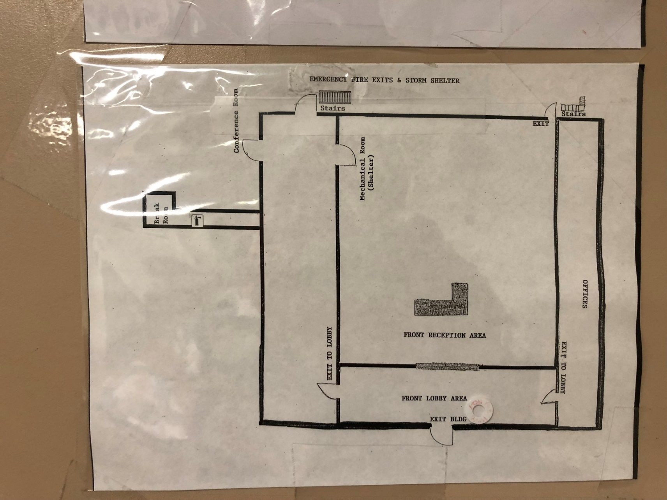

Appendix I
KCC Ashland Evacuation Routes Second Floor
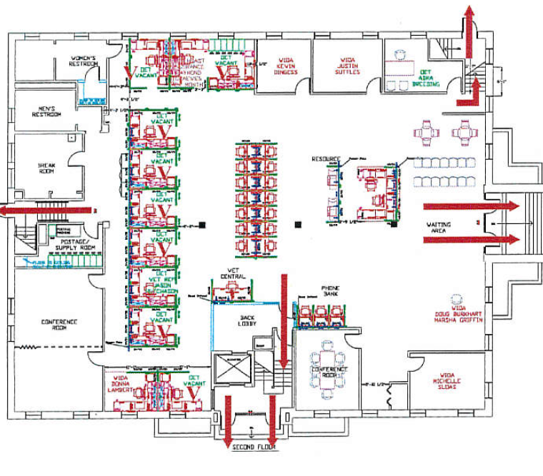

Appendix I
KCC Maysville Evacuation Routes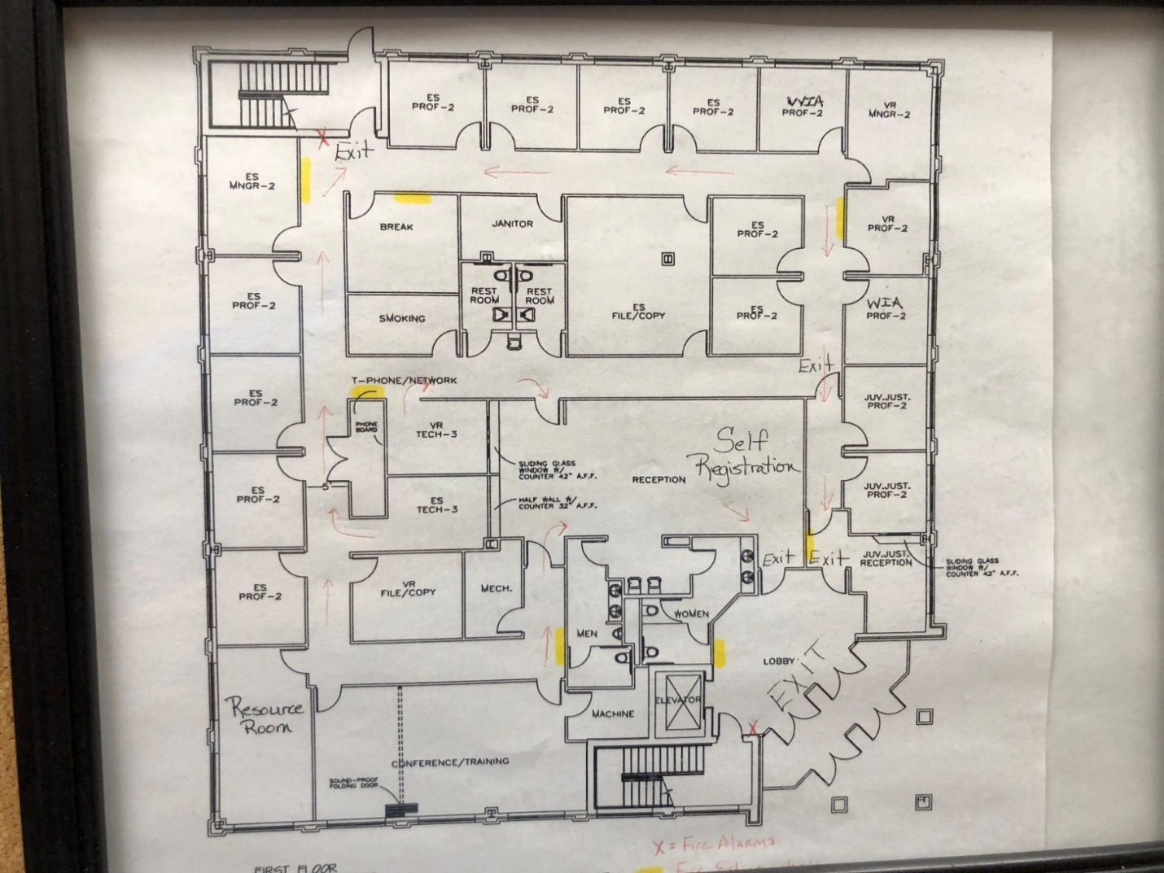

Appendix I
KCC Morehead Evacuation Routes
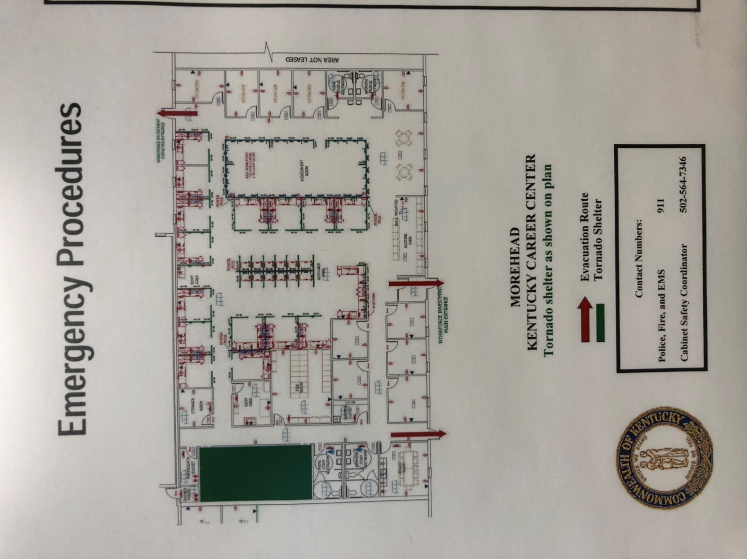
Appendix I
KCC Mt. Sterling Evacuation Routes

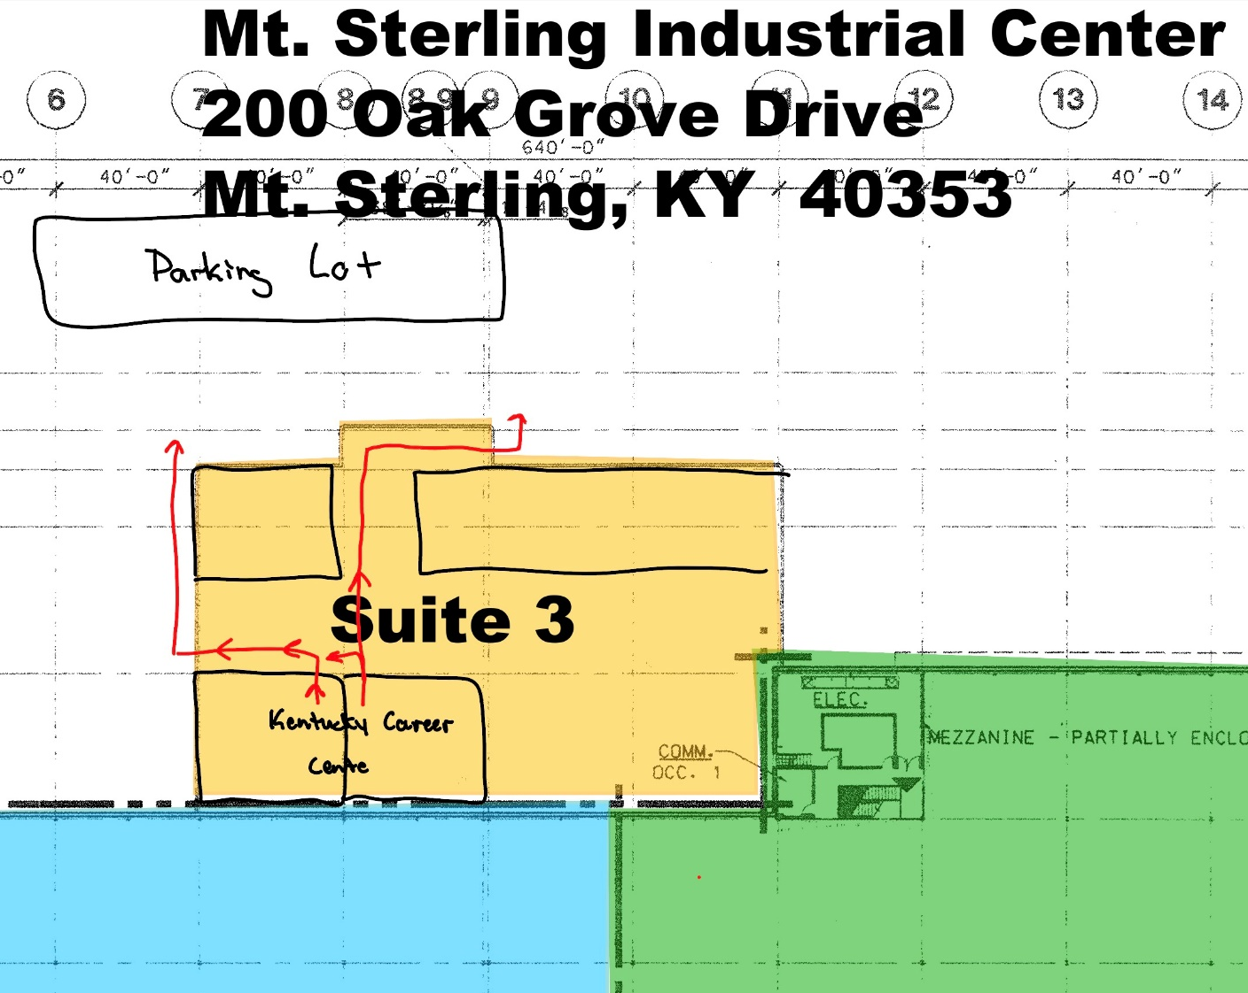

Appendix II
Kentucky Career Center – Ashland
EMERGENCY PHONE NUMBERS

FIRE DEPARTMENT: 911 PARAMEDICS: 911 AMBULANCE: 911 POLICE: 911

BUILDING MGR: Tonia Prewitt / Brittany Layne
EMERGENCY COORDINATOR: Larry Perkins (502)226-0294

AREA/FLOOR MONITORS (If applicable):
Area/Floor: 1st Floor Name: Michael Alley Phone: 68092
Area/Floor: 2nd Floor Name: Cylenna Barker Phone: 606-254-9033
ASSISTANTS TO PHYSICALLY CHALLENGED (If applicable):
Name: Michael Alley Phone: 68092
Name: Phone:

UTILITY COMPANY EMERGENCY CONTACTS
(Specify name of the company, phone number and point of contact)

ELECTRIC: Kentucky Power - 800-572-1113
WATER: City of Ashland – 606-327-2018
GAS: Columbia Gas 800-432-9515
TELEPHONE COMPANY: Windstream – 866-347-1991
Appendix II
Kentucky Career Center – Maysville
EMERGENCY PHONE NUMBERS

FIRE DEPARTMENT: 911 PARAMEDICS: 911 AMBULANCE: 911 POLICE: 911

BUILDING MGR: City of Maysville David Hord (606)564-9419
EMERGENCY COORDINATOR: Matt Wallingford – 606-564-9419; 606-584-1016 (cell)

AREA/FLOOR MONITORS (If applicable):
Area/Floor: Center Wide Name: Katrina Thornburg Phone: 606-564-3347 ext. 2
Area/Floor: Center Wide Name: Phone:

ASSISTANTS TO PHYSICALLY CHALLENGED (If applicable):
Name: Katrina Thornburg Phone: 606-564-3347 ext. 2
Name: Phone:
UTILITY COMPANY EMERGENCY CONTACTS
(Specify name of the company, phone number and point of contact)

ELECTRIC: Kentucky Utilities – 1-800-383-5582
WATER: Maysville Utility Dept. – Darren Garrison – 606-564-3531; 606-564-9419
GAS: Columbia Gas - 800-432-9345
TELEPHONE COMPANY: AT&T – 1-888-944-0447
Appendix II
Kentucky Career Center – Morehead
EMERGENCY PHONE NUMBERS

FIRE DEPARTMENT: 911 PARAMEDICS: 911 AMBULANCE: 911 POLICE: 911

BUILDING MGR: Tonia Prewitt / Cylenna Barker
EMERGENCY COORDINATOR: Larry Perkins (502)226-0294
AREA/FLOOR MONITORS (If applicable):

Area/Floor: Center Wide Name: Cylenna Barker Phone: 606-254-9033

Area/Floor: Center Wide Name: Melinda Messer Phone: 22446

ASSISTANTS TO PHYSICALLY CHALLENGED (If applicable):
Name: Cylenna Barker Phone: 606-254-9033

Name: Tara Laudermilt Phone: 502-764-2554
UTILITY COMPANY EMERGENCY CONTACTS
(Specify name of the company, phone number and point of contact)
ELECTRIC: Kentucky Utilities – 800-383-5582
WATER: Morehead Utility Plant Board – 606-784-5538
GAS: Morehead Utility Plant Board – 606-784-5538
TELEPHONE COMPANY: COT or Windstream – 800-347-1991
Appendix II
Kentucky Career Center – Mt. Sterling
EMERGENCY PHONE NUMBERS
FIRE DEPARTMENT: 911 PARAMEDICS: 911 AMBULANCE: 911 POLICE: 911

BUILDING MGR: Bruce 606-336-8118
EMERGENCY COORDINATOR: Bruce 606-336-8118
AREA/FLOOR MONITORS (If applicable):

Area/Floor: Center Wide Name: Bryanna Brown-Short Phone: 859-274-8480

Area/Floor: Center Wide Name: Phone:

ASSISTANTS TO PHYSICALLY CHALLENGED (If applicable):
Name: Bryanna Brown-Short Phone: 859-274-8480
Name: Phone:
UTILITY COMPANY EMERGENCY CONTACTS
(Specify name of the company, phone number and point of contact)
ELECTRIC: Kentucky Utilities – 800-383-5582
WATER: Mt. Sterling Water and Sewer System – 859-498-0166
INTERNET: KyWiFi – 859-274-4033
TELEPHONE COMPANY: AT&T – 866-563-4703
Appendix III
TELEPHONE BOMB THREAT CHECKLIST
INSTRUCTIONS: BE CALM, BE COURTEOUS. LISTEN. DO NOT INTERRUPT THE CALLER.
YOUR NAME: __________________________ TIME: _____________ DATE: ________________
CALLER'S IDENTITY SEX: Male _____ Female ____ Adult ____ Juvenile ____ APPROXIMATE AGE: _____
ORIGIN OF CALL: Local __________ Long Distance ___________ Telephone Booth __________
VOICE CHARACTERISTICS |  | SPEECH |  | LANGUAGE
___ Loud  ___ High Pitch  ___ Raspy  ___ Intoxicated | ___ Soft  ___ Deep  ___ Pleasant  ____________  Other | ___ Fast  ___ Distinct  ___ Stutter  ___ Slurred | ___ Slow  ___ Distorted  ___ Nasal  ____________  Other | ___ Excellent  ___ Fair  ___ Foul | ___ Good  ___ Poor  __________  Other
ACCENT |  | MANNER |  | BACKGROUND NOISES
___ Local  ___ Foreign  ___ Race | ___ Not Local  ___ Region | ___ Calm  ___ Rational  ___ Coherent  ___ Deliberate  ___ Righteous | ___ Angry  ___ Irrational  ___ Incoherent  ___ Emotional  ___ Laughing | ___ Factory  ___ Machines  ___ Music  ___ Office  ___ Machines  ___ Street  ___ Traffic | ___ Trains  ___ Animals  ___ Quiet  ___ Voices  ___ Airplanes  ___ Party  ___ Atmosphere
BOMB FACTS
PRETEND DIFFICULTY HEARING - KEEP CALLER TALKING - IF CALLER SEEMS AGREEABLE TO FURTHER CONVERSATION, ASK QUESTIONS LIKE:
When will it go off? Certain Hour ____ Time Remaining
Where is it located? Building Area
What kind of bomb? ___________________
What kind of package?______________
How do you know so much about the bomb?___
What is your name and address?
If building is occupied, inform caller that detonation could cause injury or death.
Call or have someone else call _________ and relay information about the call.
Did the caller appear familiar with plant or building (by his/her description of the bomb location)?
Write out the message in its entirety and any other comments on a separate sheet of paper and attach to this checklist. Notify your supervisor immediately.
Appendix IV
Emergency Preparedness Resources

- Options for Consideration Active Shooter Preparedness Video
The Options for Consideration video demonstrates possible actions that individuals can take if confronted with an active shooter scenario. This instructive video reviews the choices of running, hiding, or as an option of last resort, fighting the shooter. The video also shows how to assist authorities once law enforcement arrives.
https://www.dhs.gov/cisa/options-consideration-active-shooter-preparedness-video

- Active Shooter Training
https://www.fbi.gov/how-we-can-help-you/active-shooter-safety-resources

- Tornado Safety Tips from American Red Cross

https://www.redcross.org/get-help/how-to-prepare-for-emergencies/types-of-emergencies/tornado.html

- How to Prepare for an Emergency from American Red Cross
https://www.redcross.org/get-help/how-to-prepare-for-emergencies.html

- Severe Weather from ready.gov
https://www.ready.gov/severe-weather

