# Step by Step 1099 Guide

**Log in and Click Payment Request**

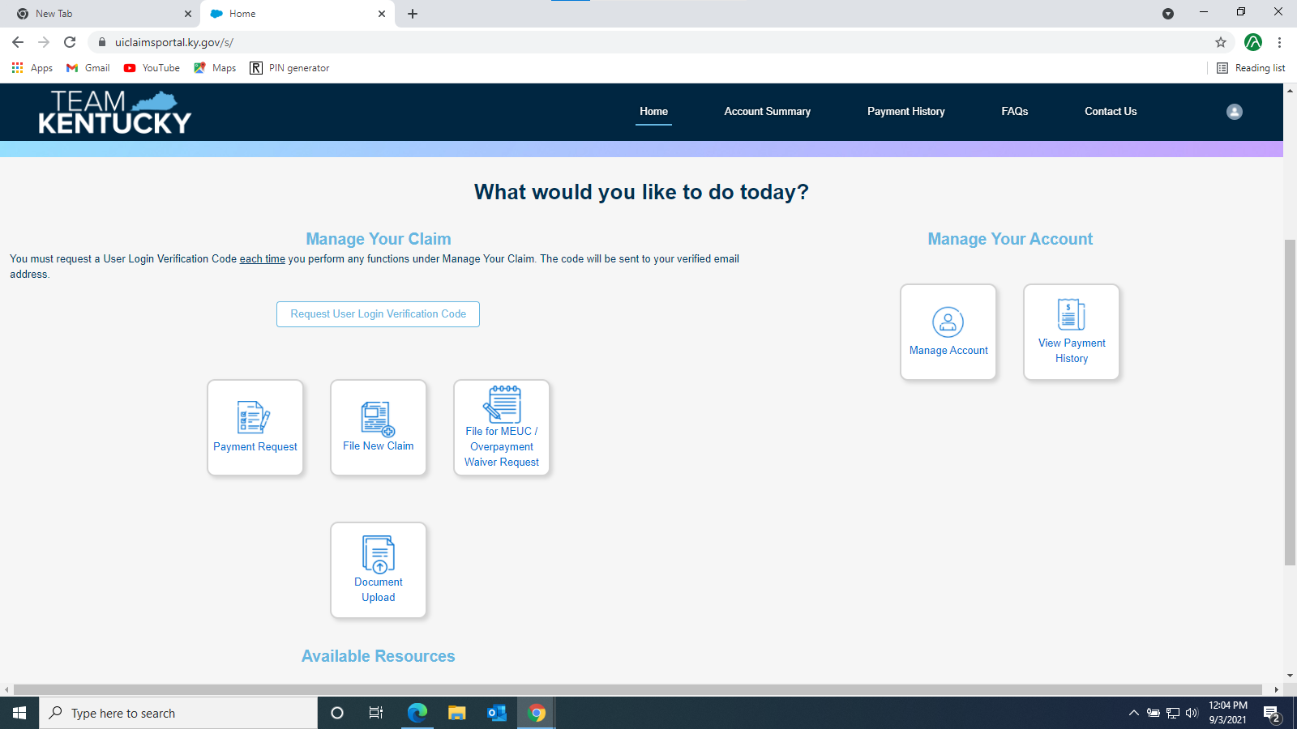

**Enter the Claimants Social Security Number and PIN**

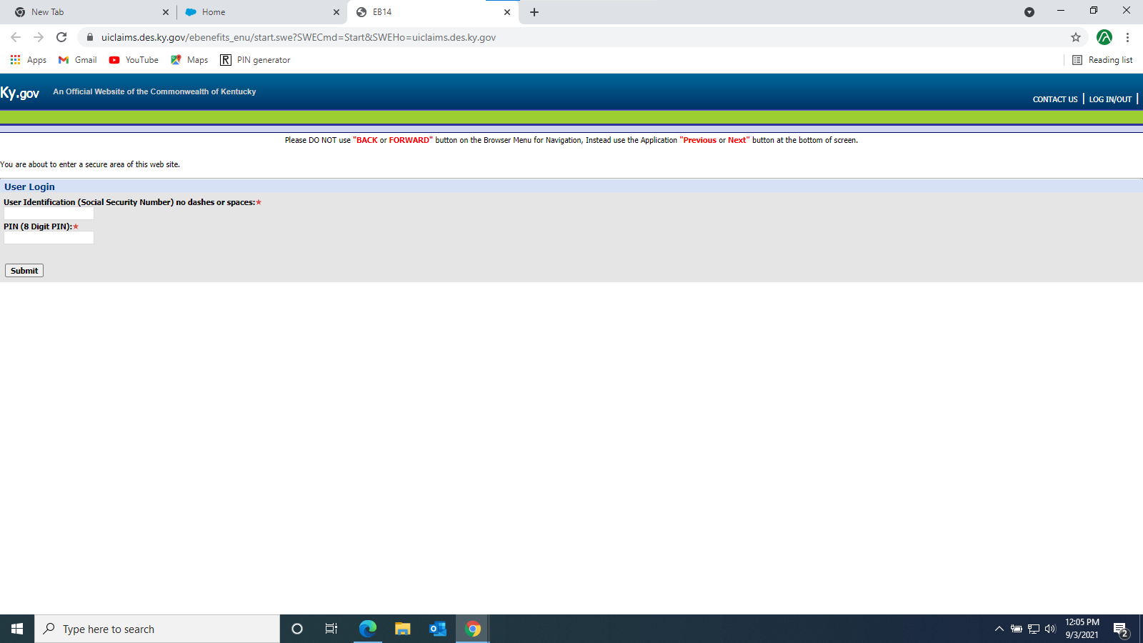

**Once logged in, click “My 1099” in the top right Corner**

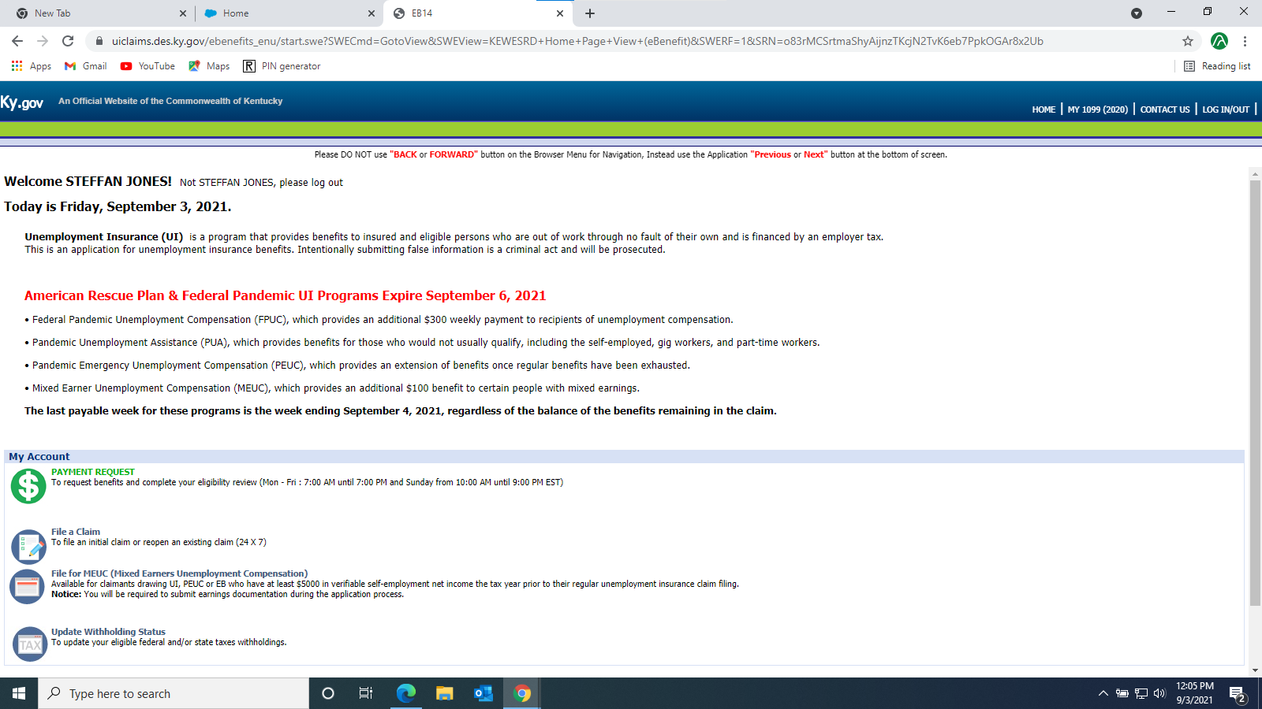

**There will be a File Name inside the Red Box, Click to open it. When opening, a Password is required. It will be The Last Four Digits of the Claimants SSN!**

