# Scheduling an In-Person Appointment

Go to [www.kcc.ky.gov](http://www.kcc.ky.gov), then click Schedule an Appointment

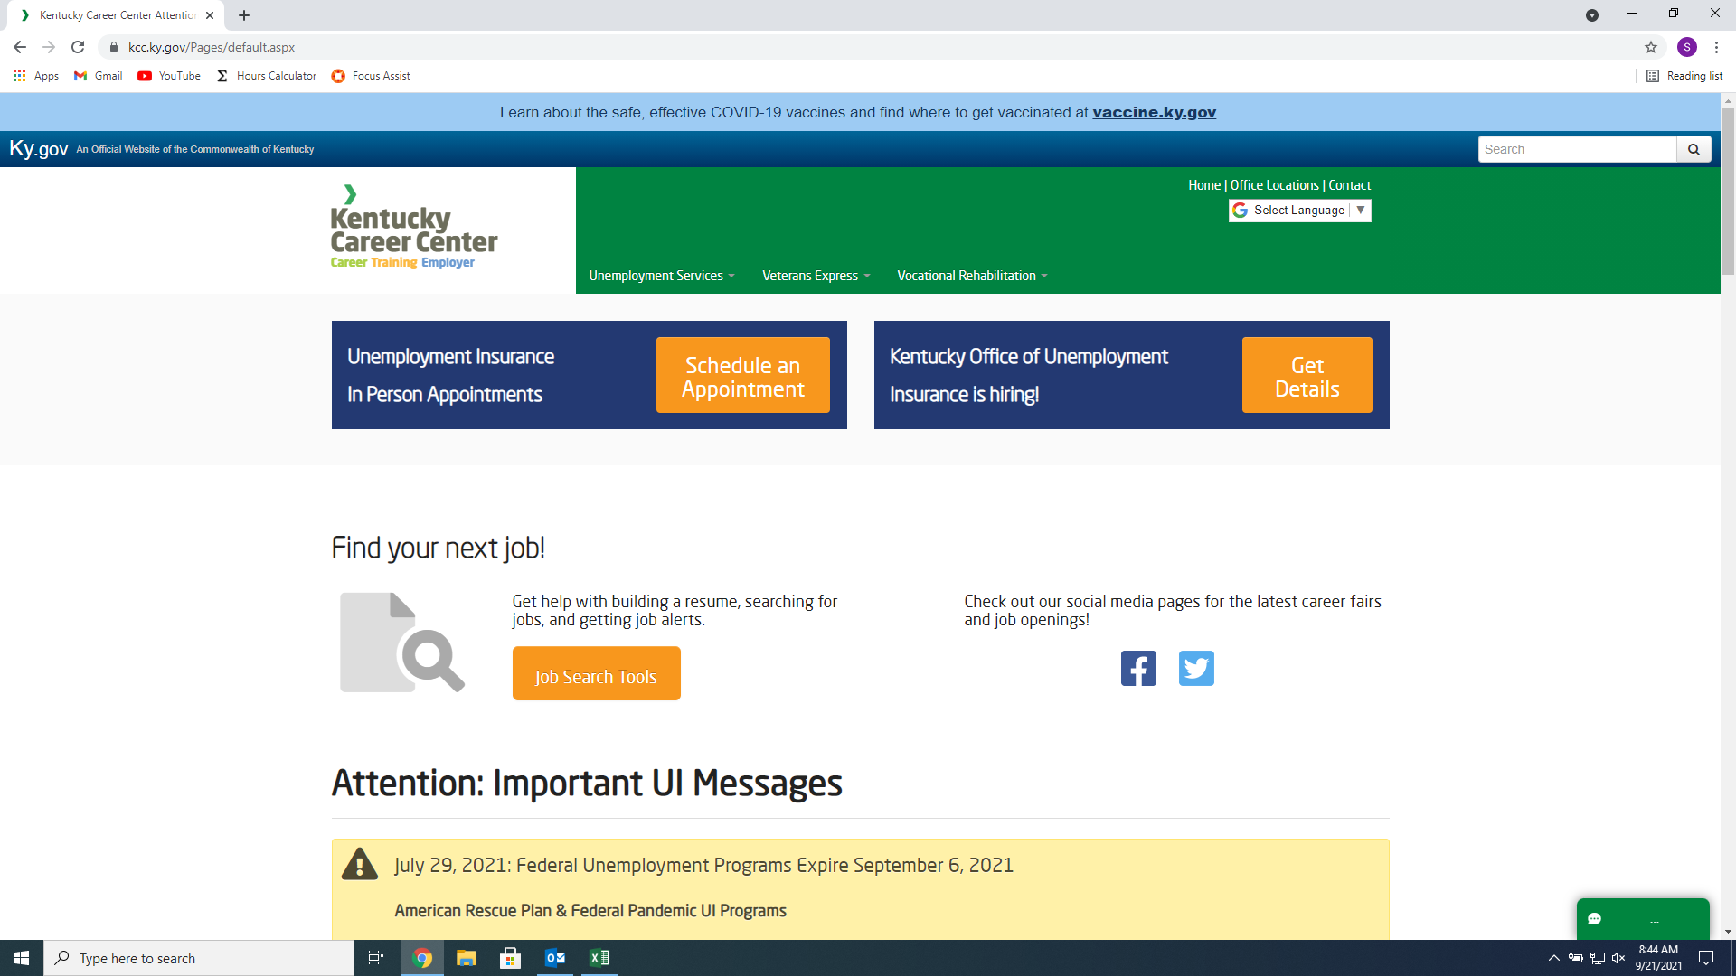

When the new page opens, click Make Appointment

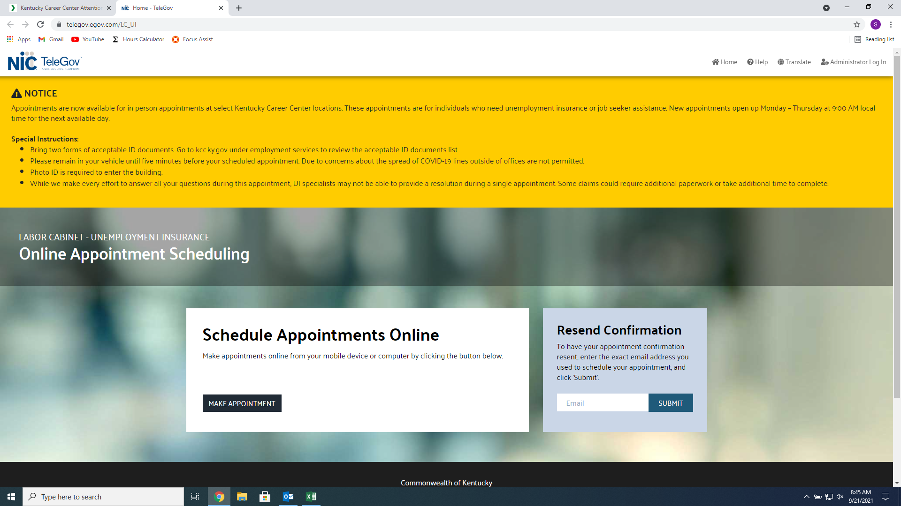

When you see a Check Mark, you can schedule an appointment. If there is an X, no appointments are available.

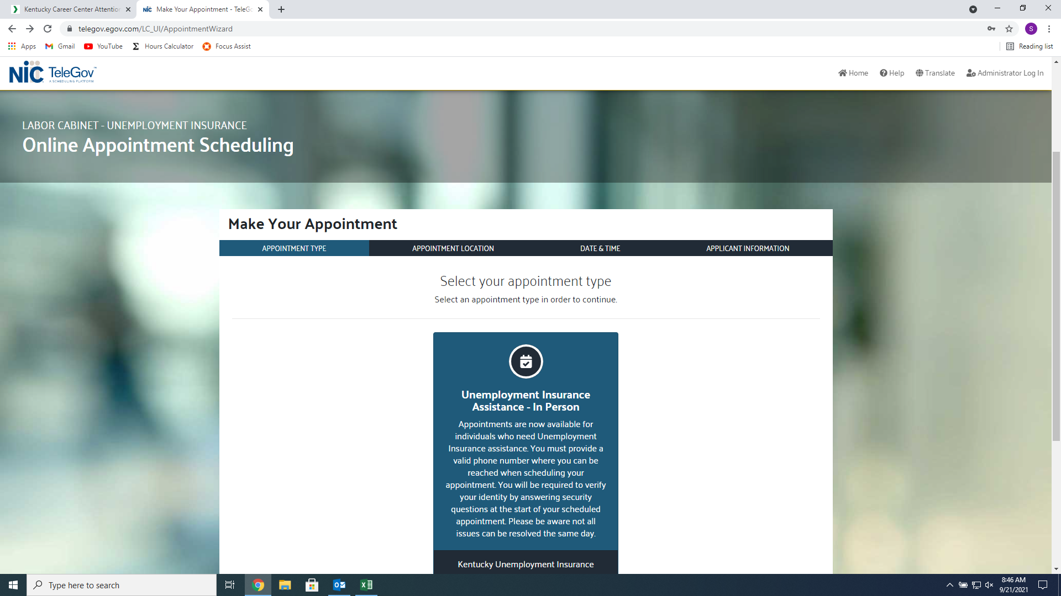

This is what the X will look like.

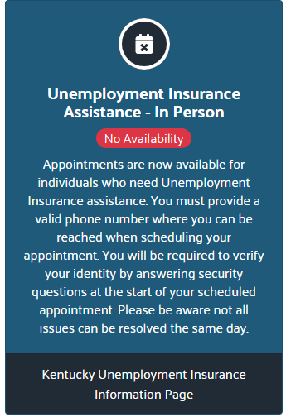

When you click the Check, you will come to this screen. Scroll down the list of Facilities in the state and choose the one you would prefer. Click “Select in person Appointment” to schedule an appointment.

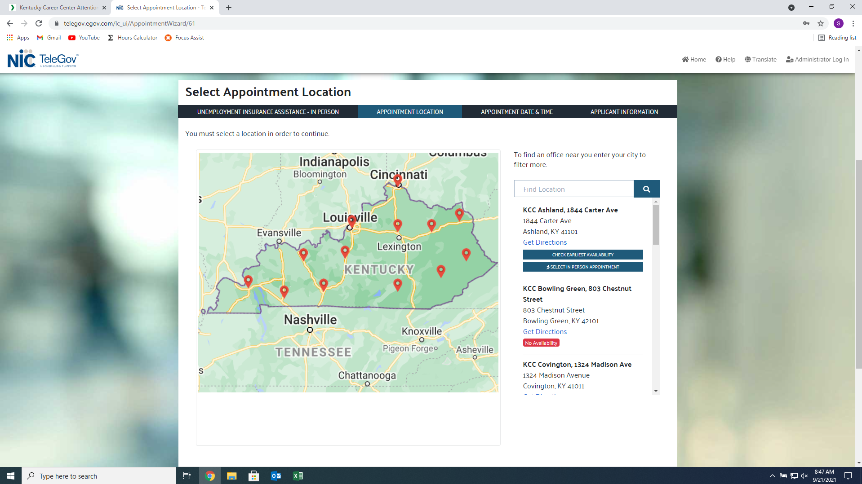

Select the time you would like, be mindful of how many are available.

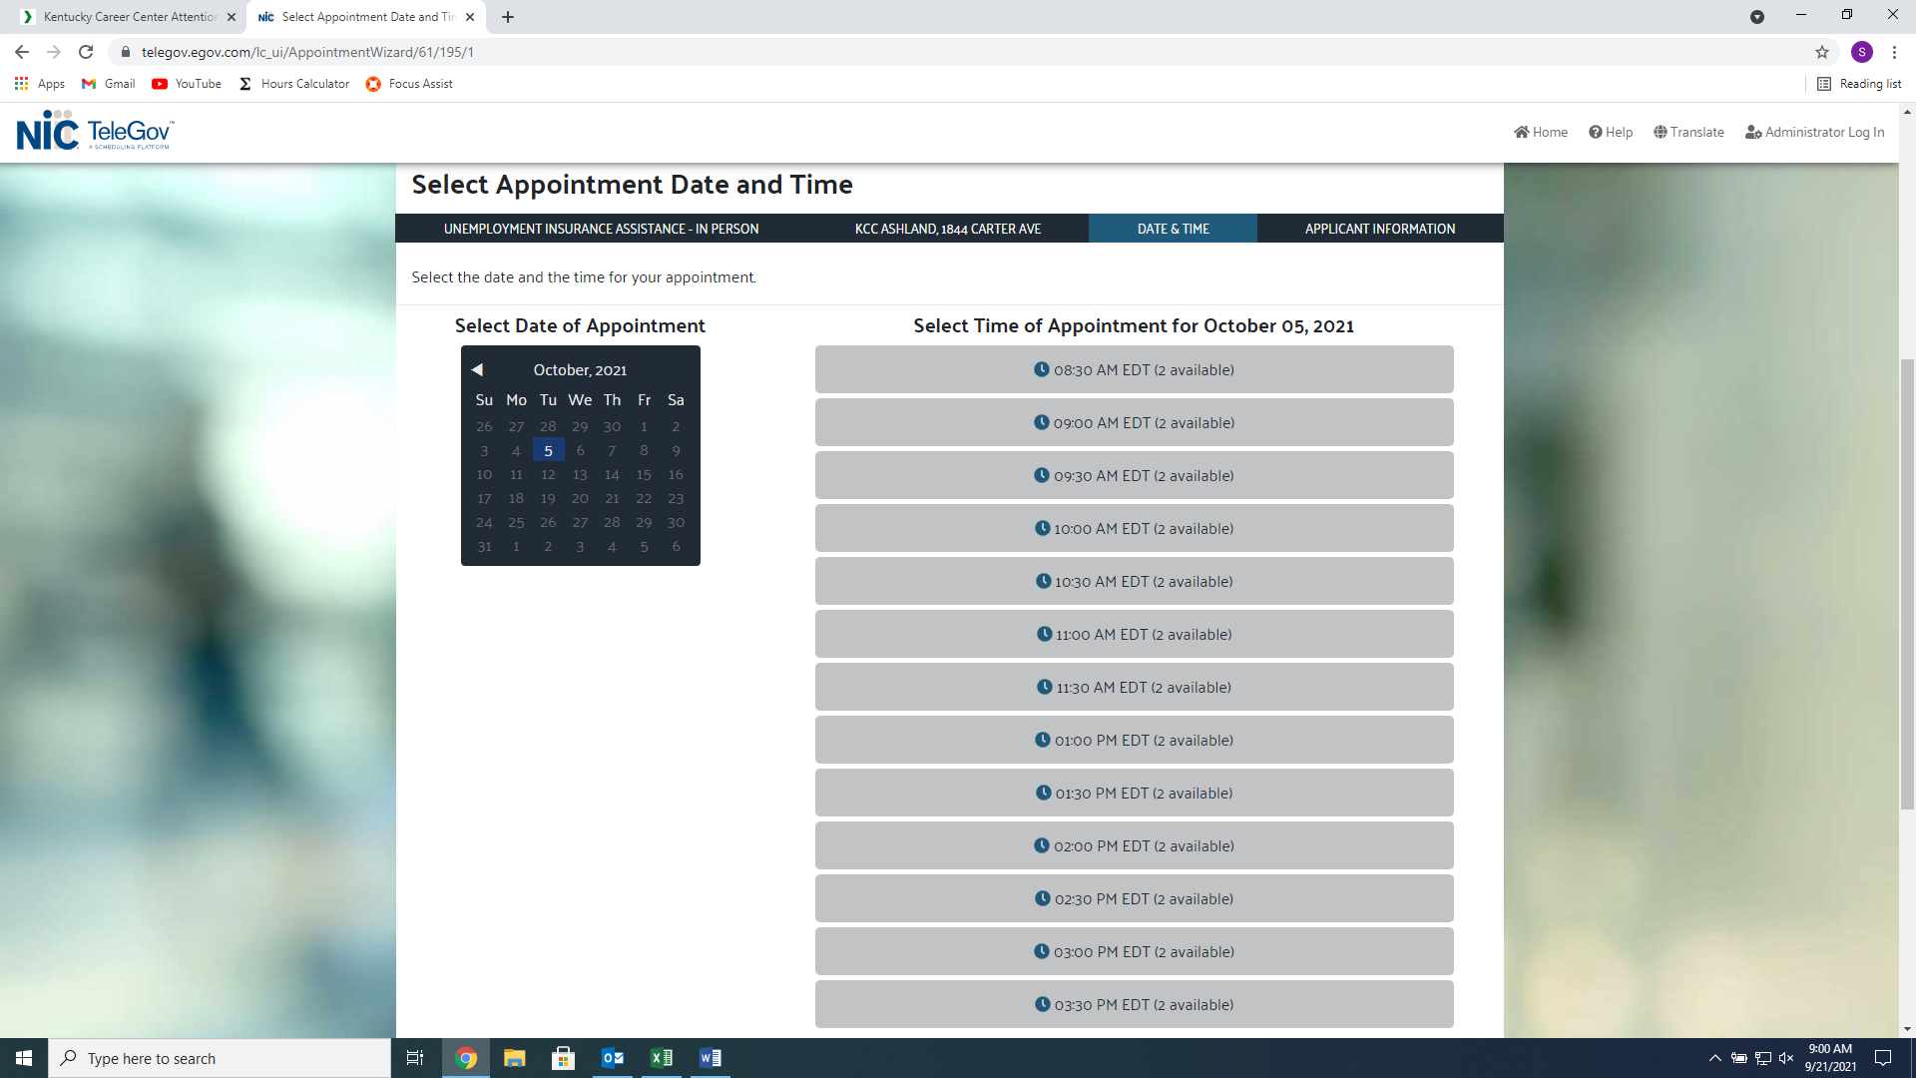

Enter the Required Information. Make sure your Name is Correct or you will not be permitted entry to the facility.

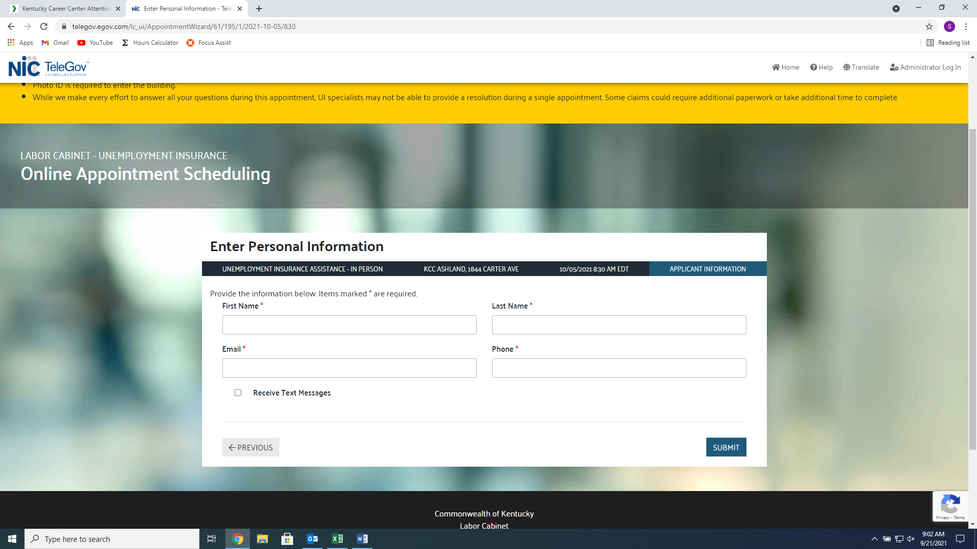

Make sure you receive your Appointment Confirmation.

