Registering a New Account

In the top right corner, Click Register

Click Next
Enter your Social Security Number in the Fields, then click Continue
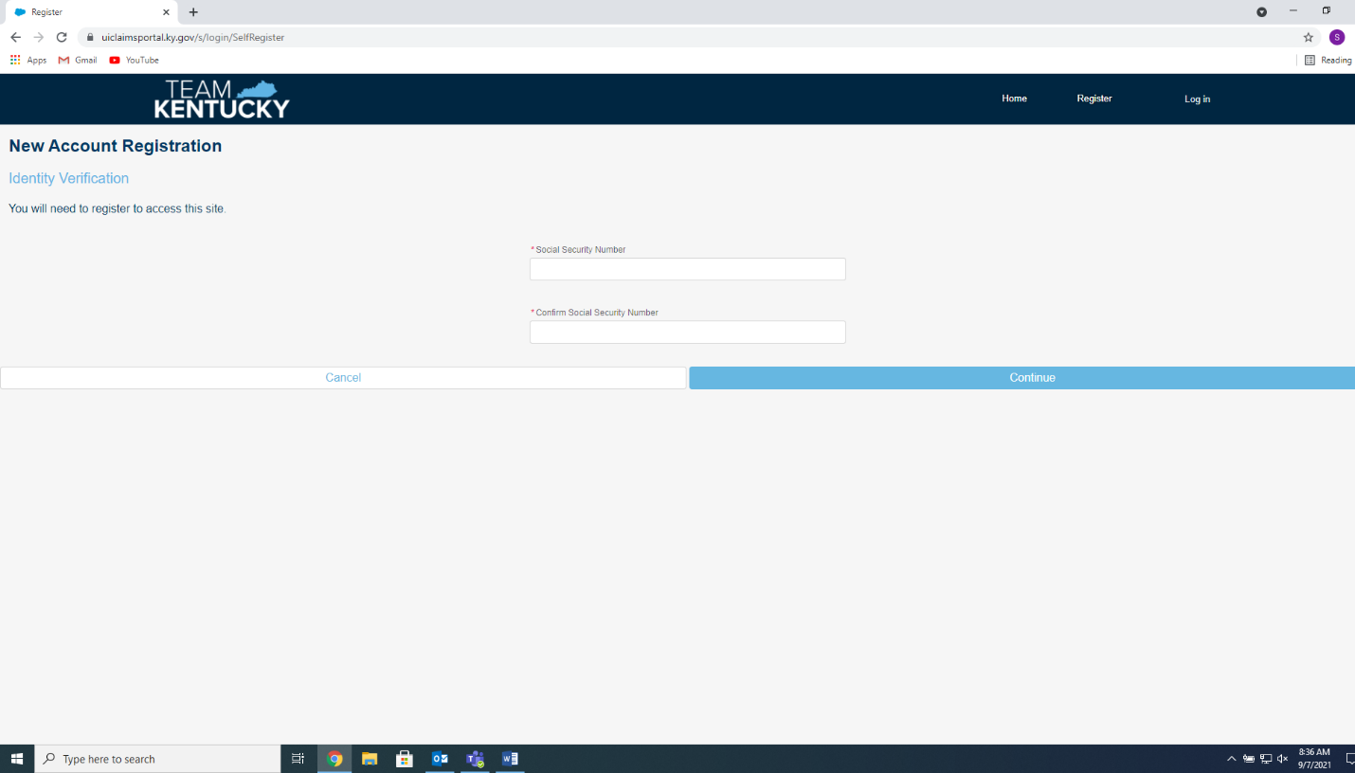
Enter your E-Mail Address as your Username.
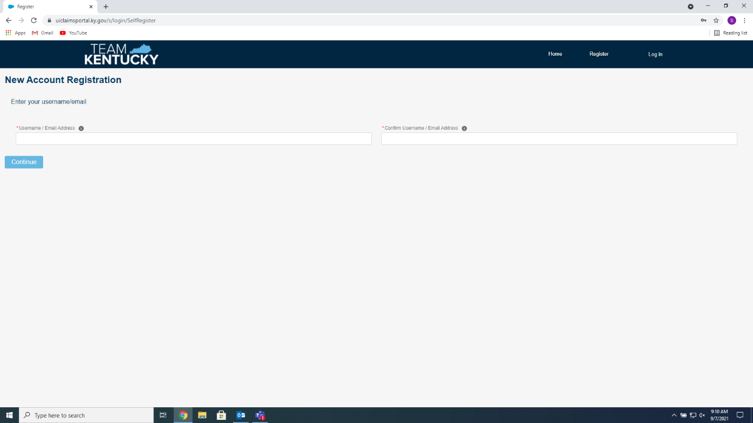

Your E-Mail Address will already be on this page, Enter your PIN if you have it (If not, ask a Staff Member for help), Create a Password (It must be Twelve (12) Characters Long, Include One (1) Uppercase Letter, One (1) Lowercase Letter, and a Symbol (!,@,#,$). NO SPACES! Check your E-Mail, there will be an email from kyui_noreply or kyui_noreply@ky.gov. It will contain a Six (6) Digit User Registration Verification Code. Finally, Select your Security Question and Enter your answer (It is Case-Sensitive, so be mindful of Caps Lock). Click Register.
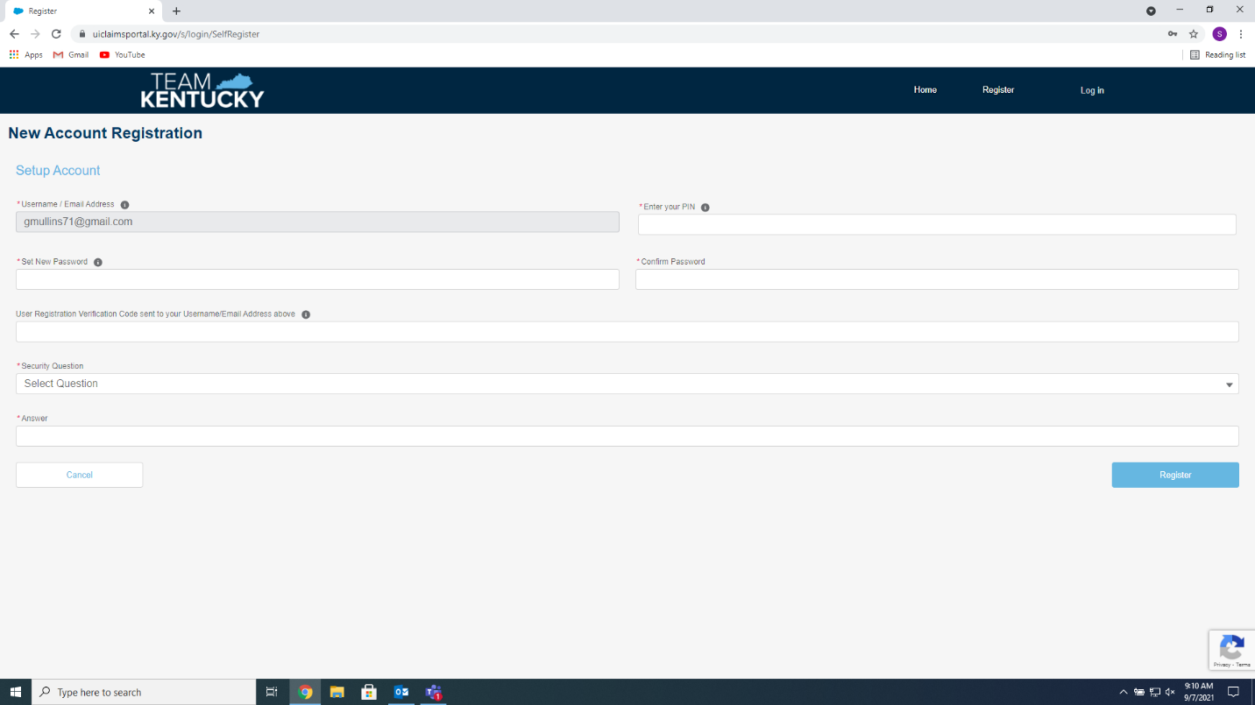

You’re all set, Click Go to Login
