# Password Reset

Click the text that says, “Click here to recover”



Enter your E-Mail Address that is Associated with your account, along with your Social Security Number.

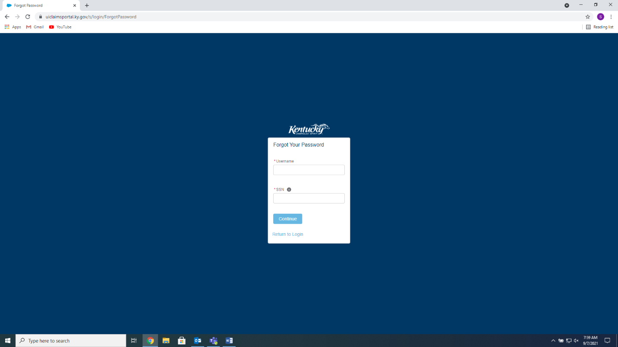

Answer the Security Question (This can be reset if you do not remember your answer)

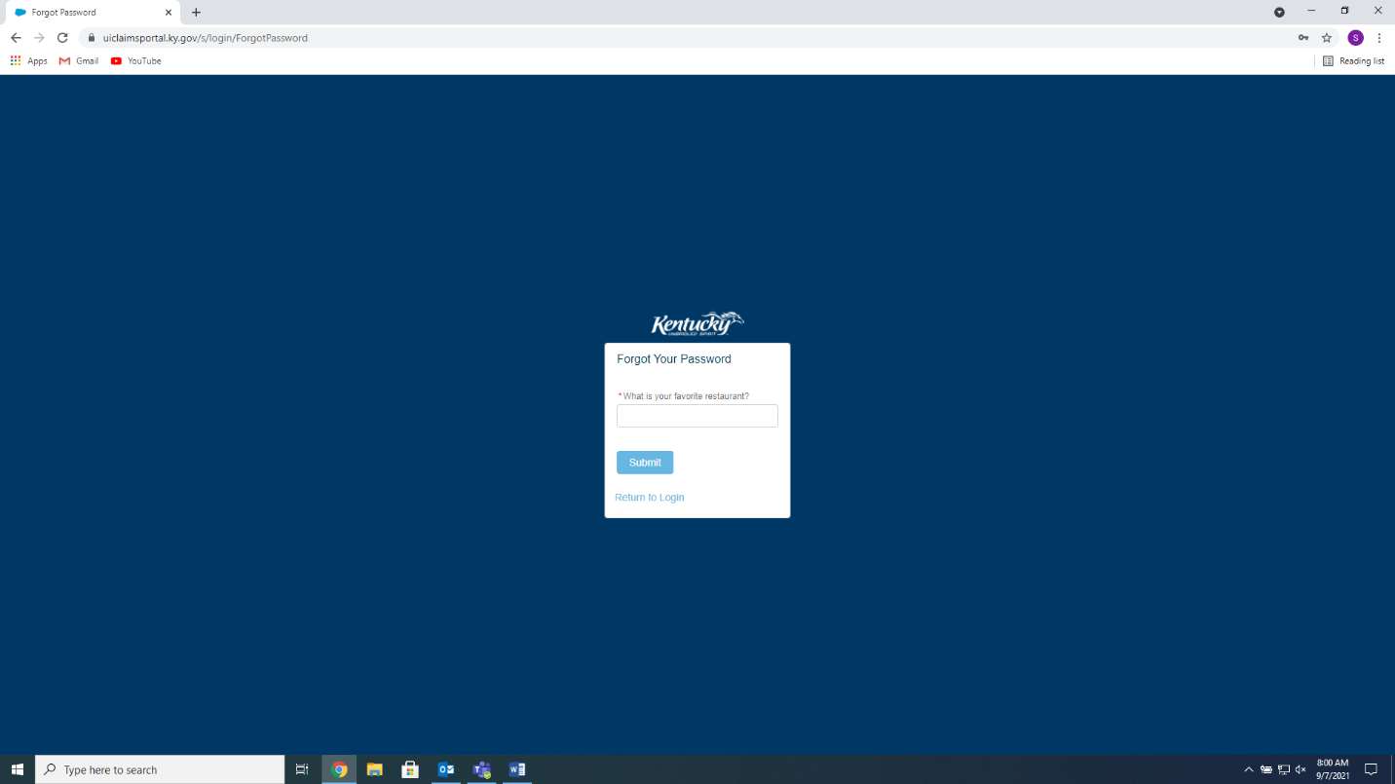

An email will be sent to the E-Mail address you provided. It will be from kyui_noreply or [kyui_noreply@ky.gov](mailto:kyui_noreply@ky.gov), it will be a Six (6) Digit Number, enter that in the Password Reset Token Field. New Passwords must be Twelve (12) Characters long, Include One (1) Uppercase Letter, One (1) Lowercase Letter, and One (1) Special Character such as !,@,or #. NO Spaces. Passwords are required to be changed Every 90 Days.

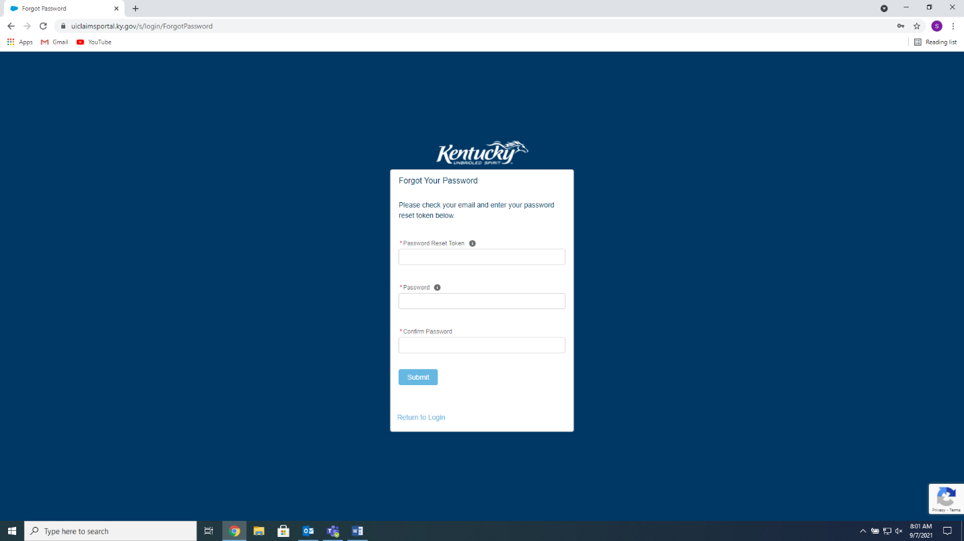

When you successfully change your password, click the Return to Login button, to return to the login page.

