# Job Seeker Services with Focus Career

This is your Job Seeker Dashboard, from here you can Create, edit, or upload a resume; Search for Jobs; Explore Your Career Options; Research a specific program of study, career, or employer; See what you can study to get ahead; and See where your experience can take you.

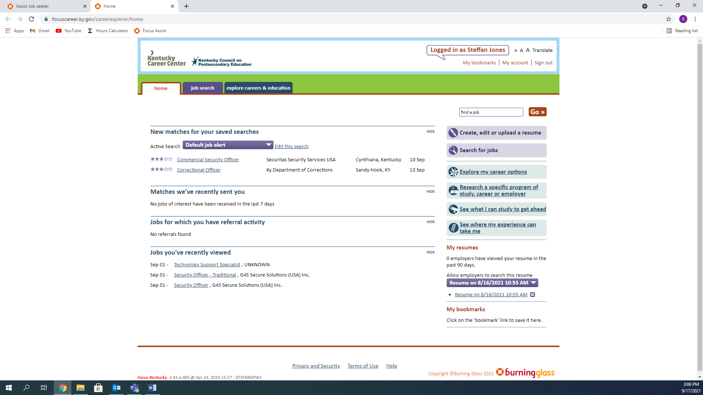The first thing you will want to do is Create, edit, or upload a Resume. If you have a Resume you want to upload, you can do so now. Otherwise, Click Start Resume>>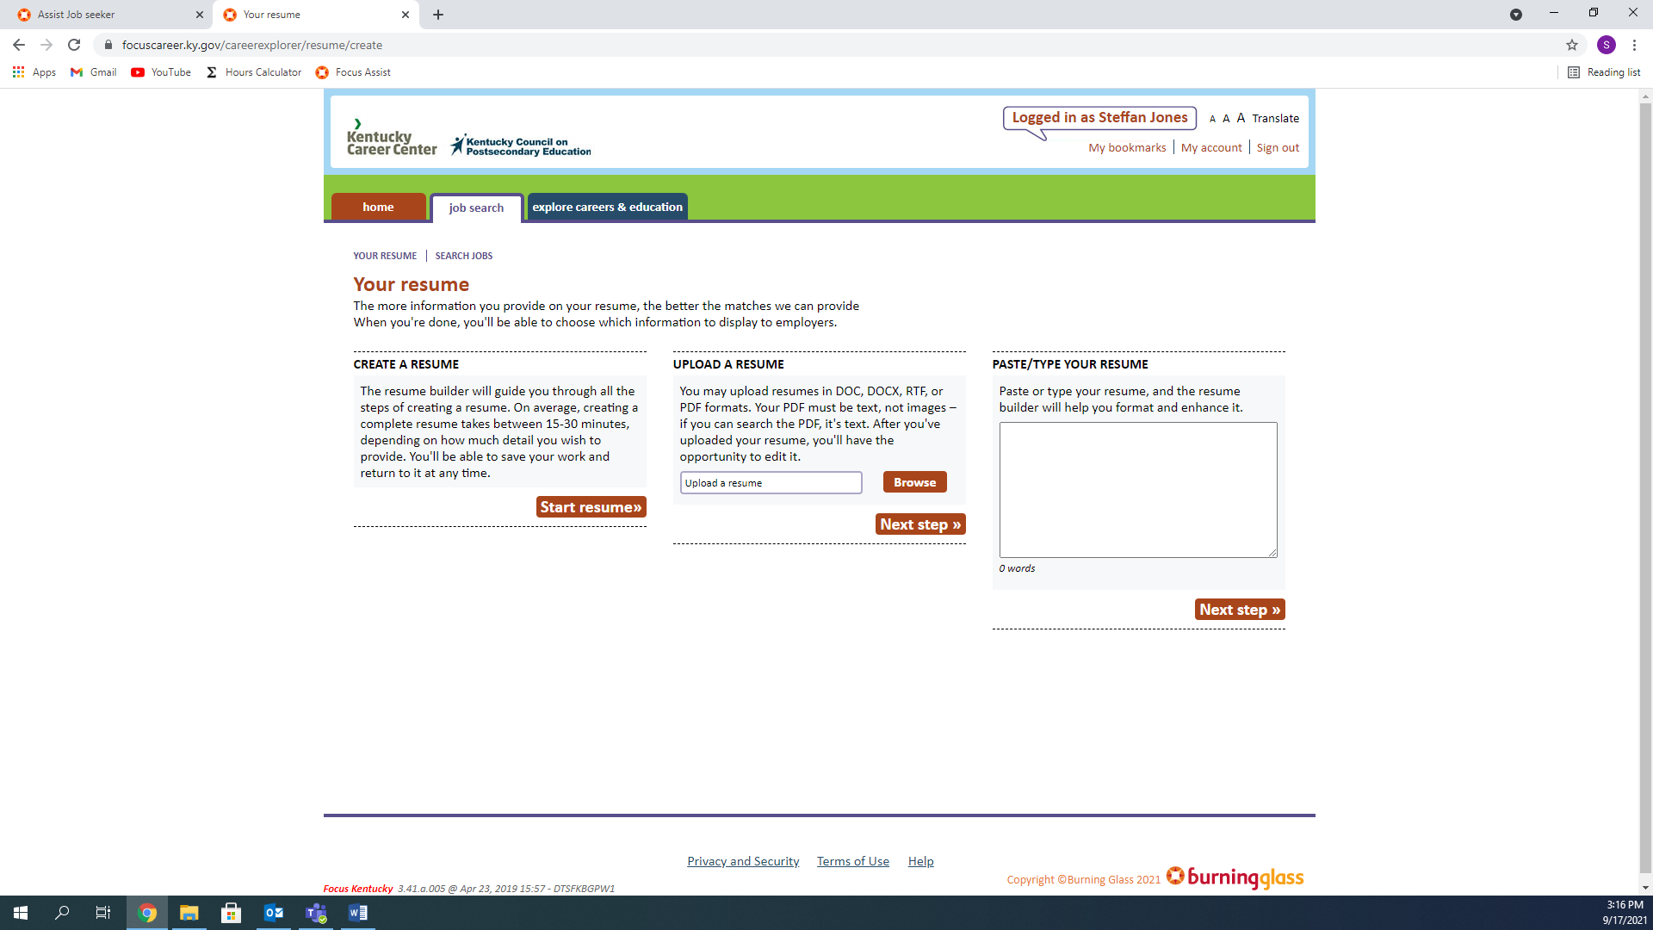

Fill out all the Information that is required, then click save and move on to next step

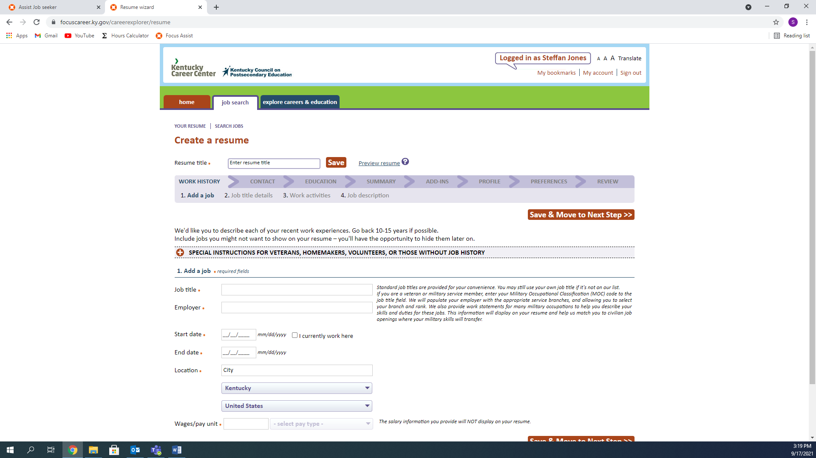

The system will suggest a job title, depending on what you type. Select the one that is most accurate.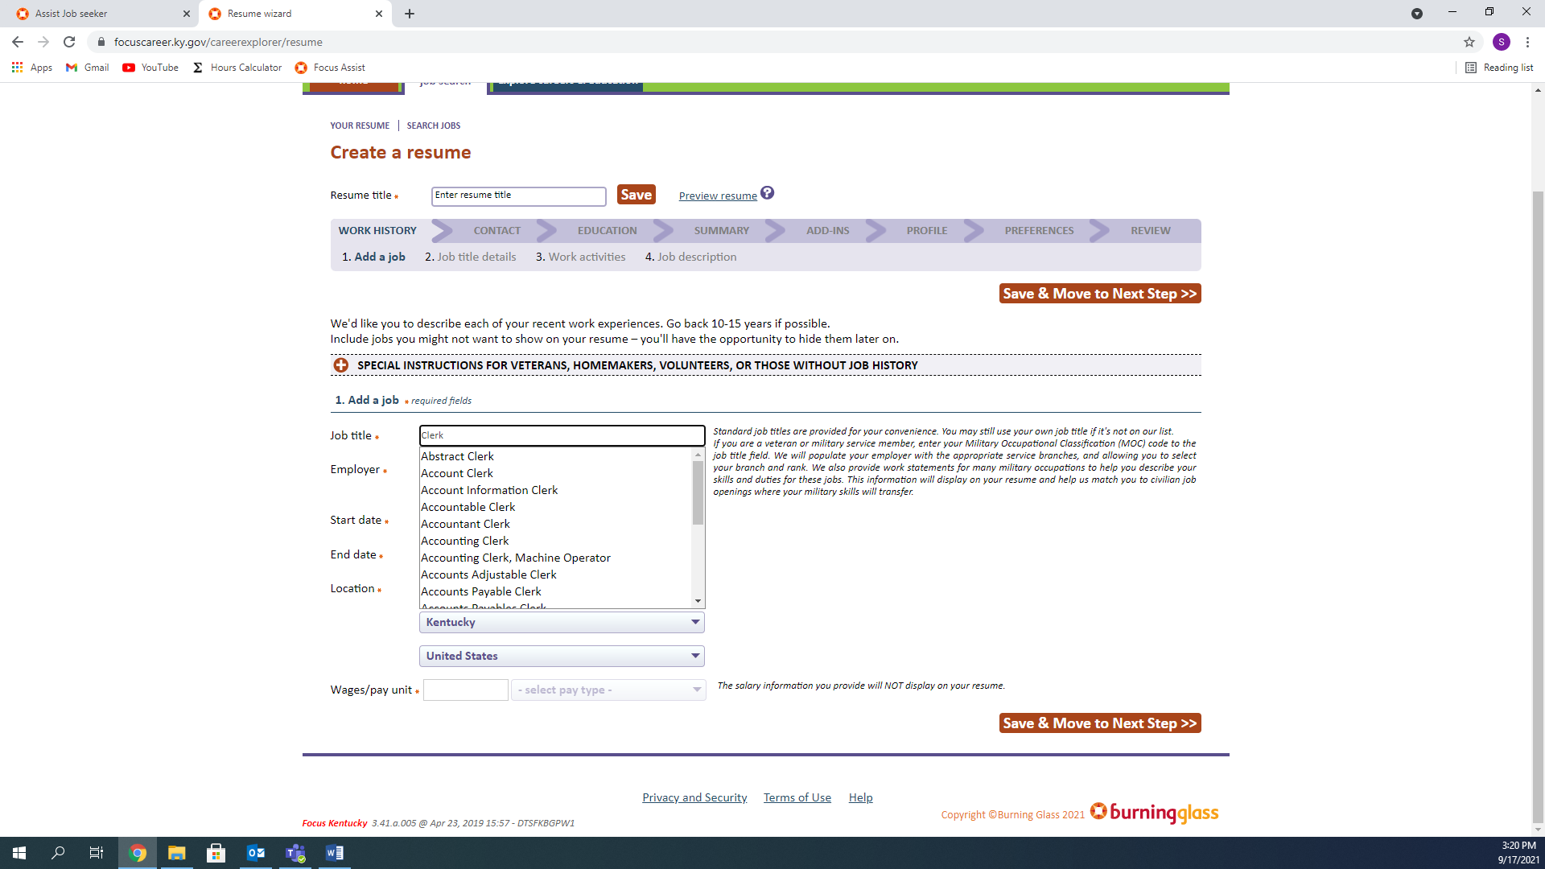

From there, you can select the best fit one more time, to help provide information for your resume.

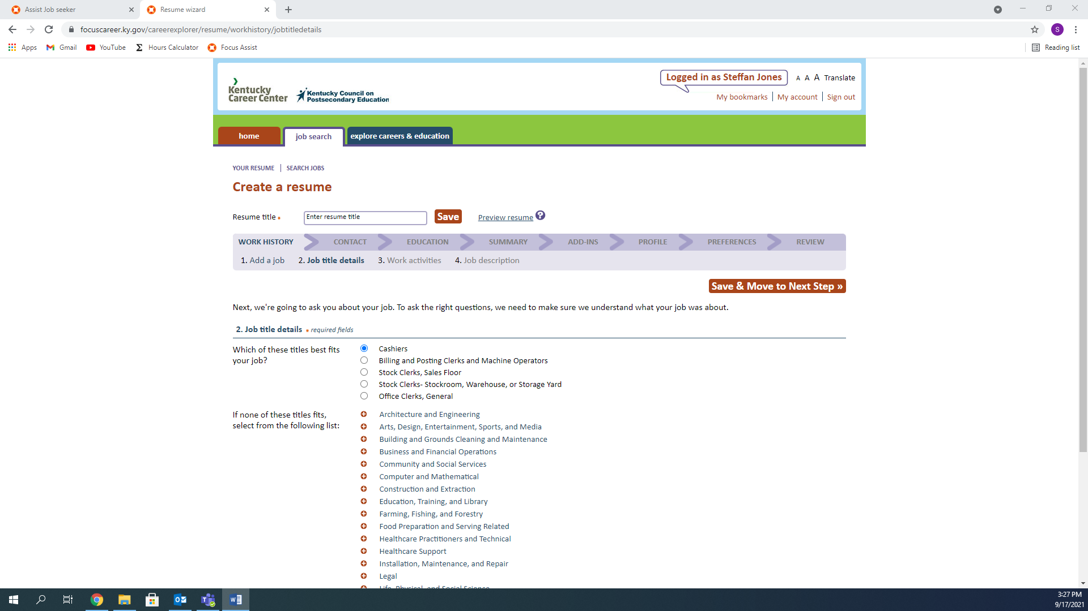

As you can see, I can now select yes or no to various questions related to my previous job title. The information is then compiled and inserted into your resume as a Job Duty, Choose what you believe are the best, because you can only choose up to Twelve (12).

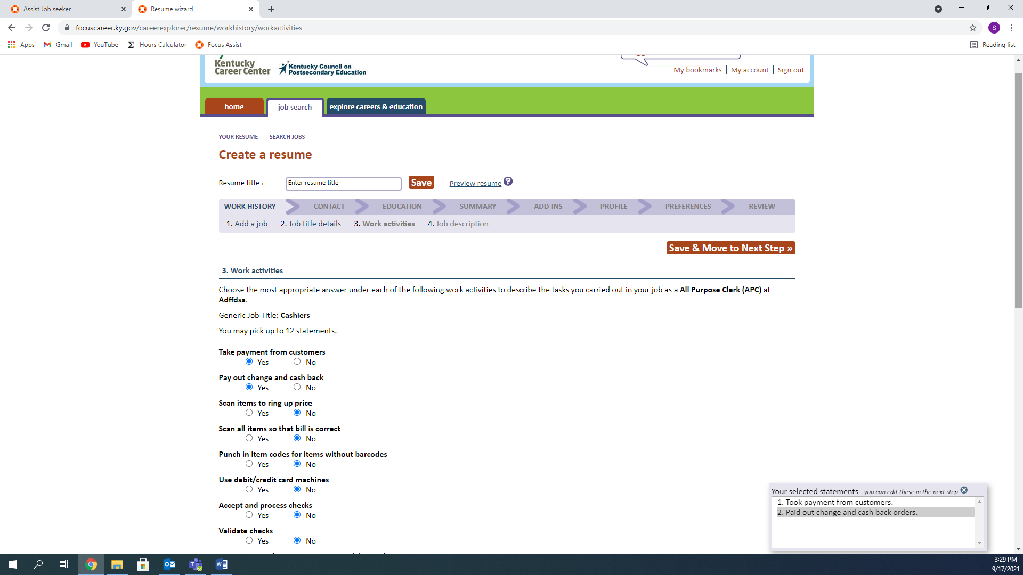

You can add more work history, or move on to the next step

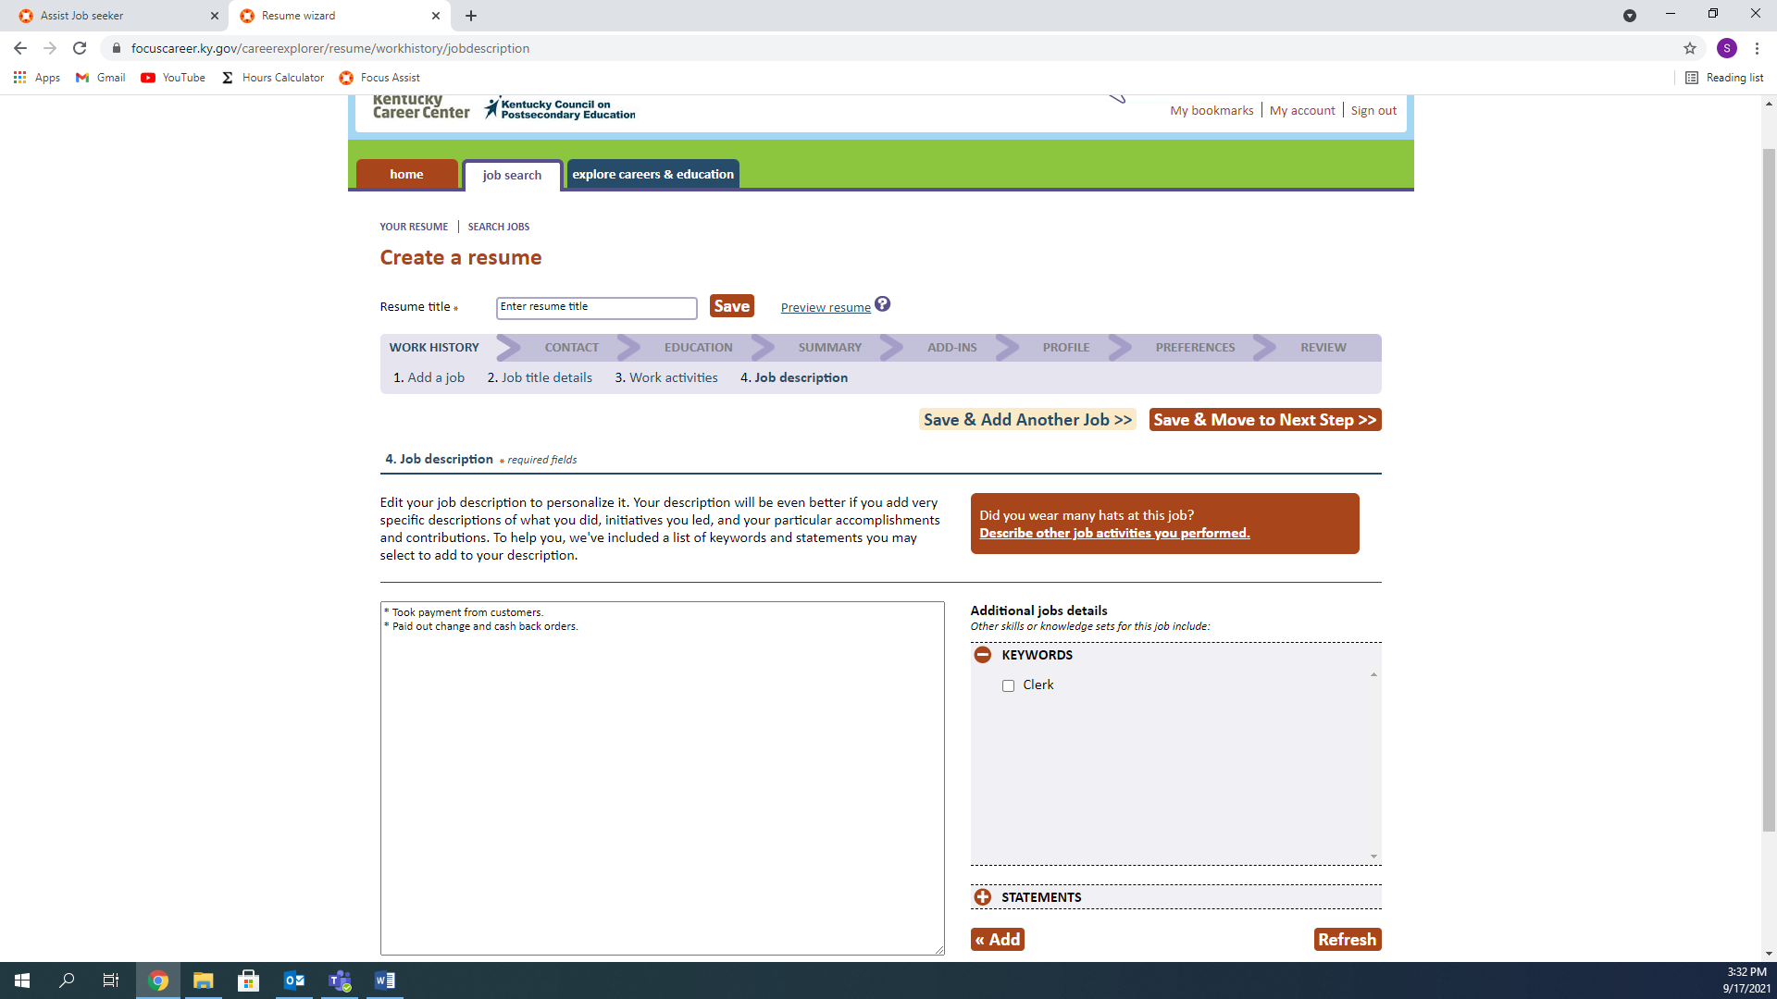

When you move on, you will be asked your Contact Information. Make sure all fields are correct before moving on.

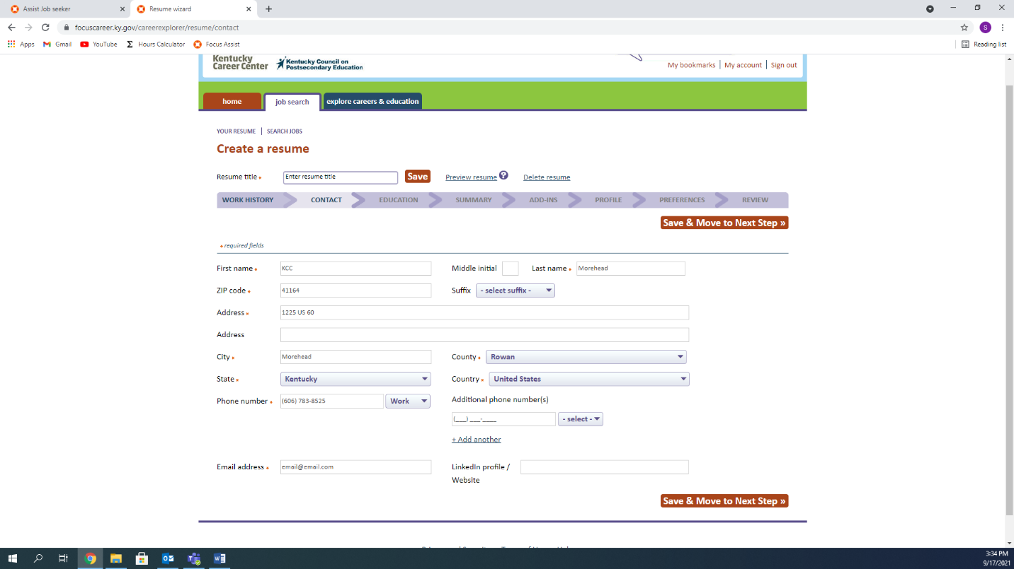

Next is your Education Information, don’t forget to scroll down to make sure all fields are completed.

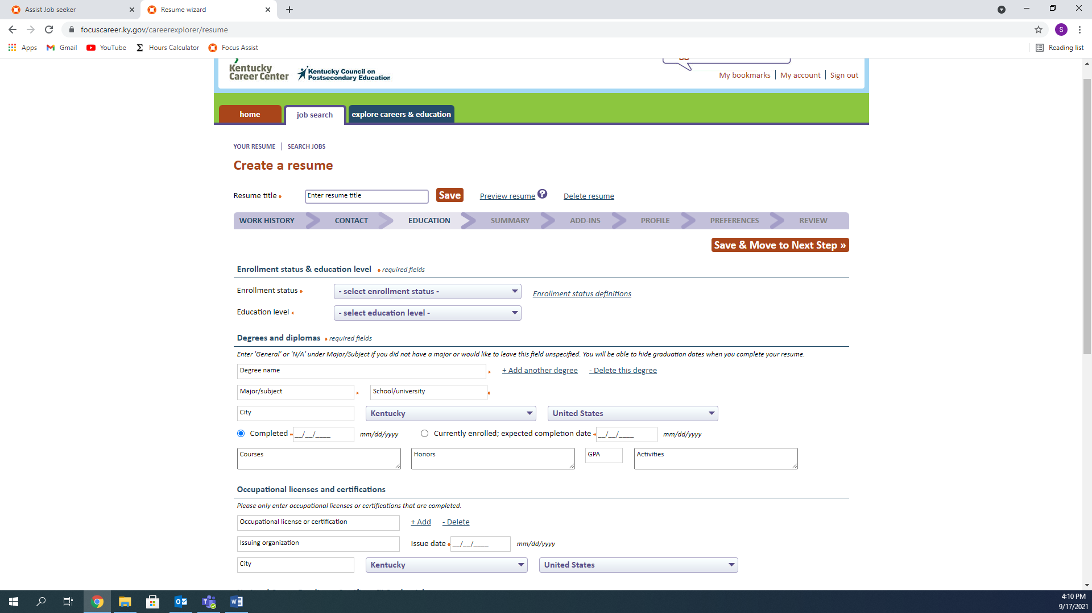

Here, you can review the summary of your resume, and choose whether to include it or not.

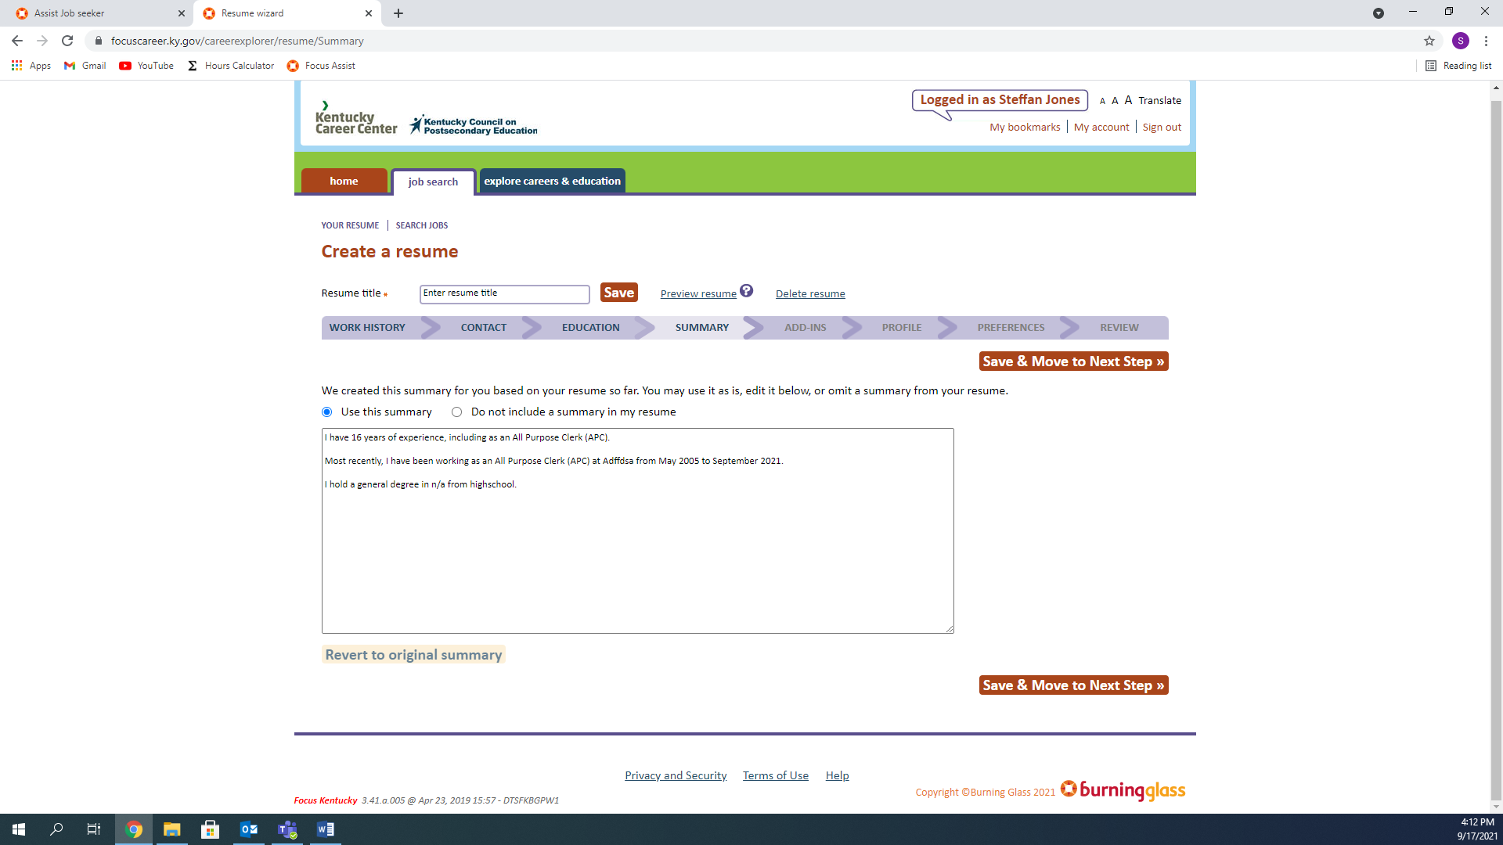

You can add a title, add more sections to your resume, or move on to the next step.

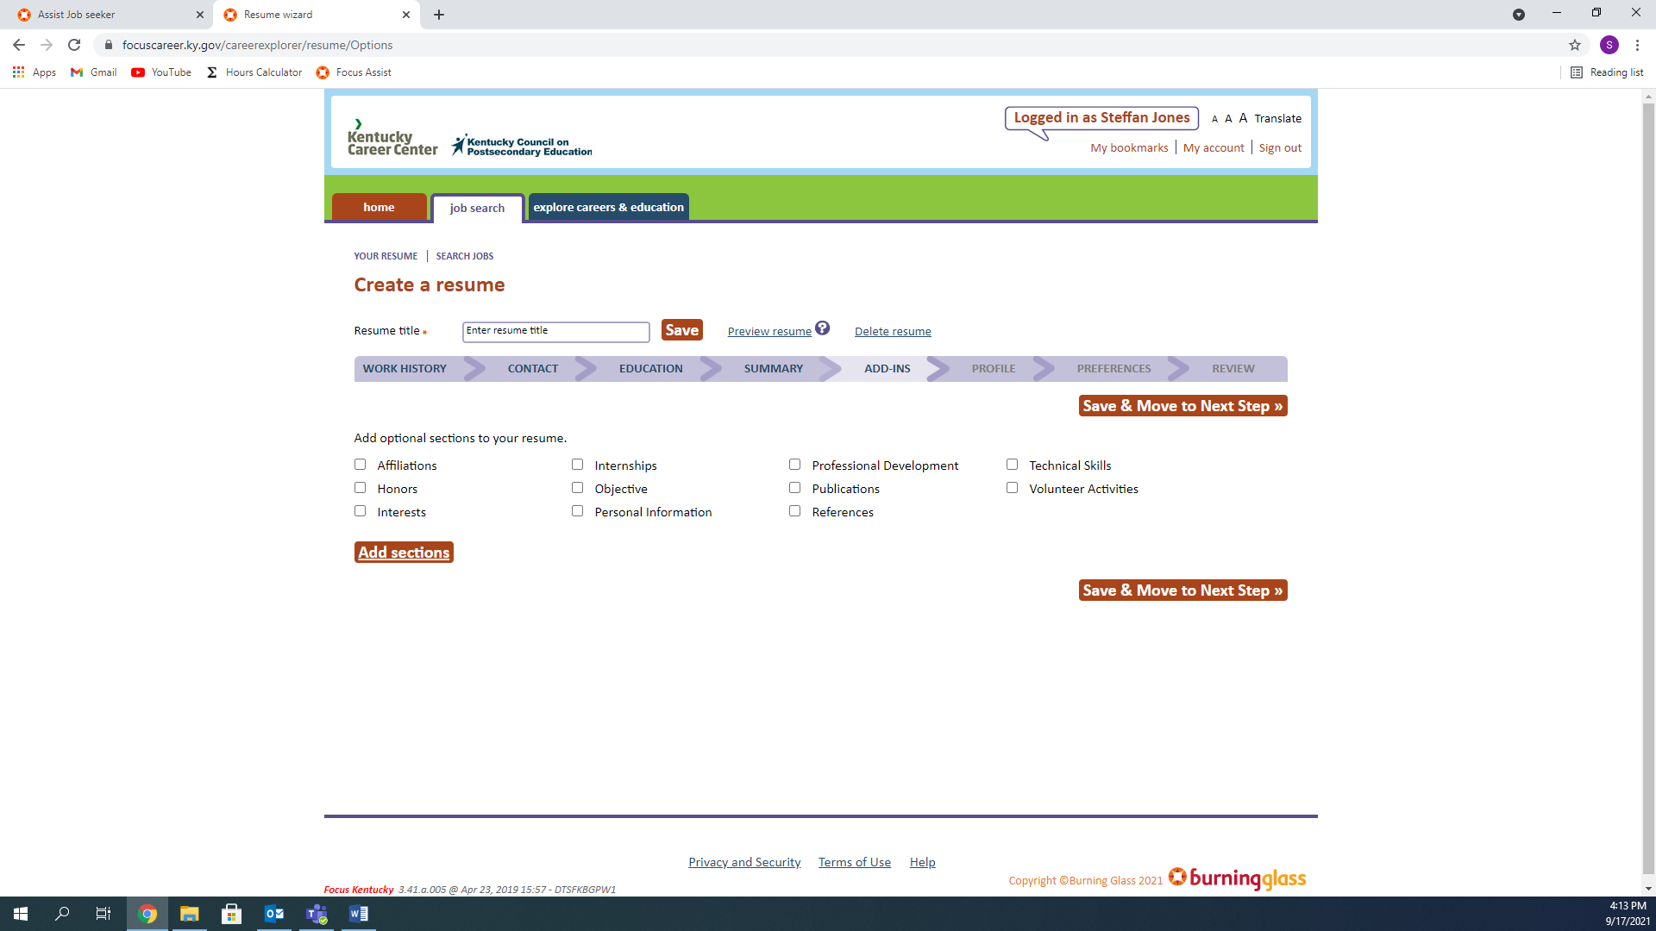

Answer the questions, some of them you can choose not to by clicking “Not Disclosed”

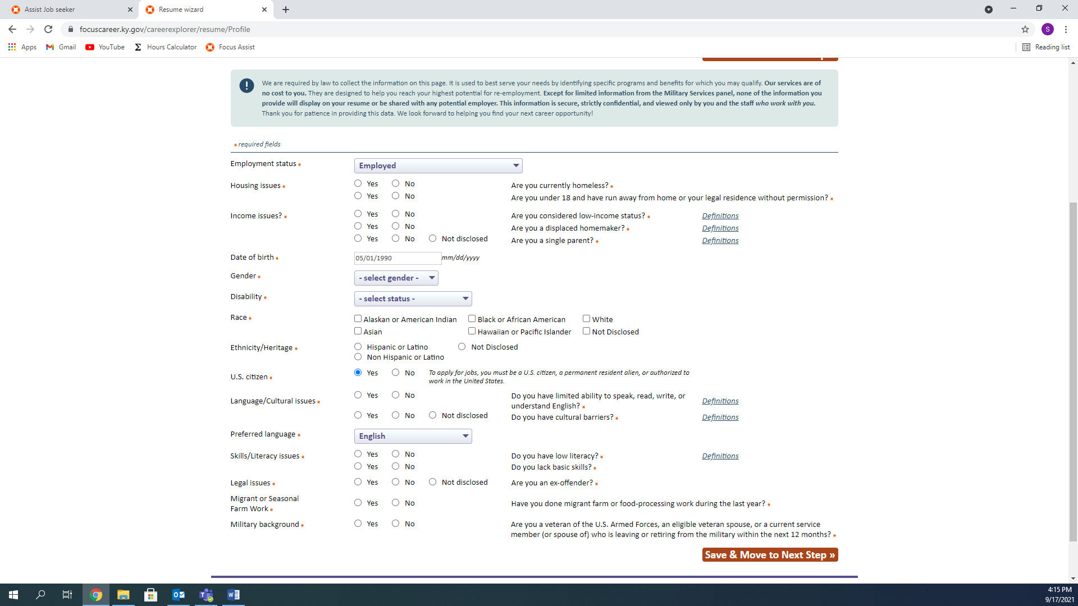

The most important part of this page, is to make your resume searchable. Let employers be able to find you!

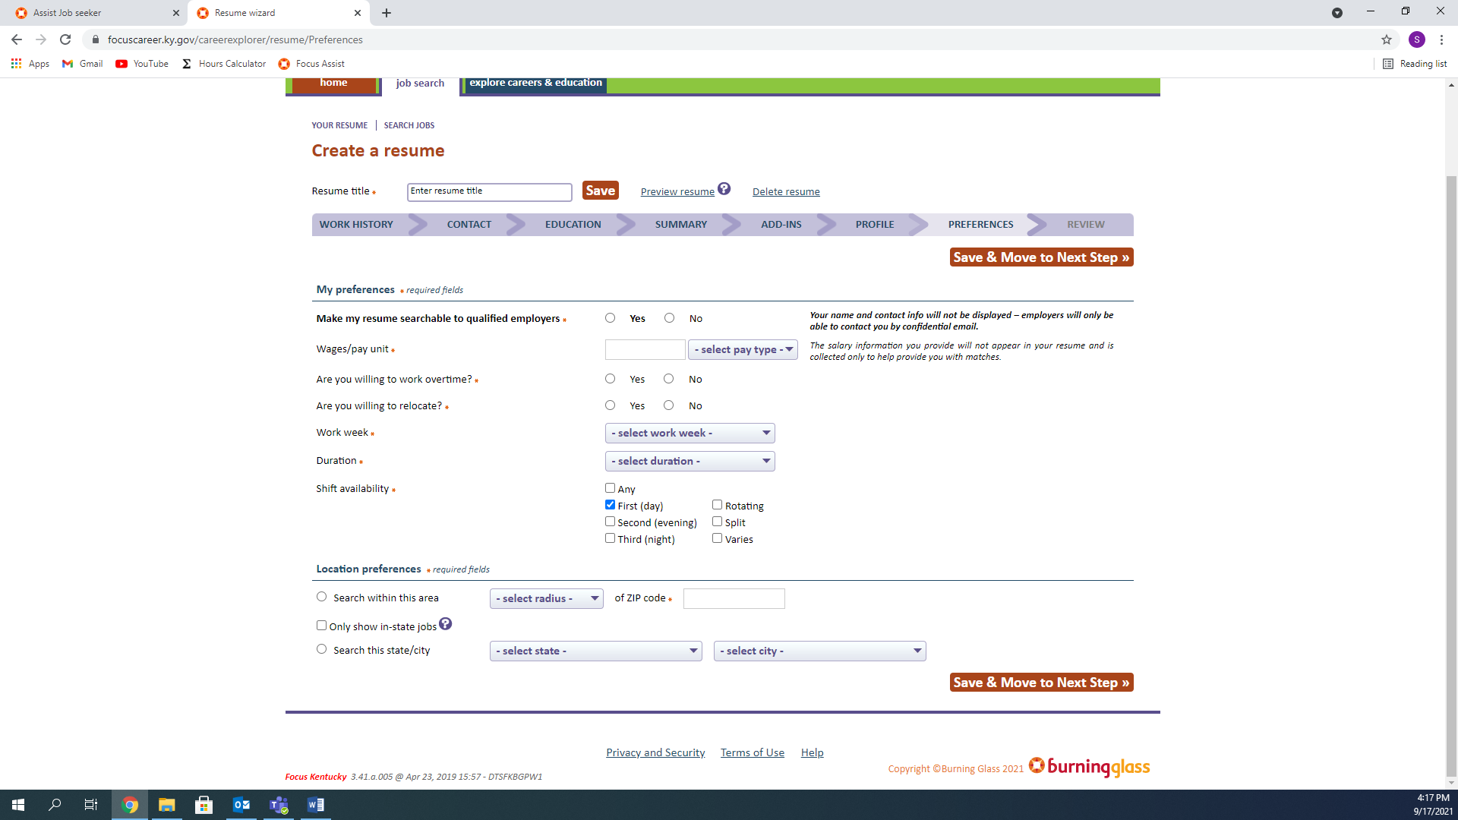

The last part of the Resume Creation, look over everything and make sure everything is accurate. Make sure you list all of your experiences and skills are listed, do not sell yourself short. 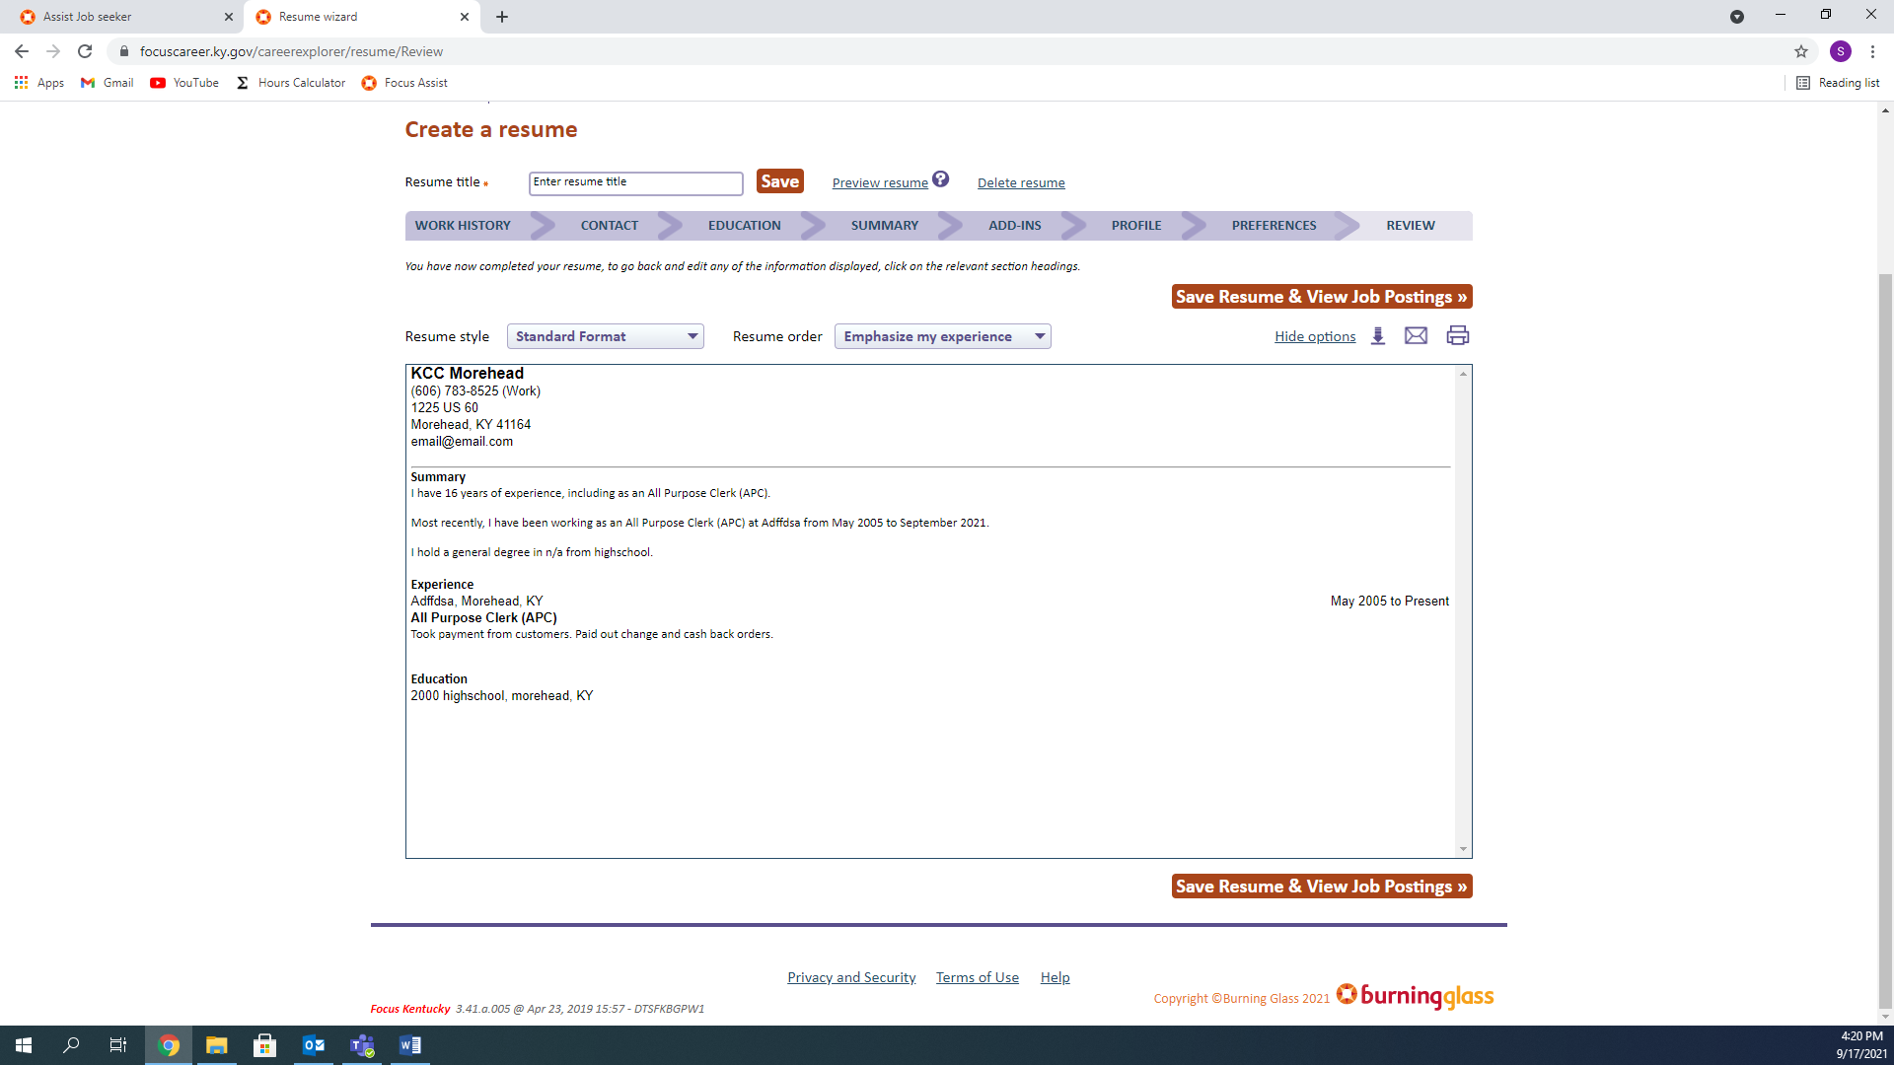

Save your Resume and View Job Postings.

# Search for Jobs

Now it is time to begin your Job Search.

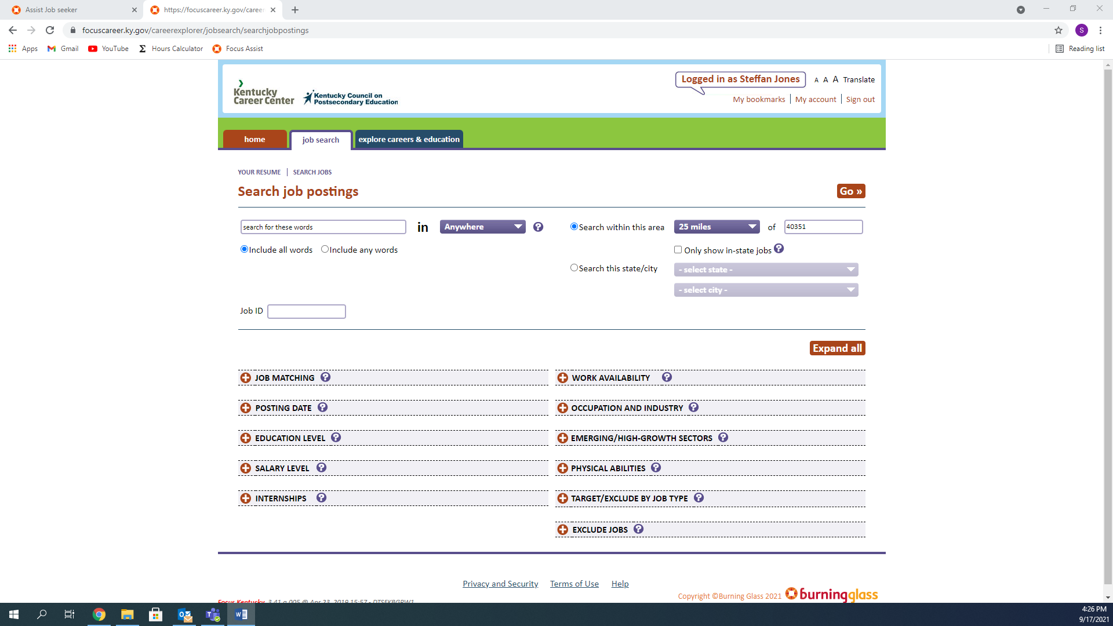

You can search for jobs containing specific words or jobs that match according to your resume.



By expanding the “JOB MATCHING” section, you can change the amount of “Star Match” each job is according to your resume or All Jobs no matter the match. This will be the most common selection. When you are ready, click Go to begin your search.

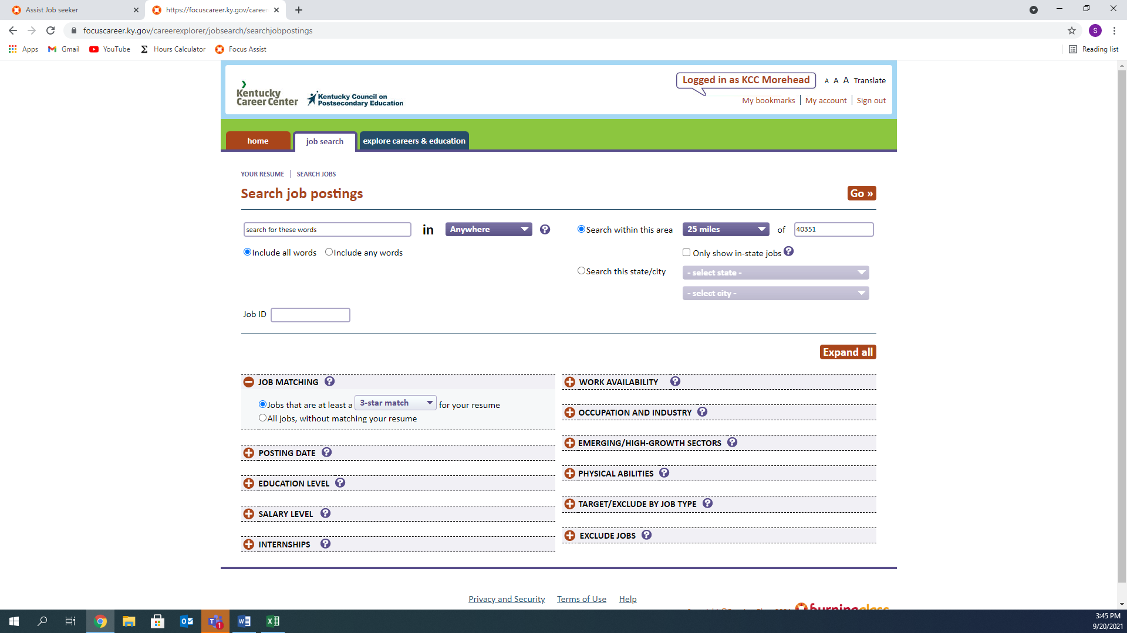

For this search, I selected all jobs rather than matching with my resume. Click the Job you’d like to apply for.

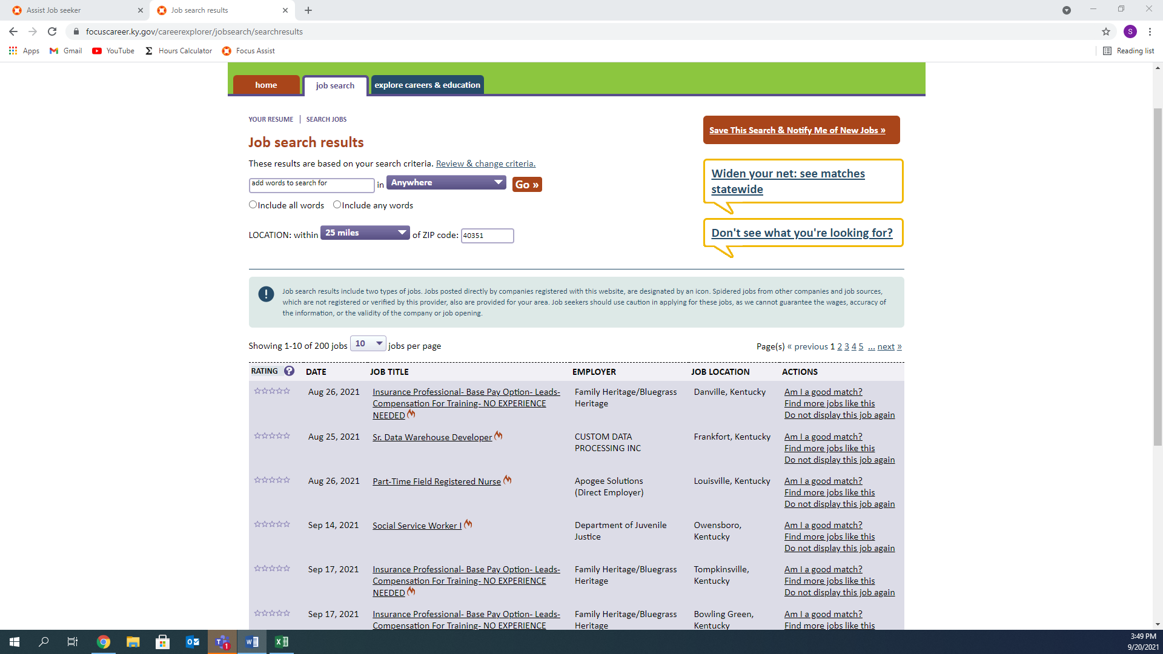

Once you find a job you want to apply for, click How to apply for this job

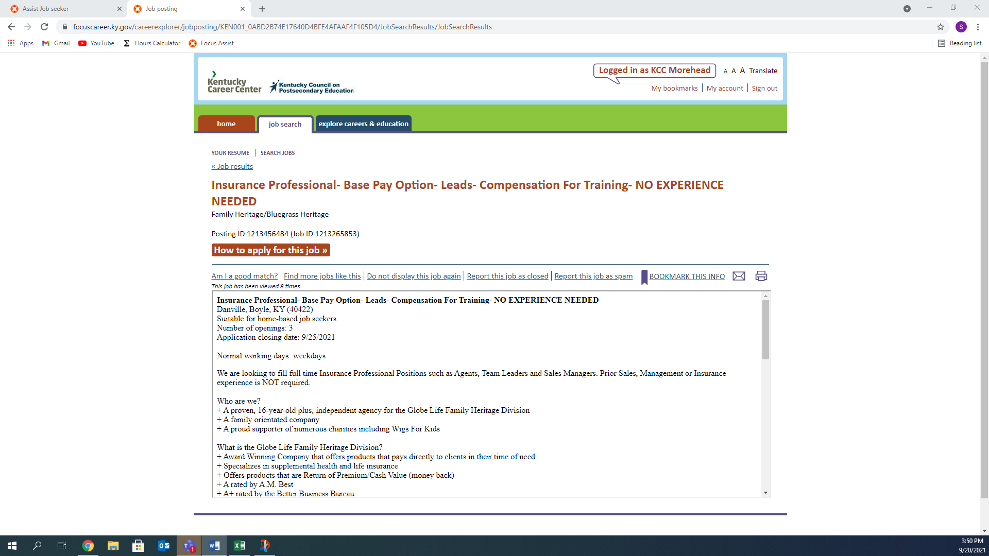

Verify the requirements, then choose the corresponding answer.

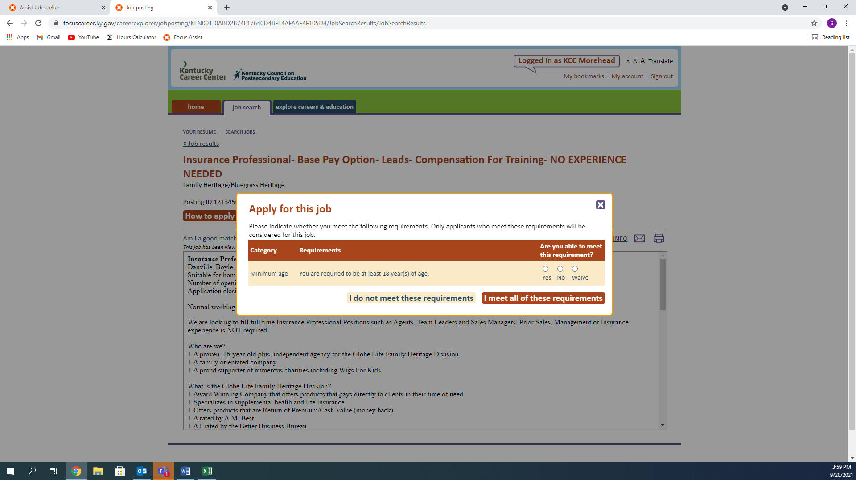

This Employer as a requirement, click submit to move on.

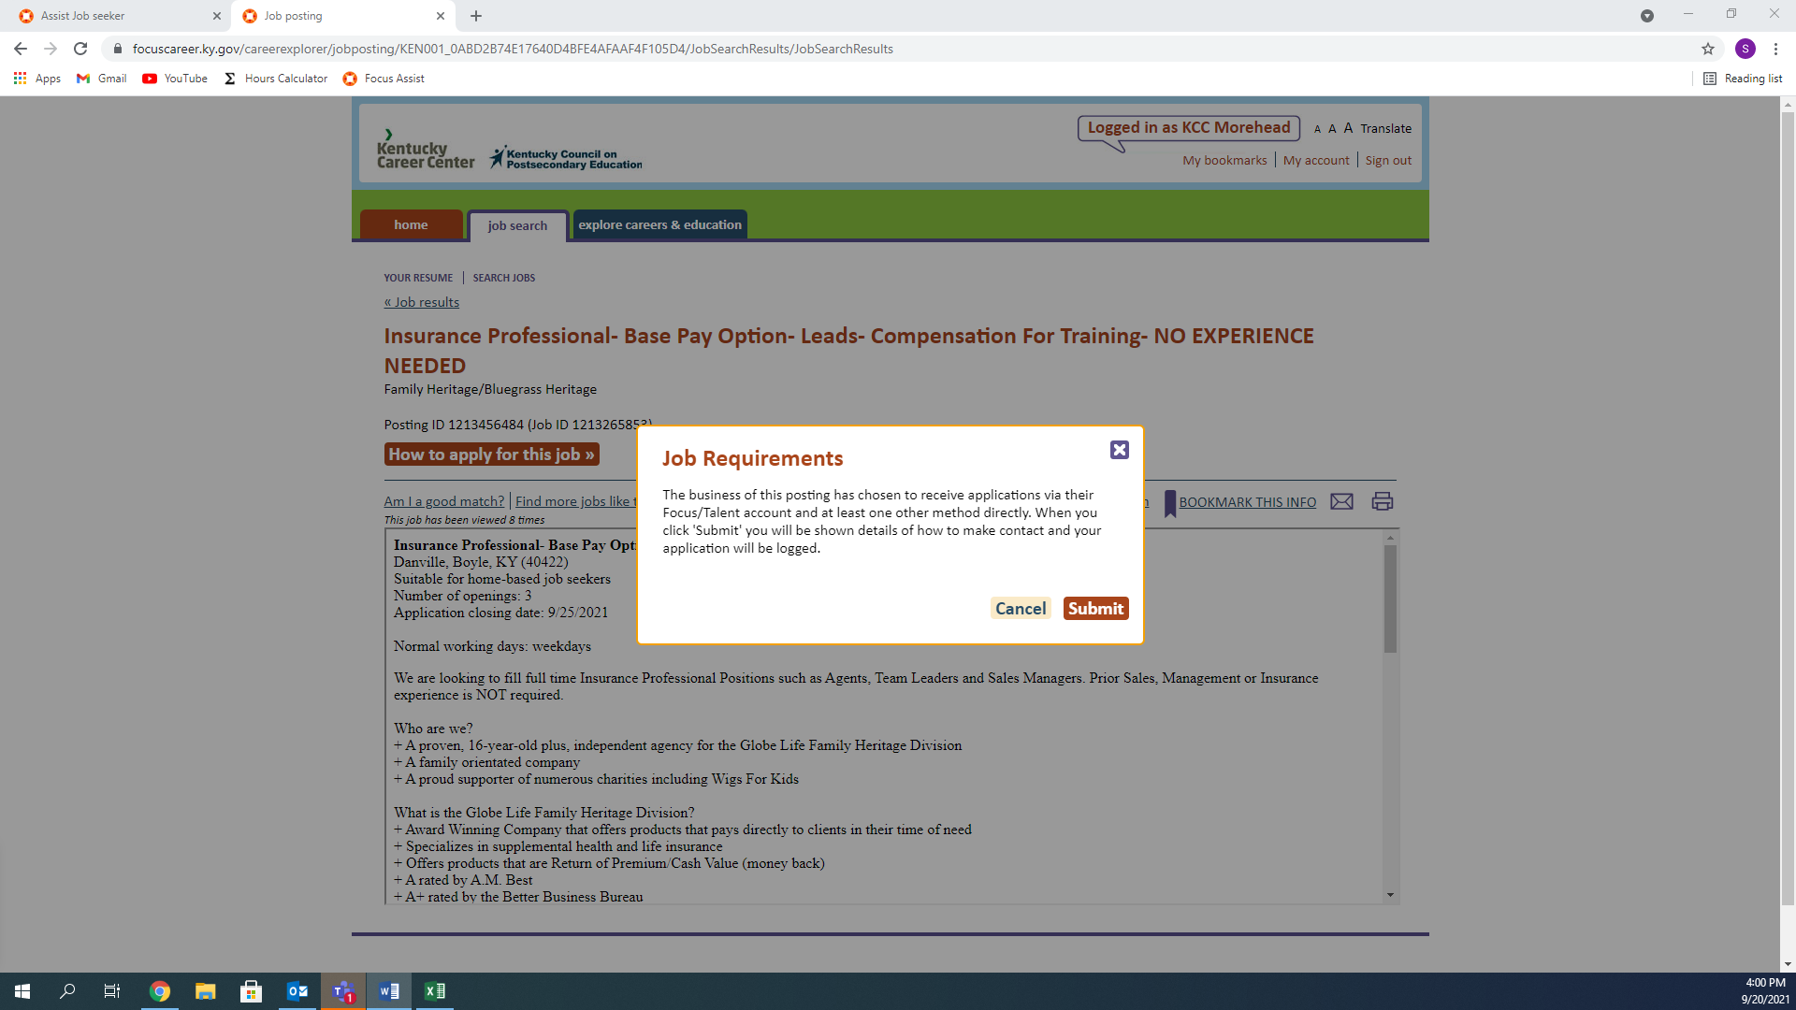

As you can see, the resume has been sent to the employer for review, and I have contact information to follow up with them.

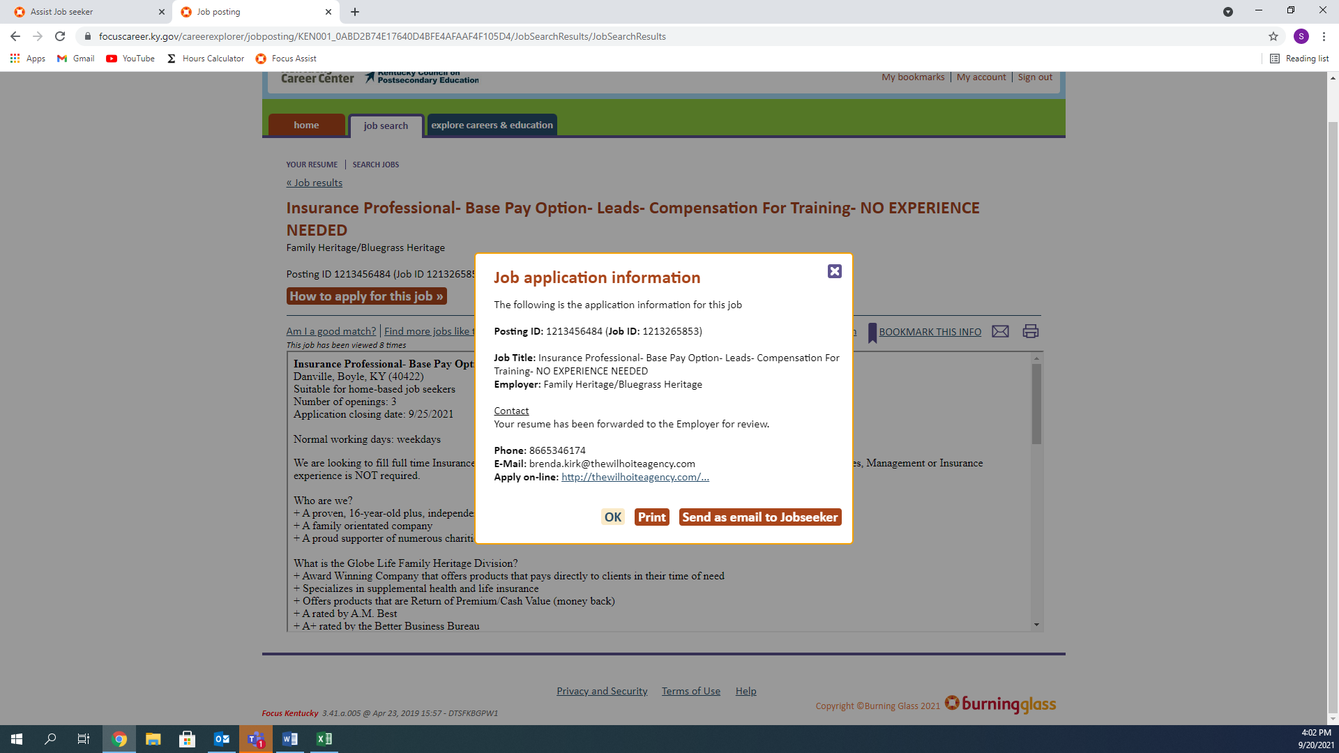

# Explore My Career Options

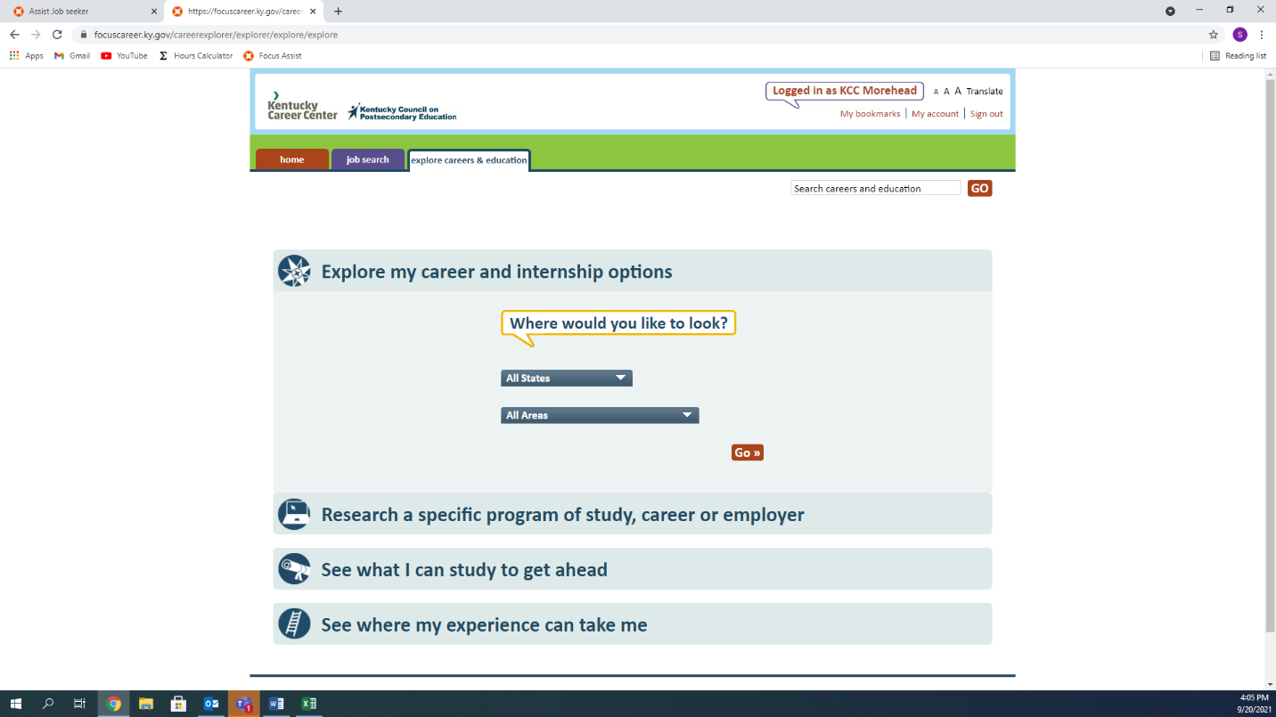

Here, you can see what positons are in high demand as well as the salary.

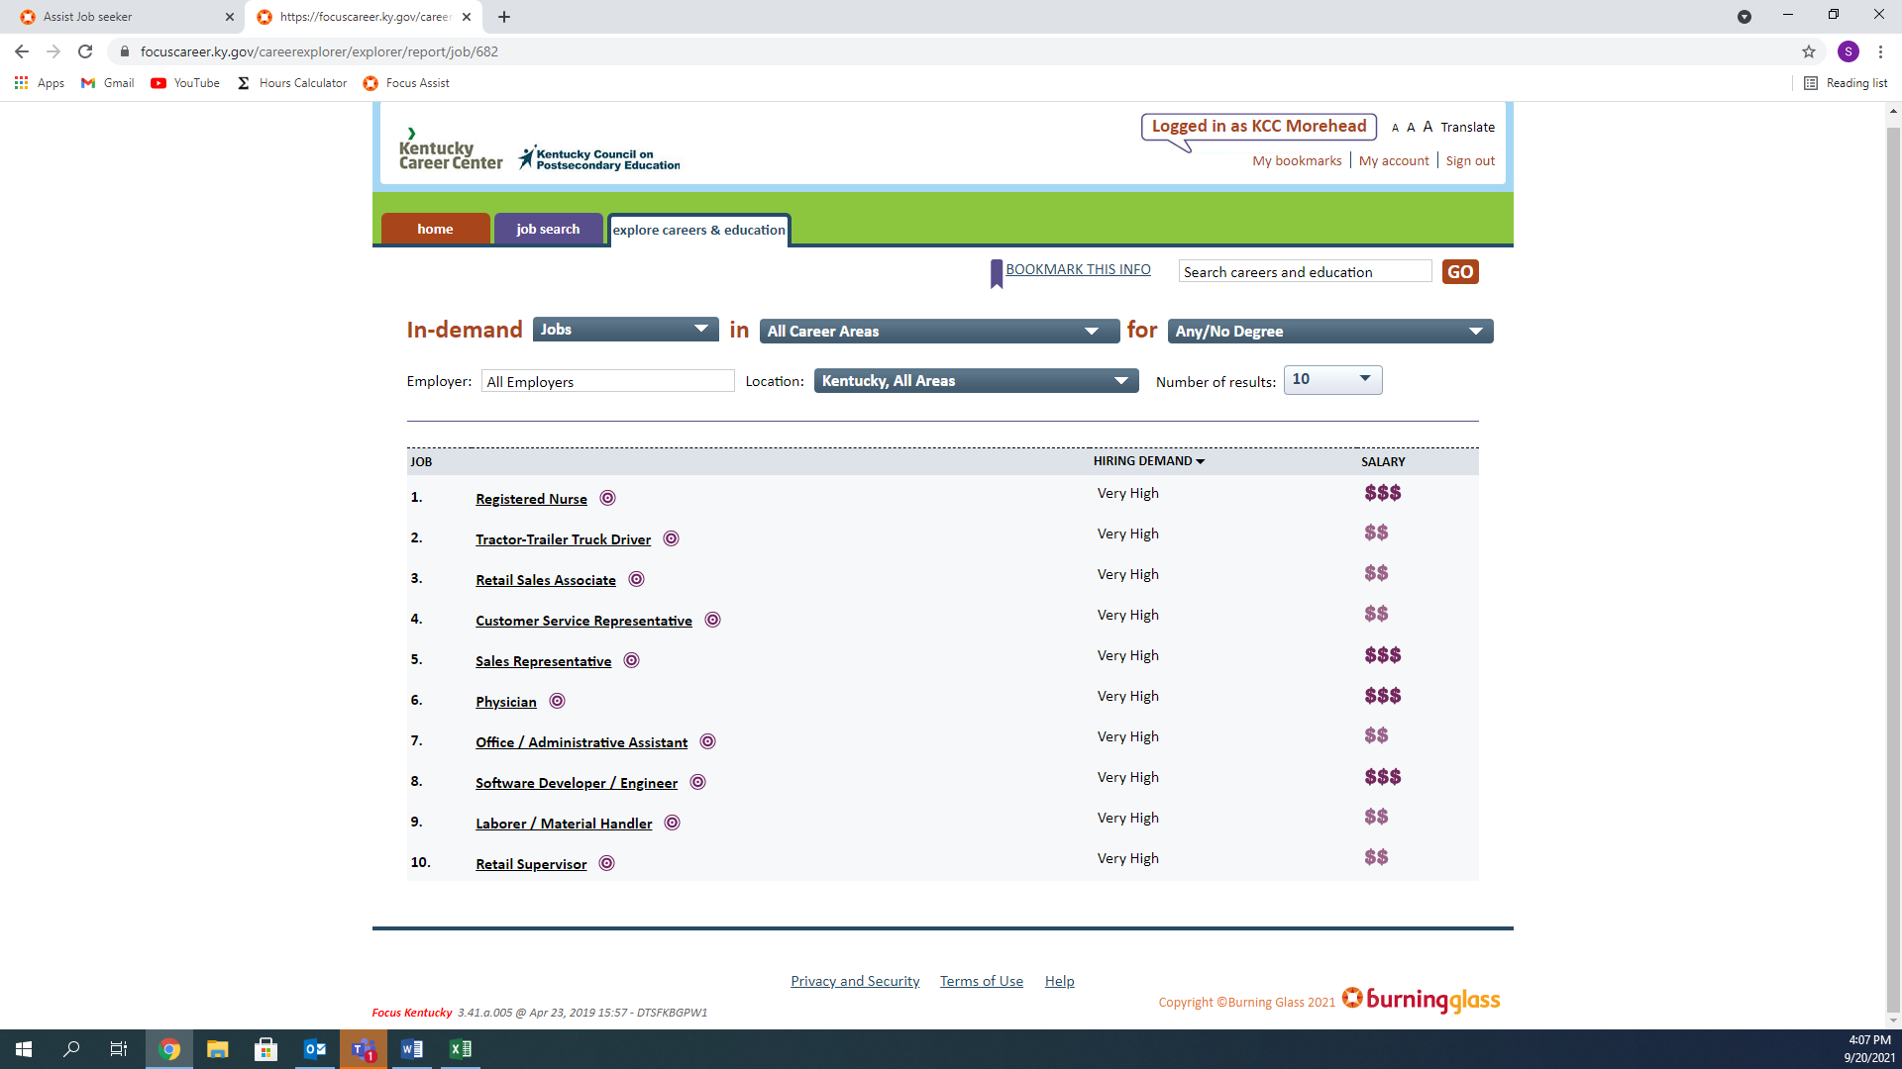

When you select a potential position, it will provide you with more details.

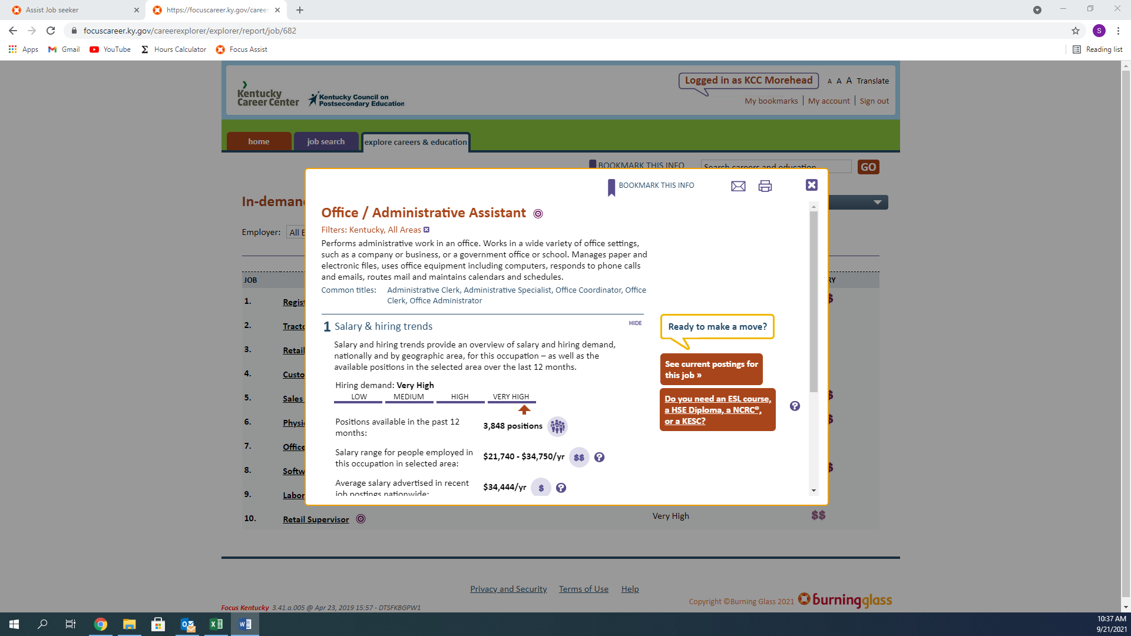

There are Seven (7) areas to choose from, each providing different information.

