ID.me Guide
In Google Chrome, go to uiclaimsportal.ky.gov, and click Sign in with ID.me
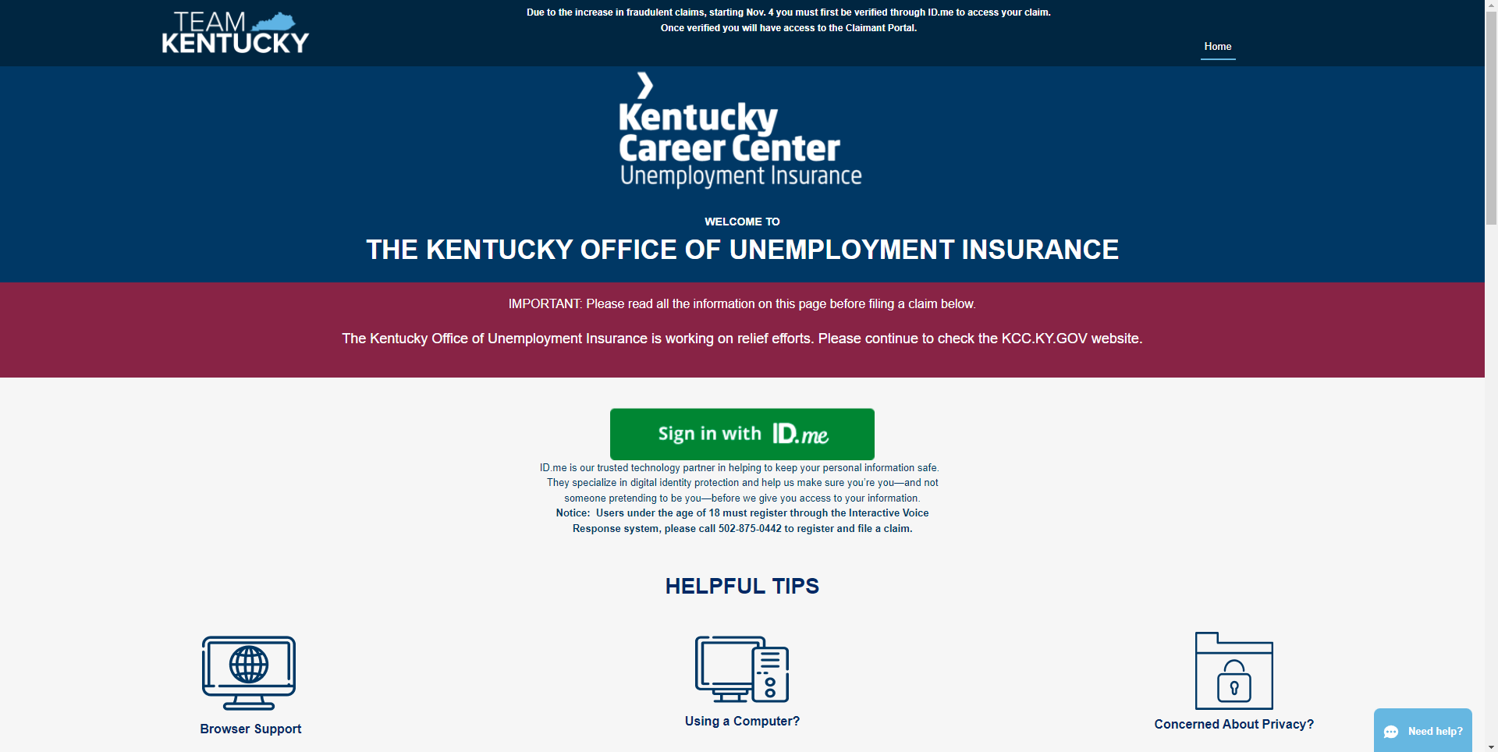
The First Page doesn’t require an email address, anything typed will be accepted and it will load the next page.
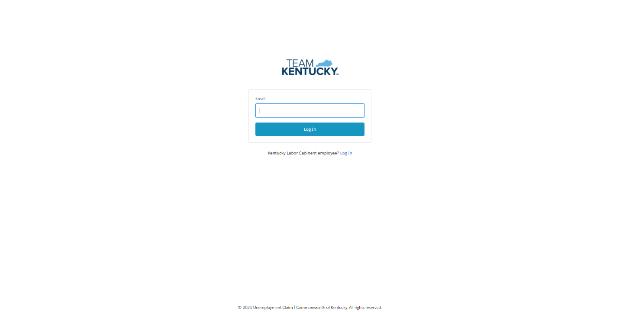

If you have already created an account, enter your information and log in, otherwise click Create and ID.me Account
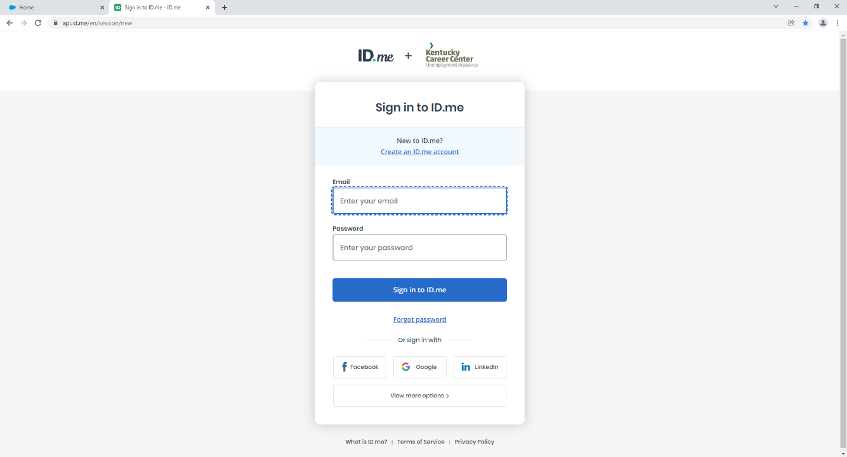
Enter your email and Create a Password and be mindful of the Password Conditions, they all have to be met. Once you accept the Terms of service, click Create an ID.me Account to Proceed.
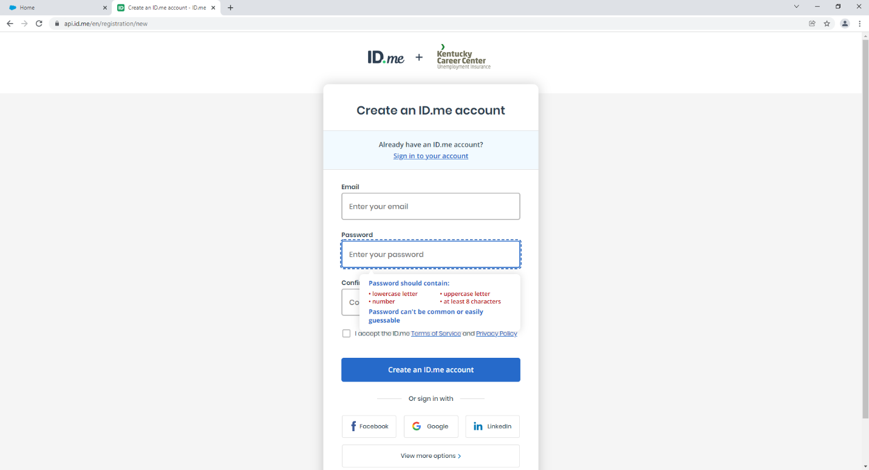

Click the link that was sent to your email you provided or enter the Code at the bottom of the email. Click Continue.
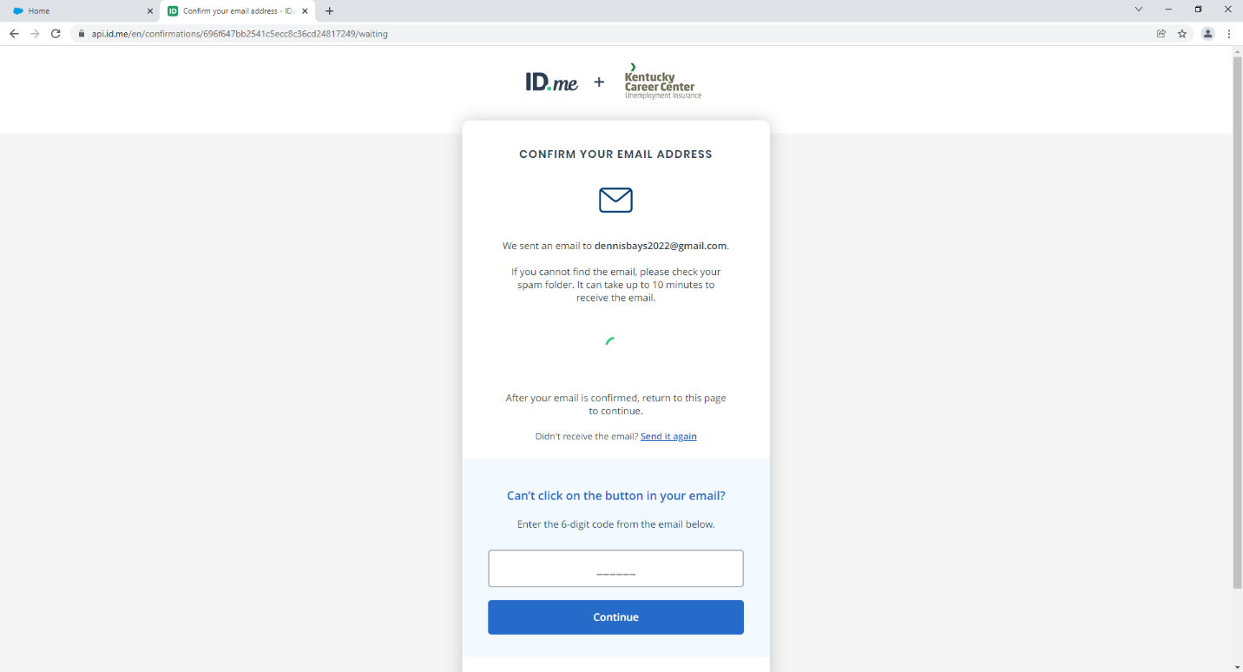
Once you Confirm your email, you will be asked to set up MFA (Multi-Factor Authentication). It is best to choose Text Message or Phone Call, but any will work.
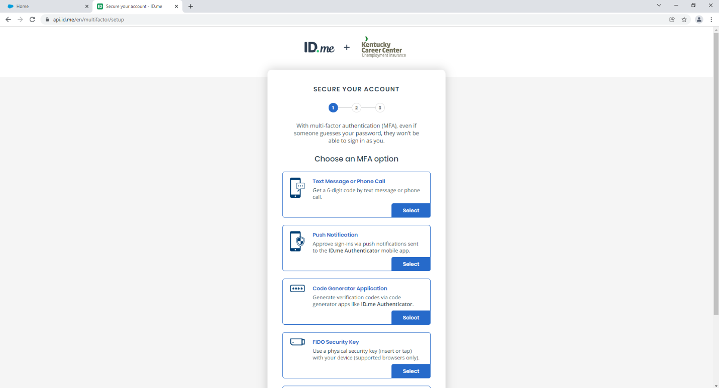

Enter you Phone Number and Choose your preferred method, Text is selected by default, if you are unable to receive Text Messages, you can opt for the Phone Call.
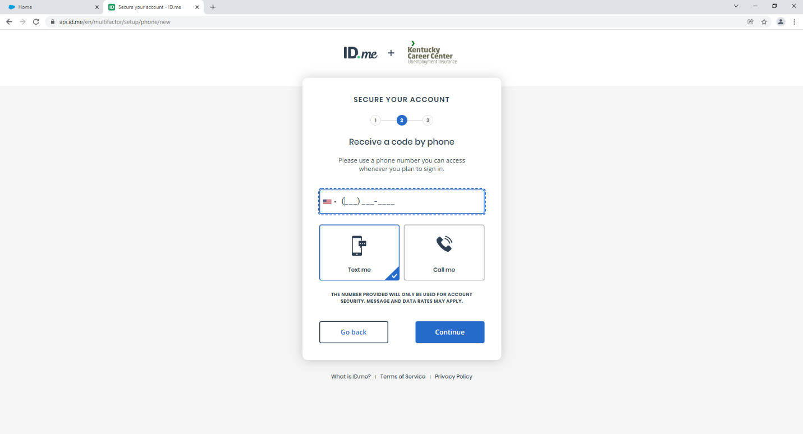
You will Receive a Text with a 6 digit code (or receive a phone call with an automated voice providing the number)
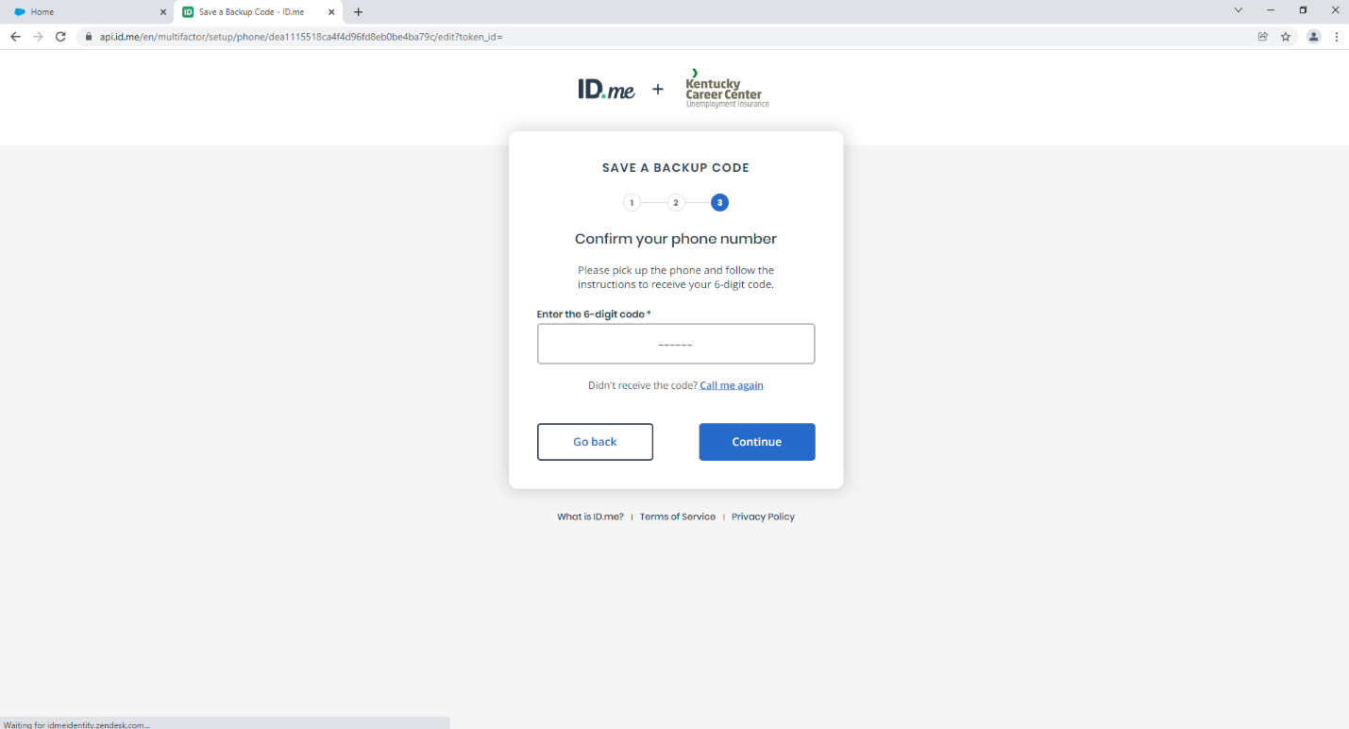

This completes your MFA (Multi-Factor Authentication), you can generate a recovery code if you’d like and write it down, take a photo, or print it for your records. The code is IDME-XXXX-XXXX-XXXX with a mix of letters and numbers.
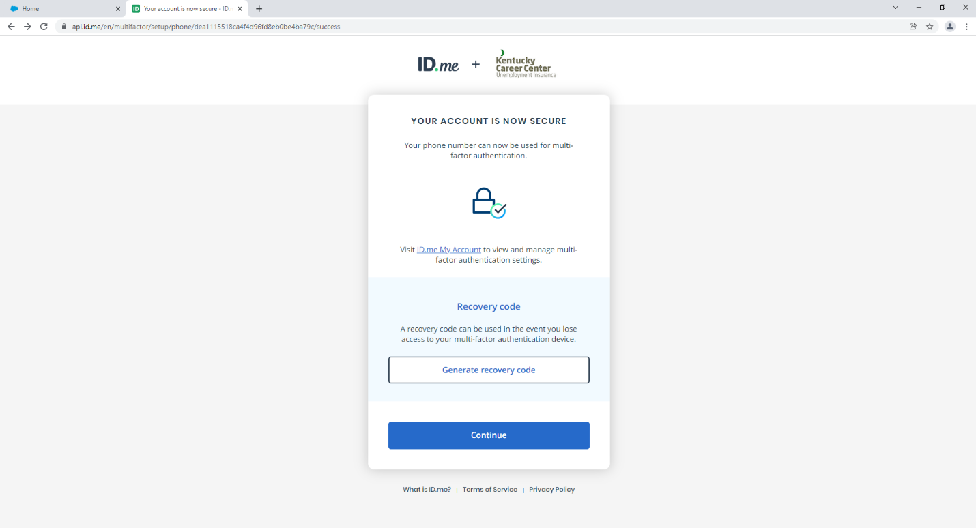
Now you will need to verify your identity, but uploading a picture of your Driver’s License or Identification Card. You can also use a Passport.
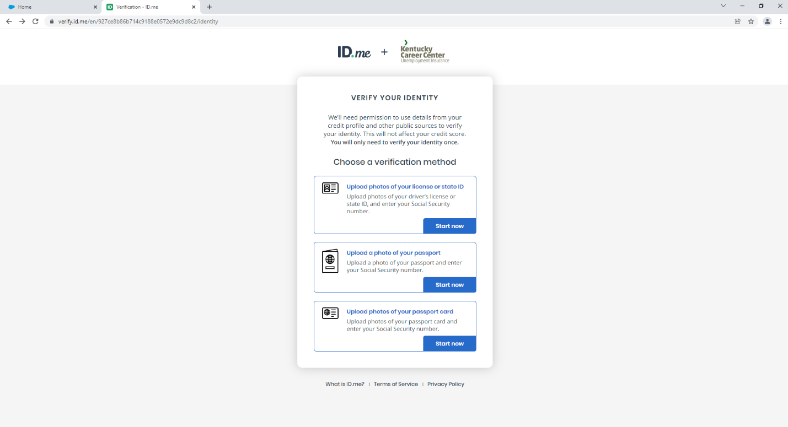

You will be required to do a “Video Selfie” or, more commonly referred to as a “Face Scan”, so you will have to agree to the Biometric Data Consent. Click the Little Box agreeing, then the gray continue box will turn blue.
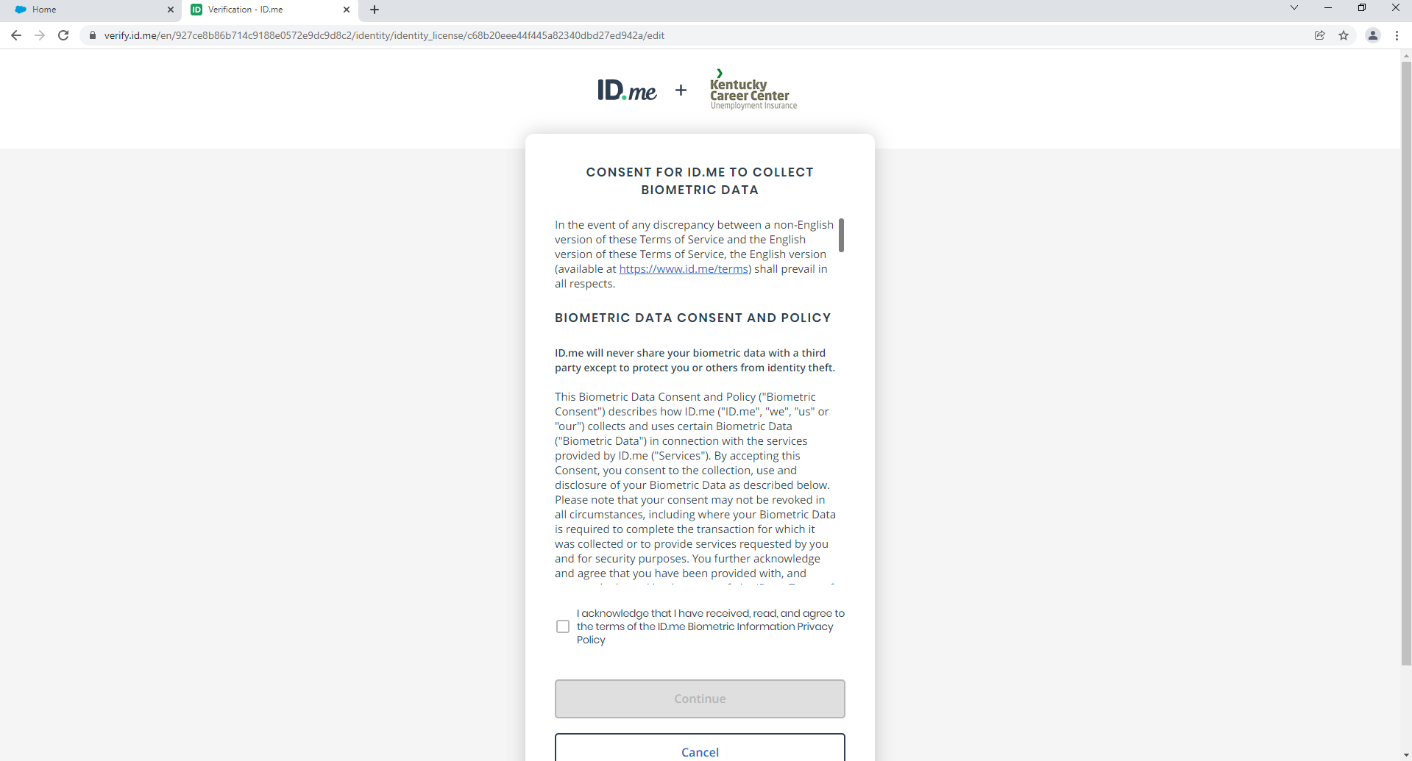
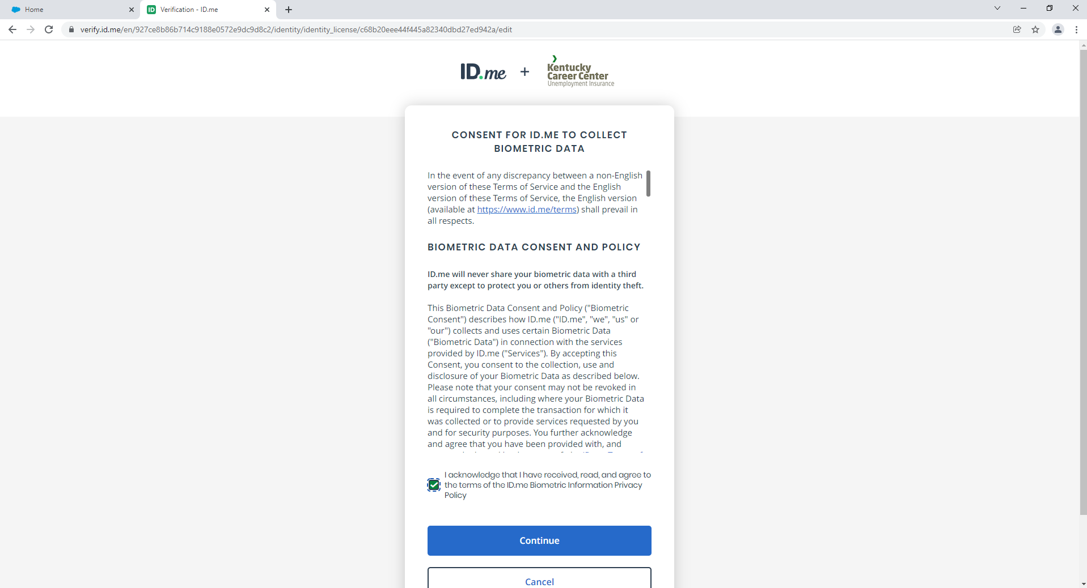

If you have a Smartphone, you can click Take Photo to have a link sent Via Text Message to take a photo of your Identification.
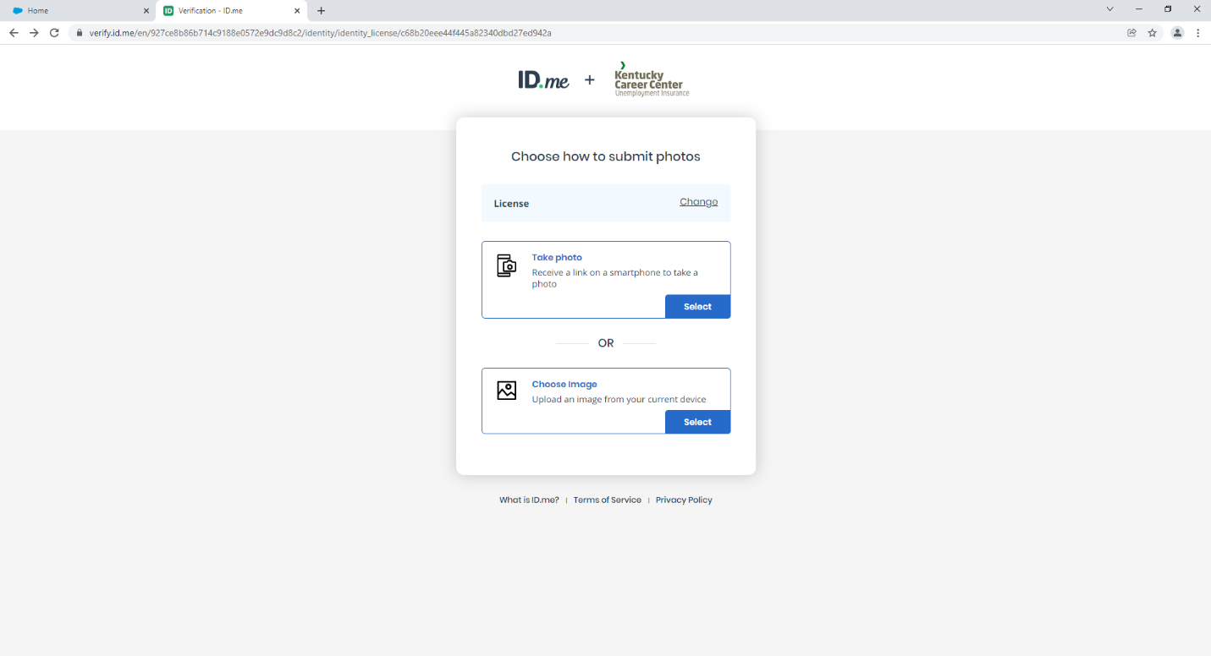
Verify the Mobile Number is Correct, and click Continue (It will have your number already in the box)
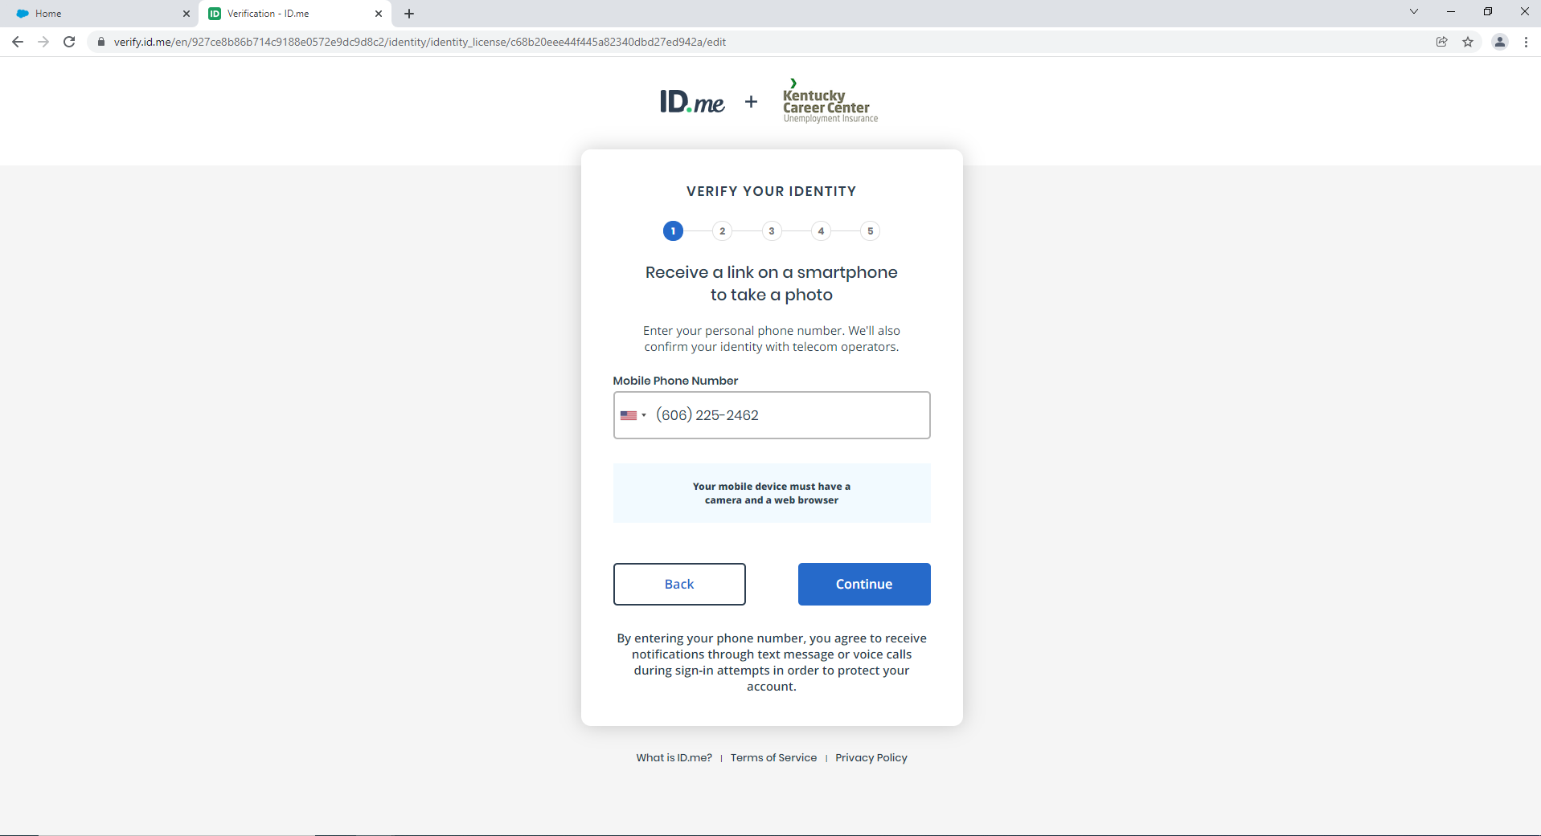

You will be notified when the link is sent.
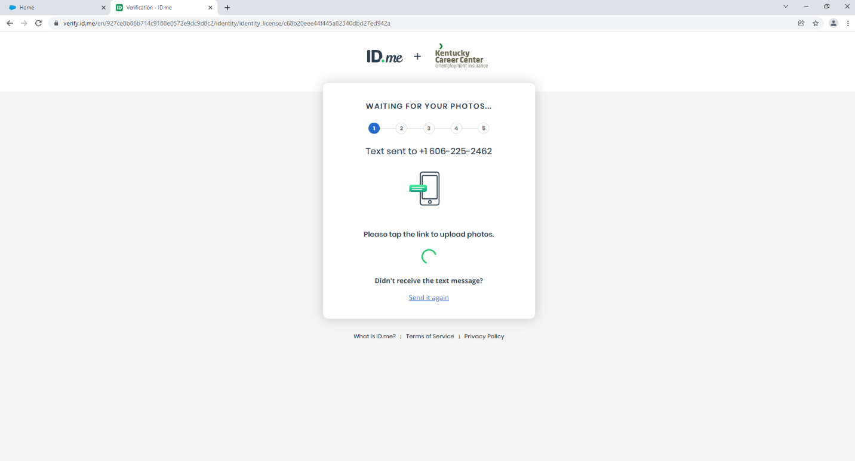
Once your documents are uploaded, and your Video Selfie is complete, you will need to verify your Information for accuracy. (The Information is taken from your Identification Documents automatically.)
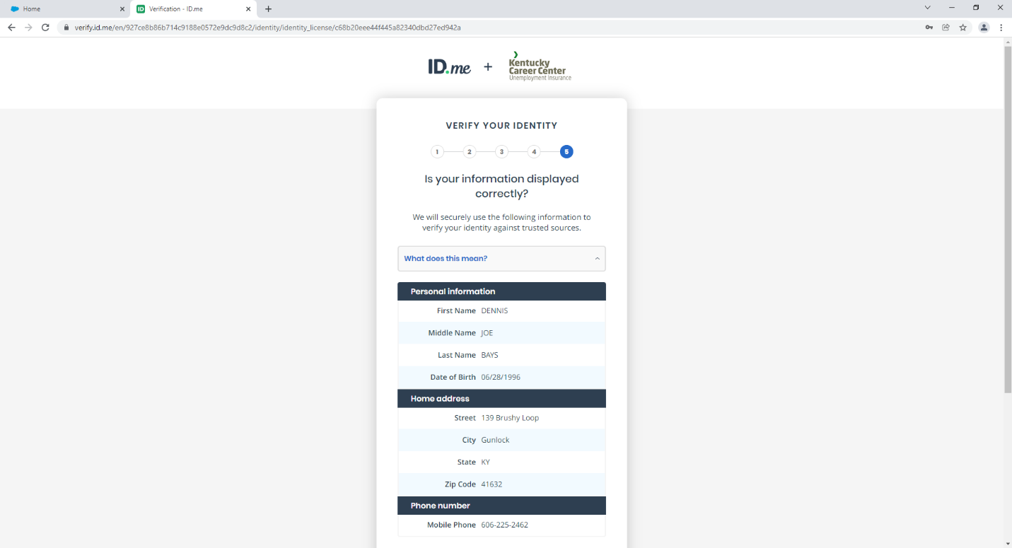

After Clicking Continue, ID.me will verify your Information, to make sure it Matches.
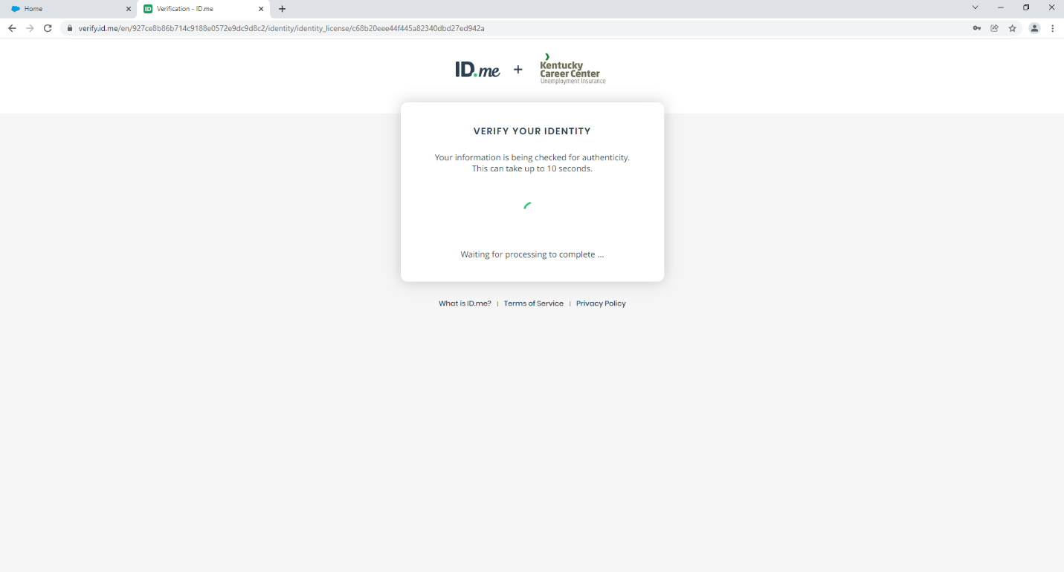
Click allow and you’re all set!
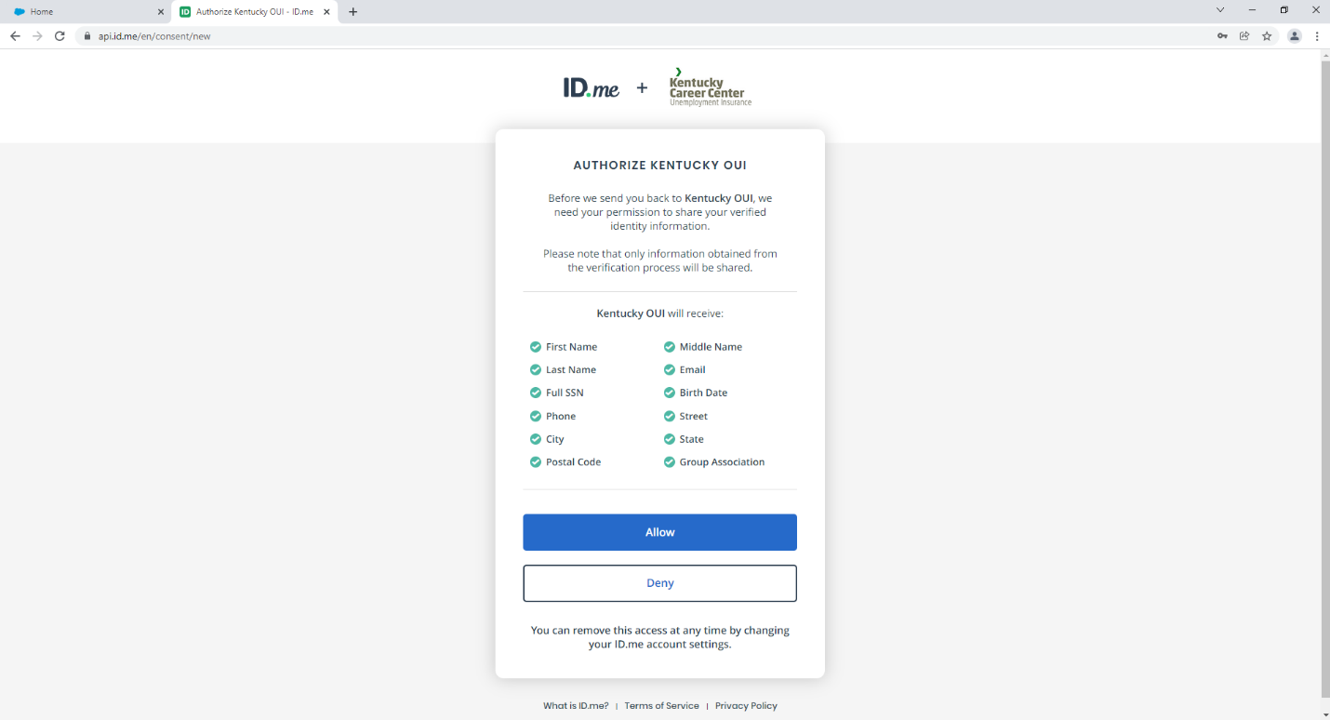

Sometimes it will say there is a Single Sign-On Error, Don’t be Alarmed, it’s a Common Issue. Just Close out of that Tab (Not the Window) and Sign in again.
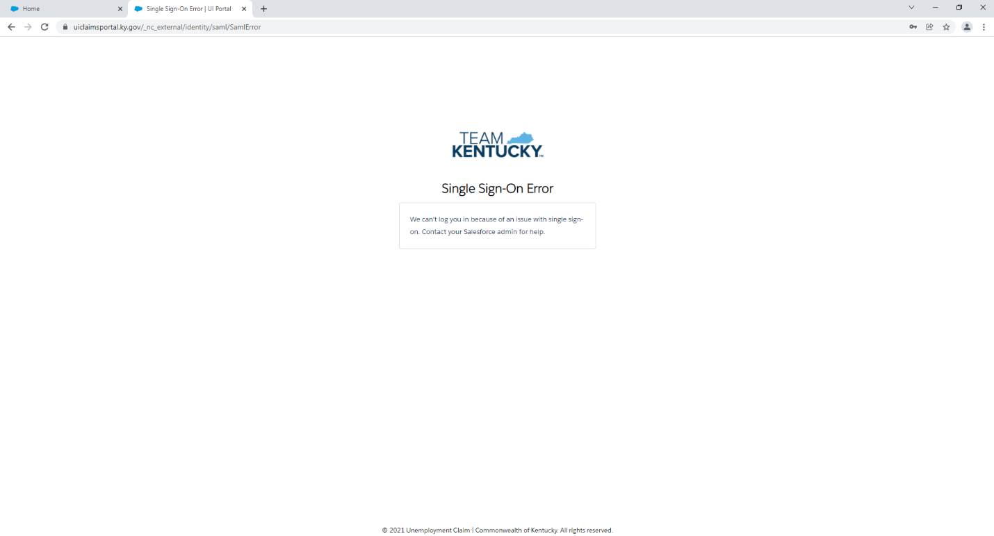
When you sign back in, you will be asked to create a New Security Question and PIN. You can set the PIN to any 8-Digit Number You’d like, but it must be 8 digits and it will take the place of any old PIN Numbers you may have had before.

