# Filing a New Claim

Log in to your Account. You will need to click “Request User Login Verification Code” This will send a code to your E-Mail address; It is NOT your 8-Digit PIN. It will contain letters that ARE CASE SENSITIVE! You do not need to write this code down, just keep it ready.

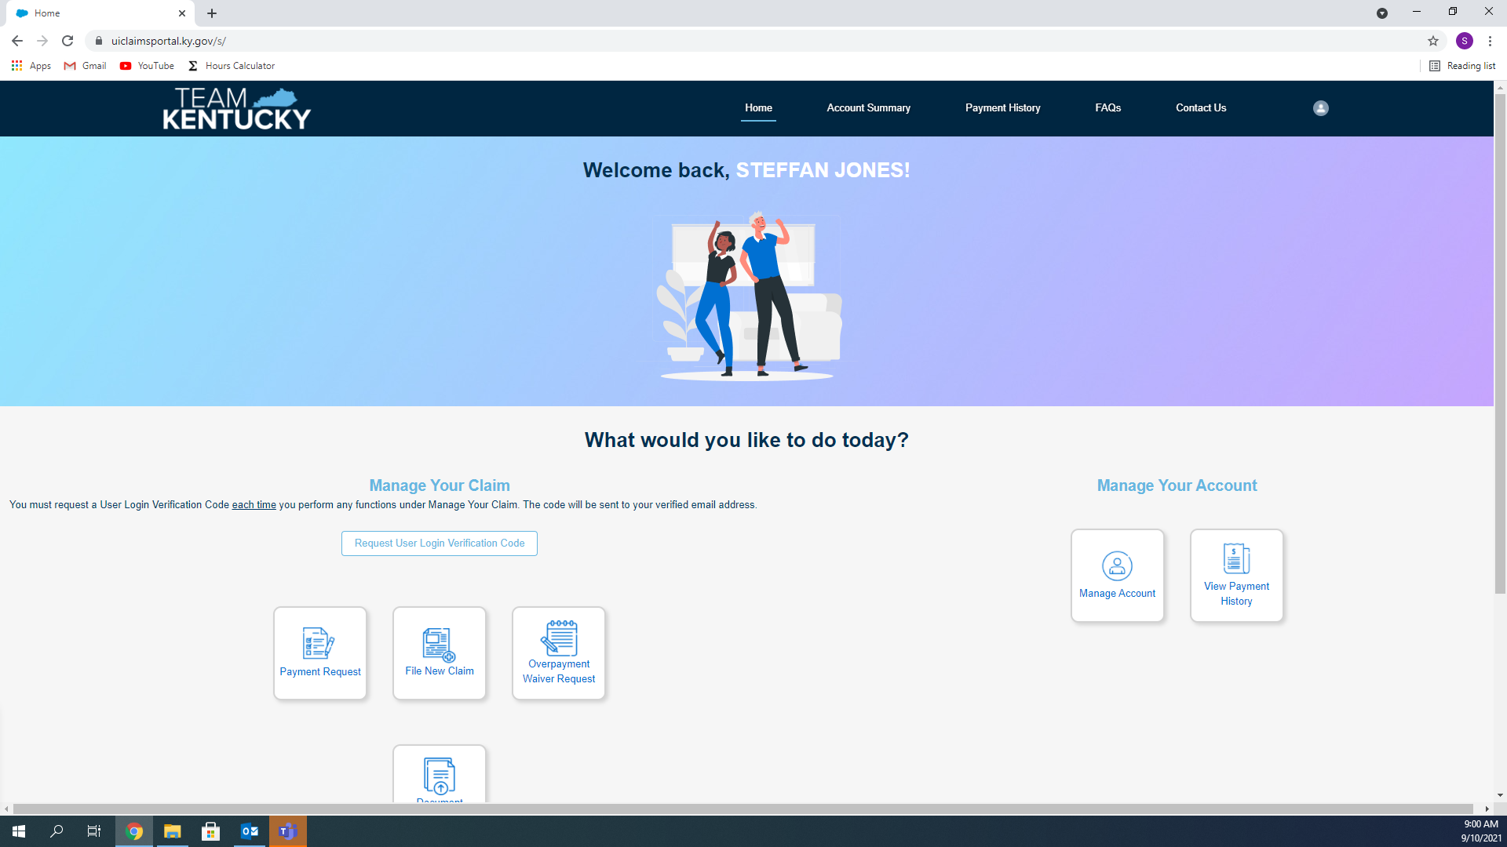

Now, Click “File New Claim” 

Once you have entered your Social Security Number and Your 8 digit PIN, verified you are human, and entered your User Login Verification Code, you can click File a Claim.

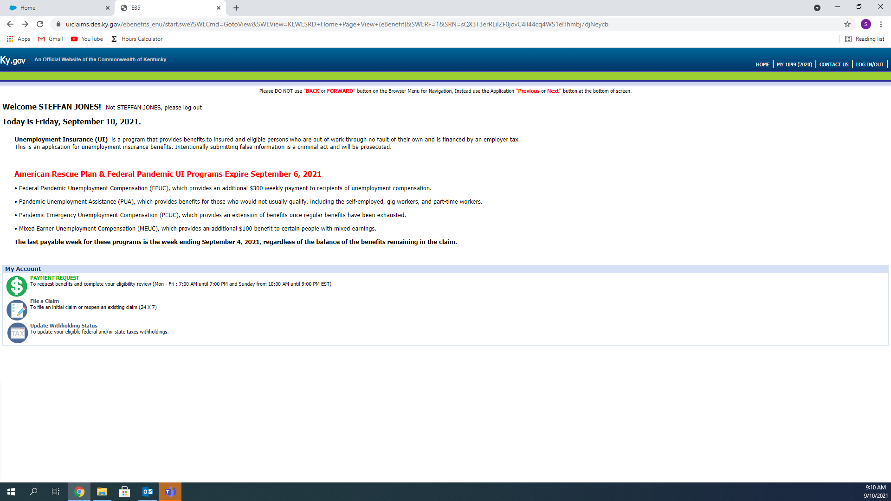

Once you Read everything, Click Next

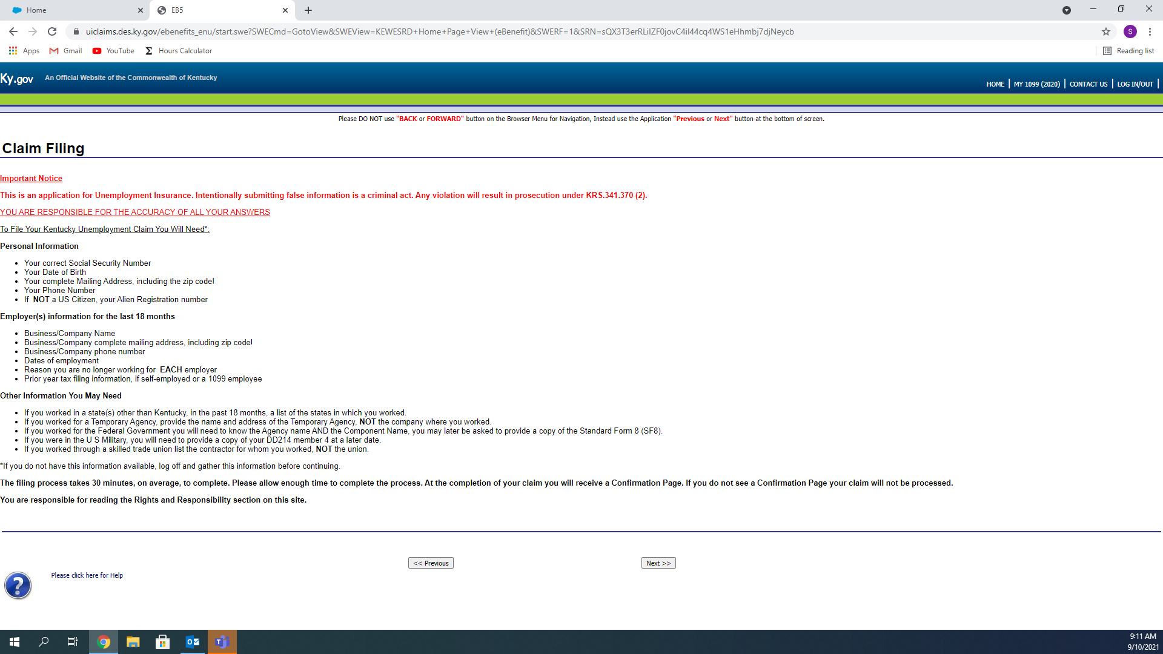

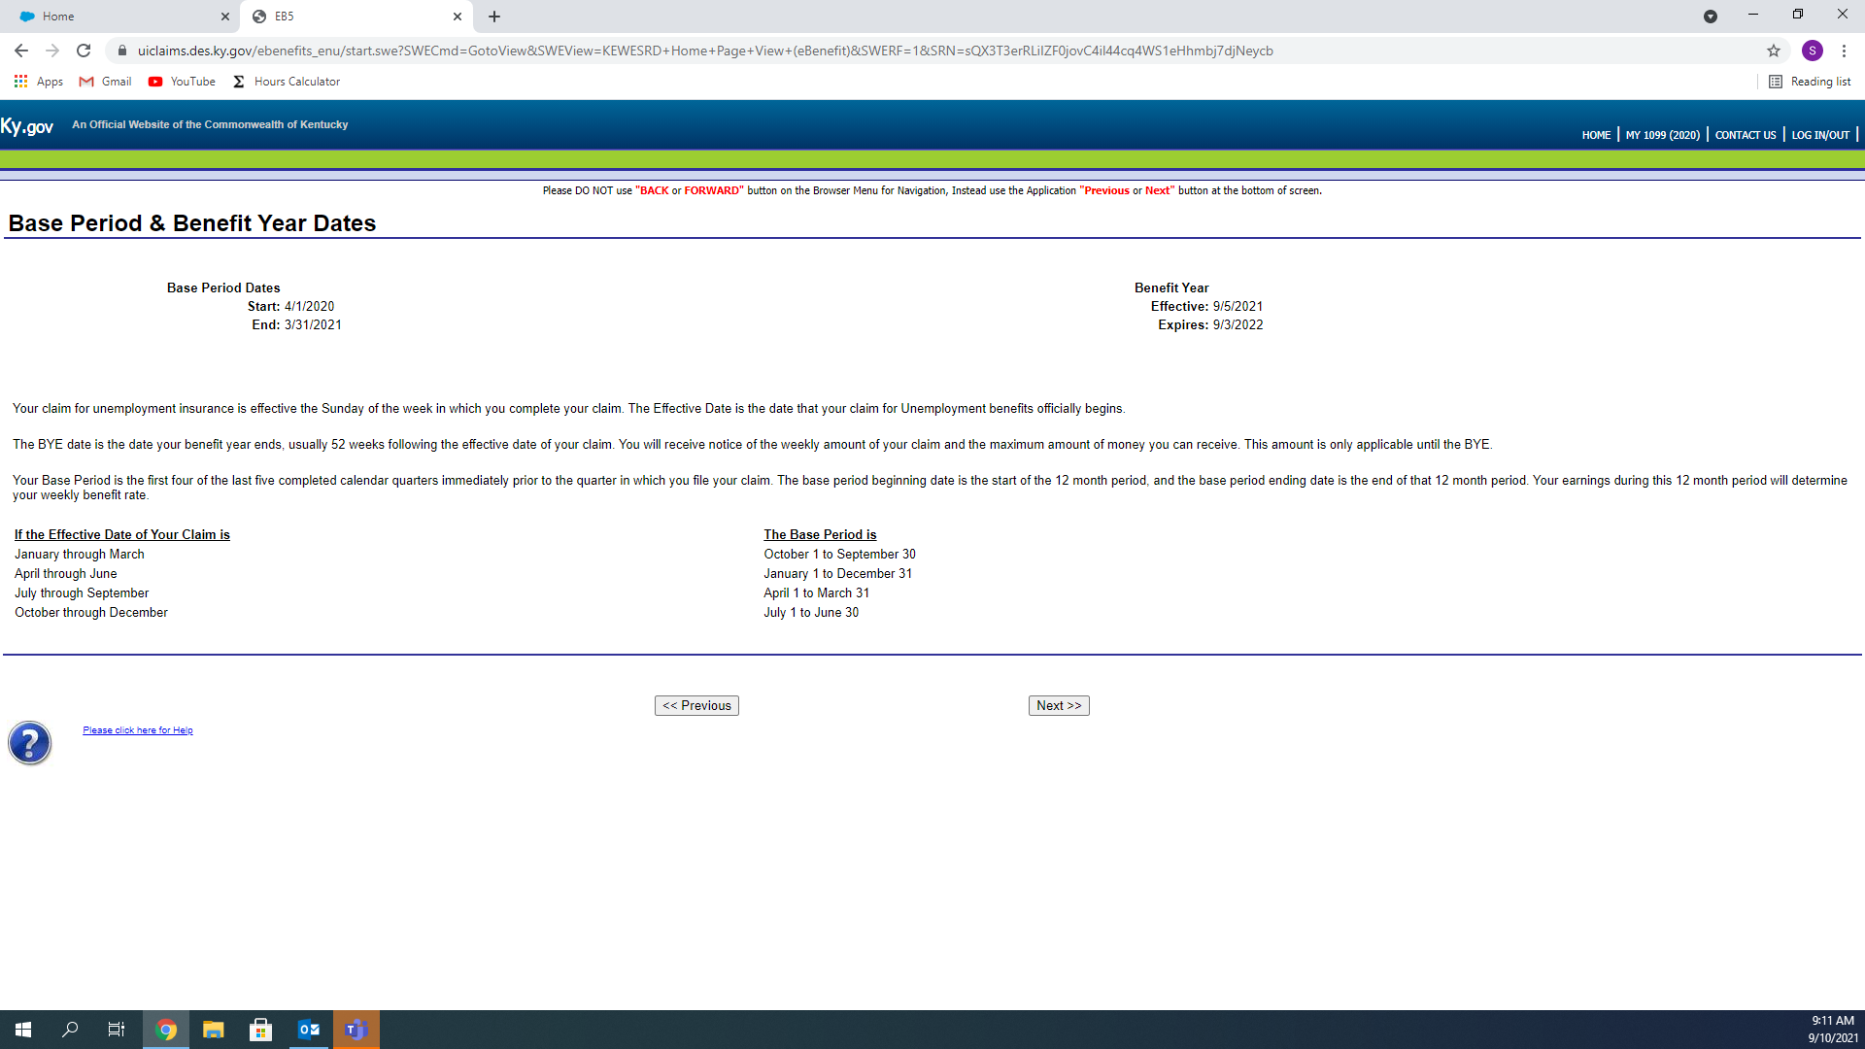

The next pages requires you to answer the Question before Proceeding, click the Drop down Box and select either Yes or No, then click Next

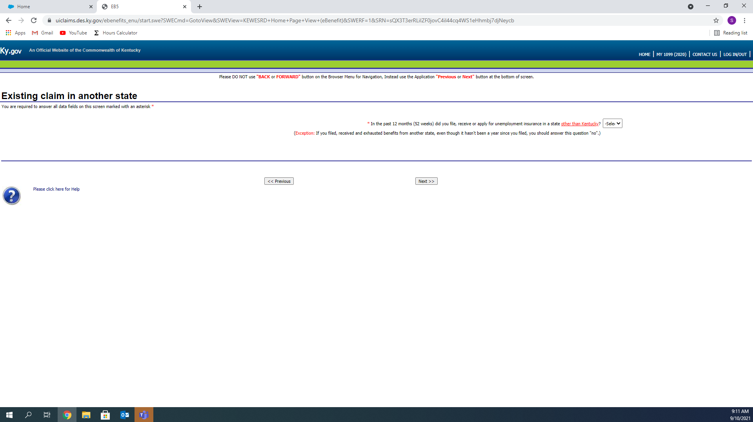

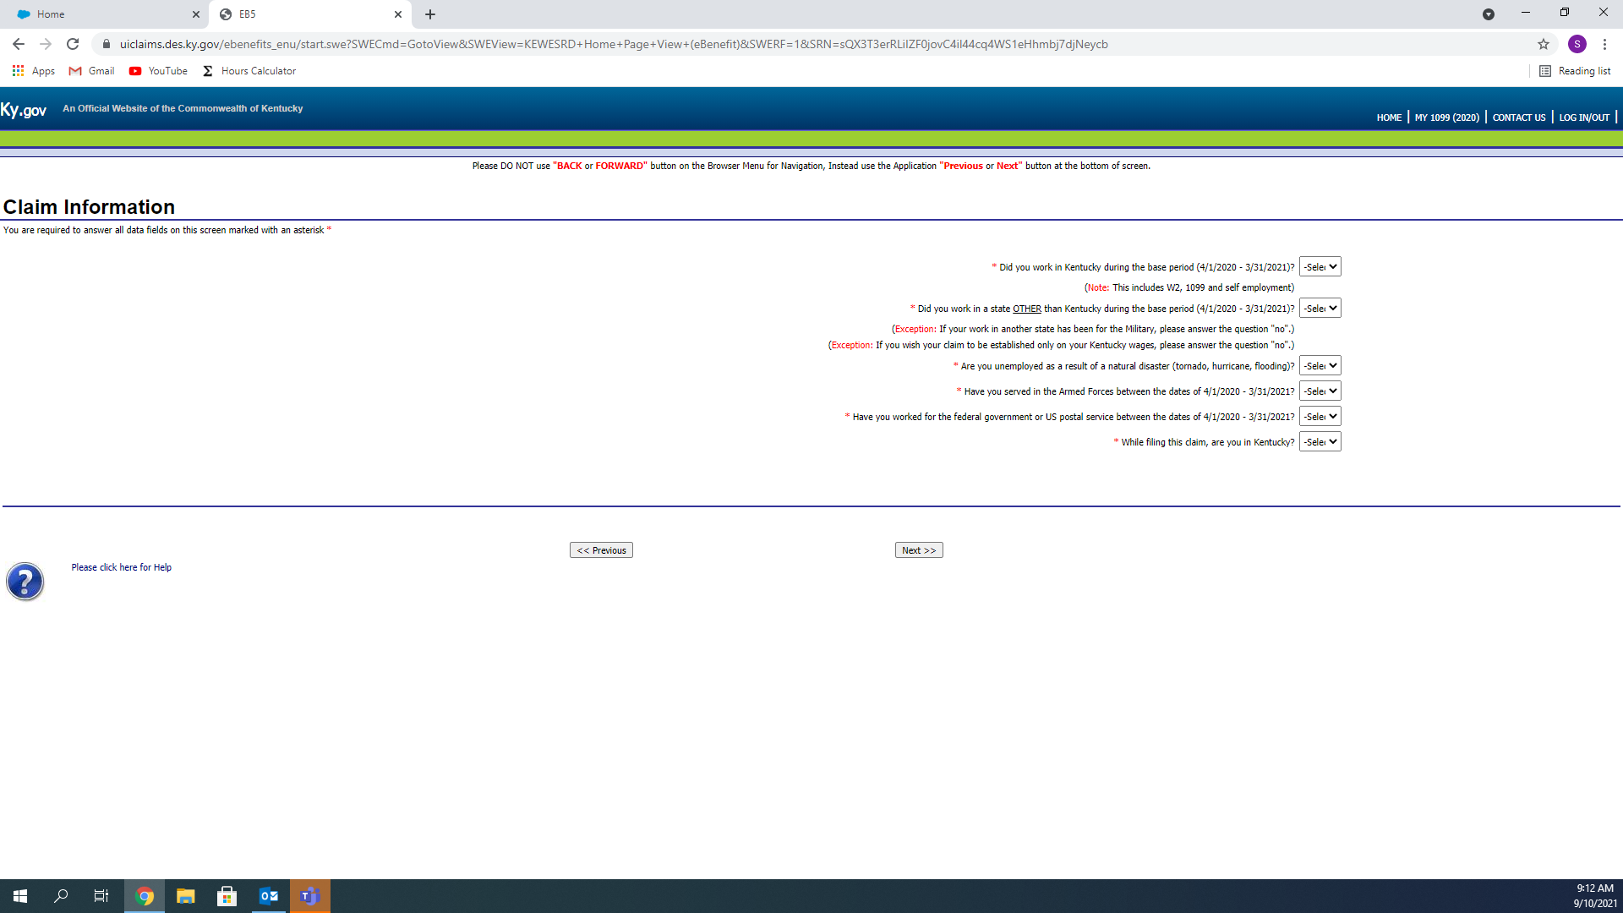

Verify that your information is accurate, and correct any issues.

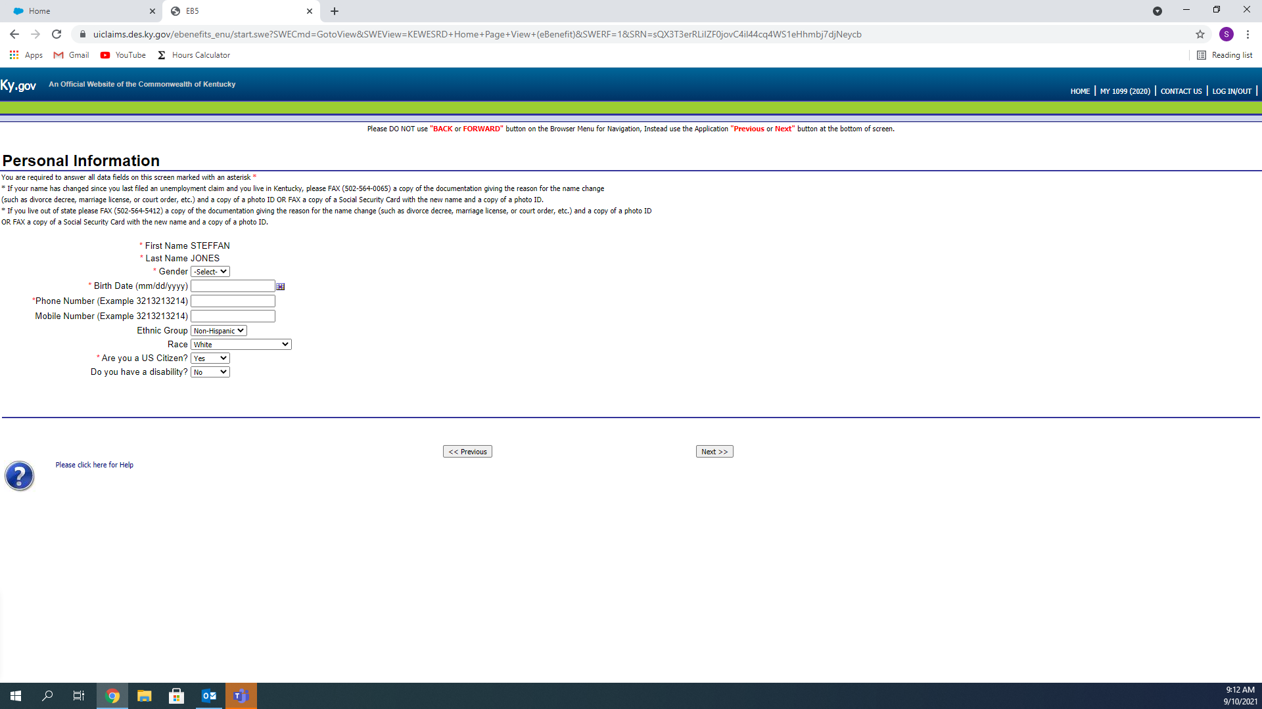

Select your preferred Payment Method, you can choose between Direct Deposit and Debit Card. The Debit Card is a U.S. Bank ReliaCard; some banks are not eligible for the Direct Deposit option.

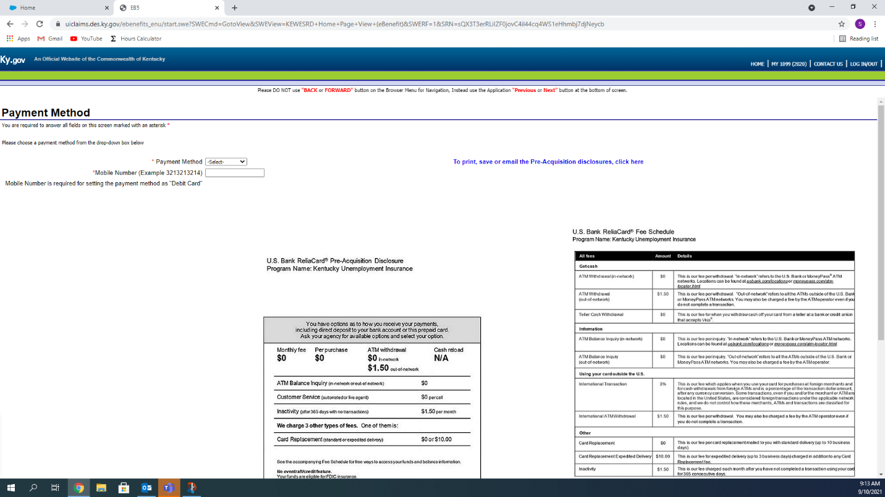

Depending on which option you choose, the next page will vary.

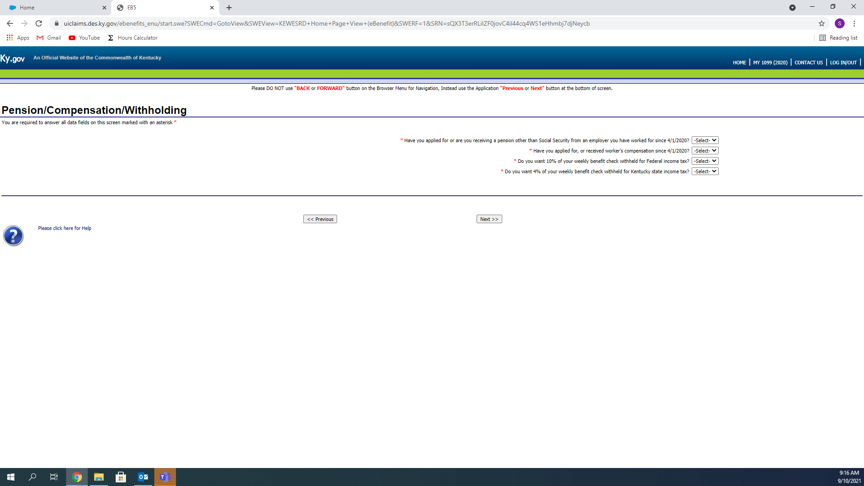

Verify your information again, and be sure to select whether or not your address that is listed is a P.O.Box or not, it will not let you continue without it.

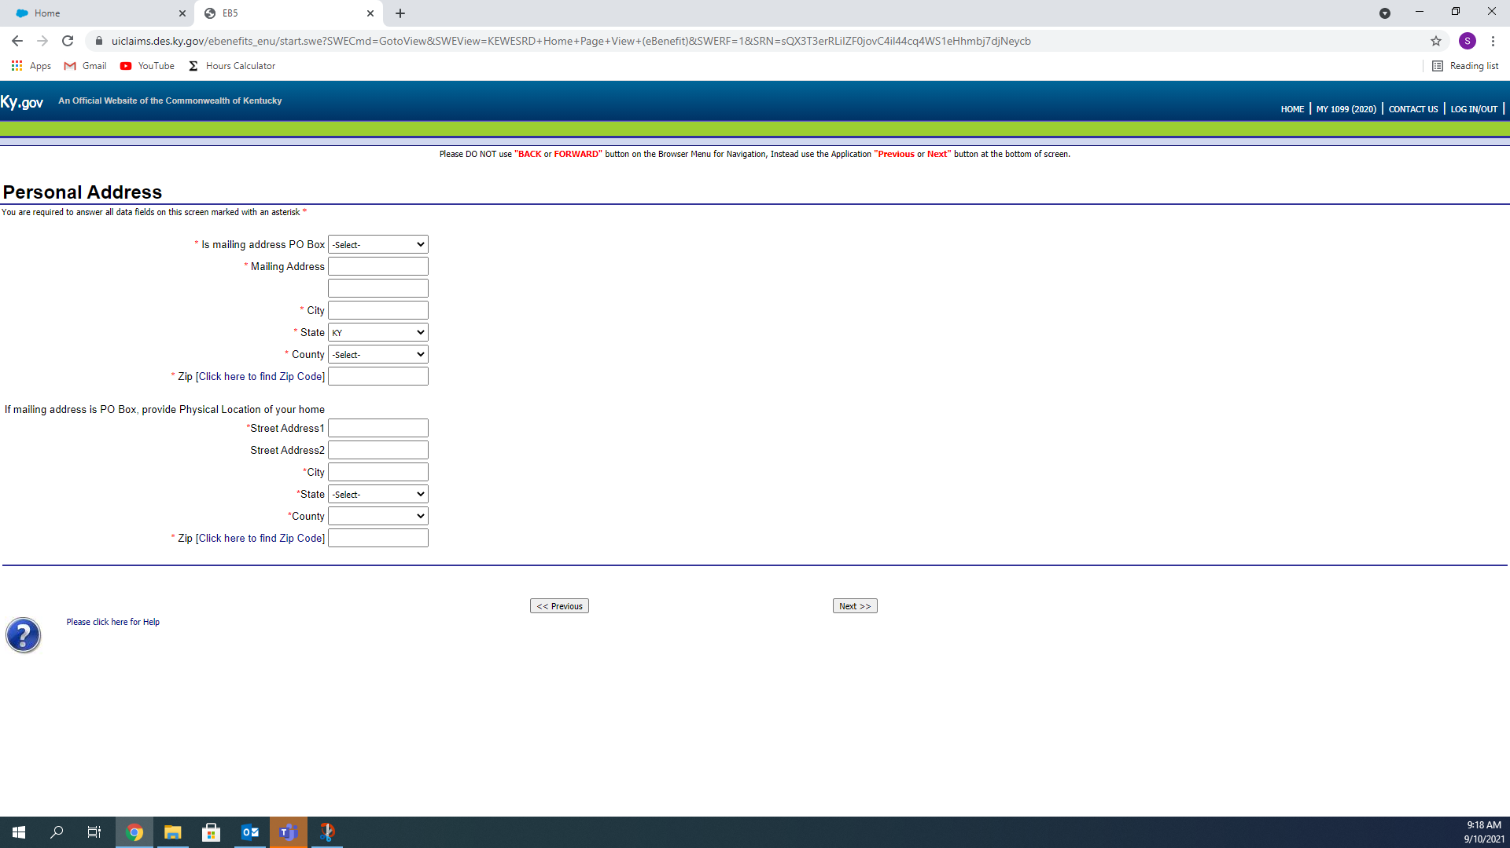

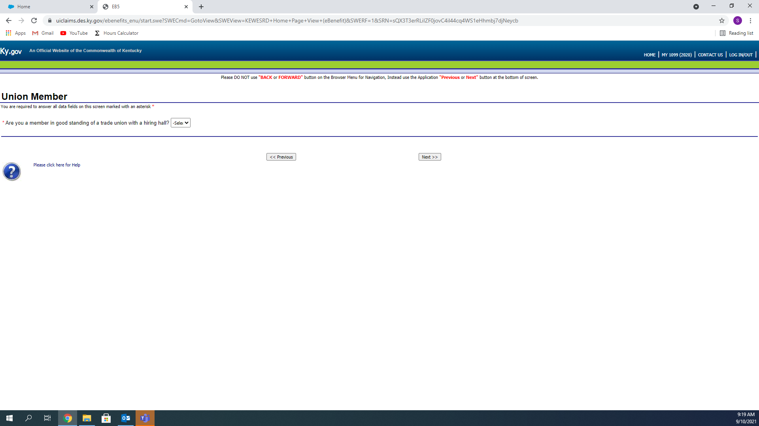

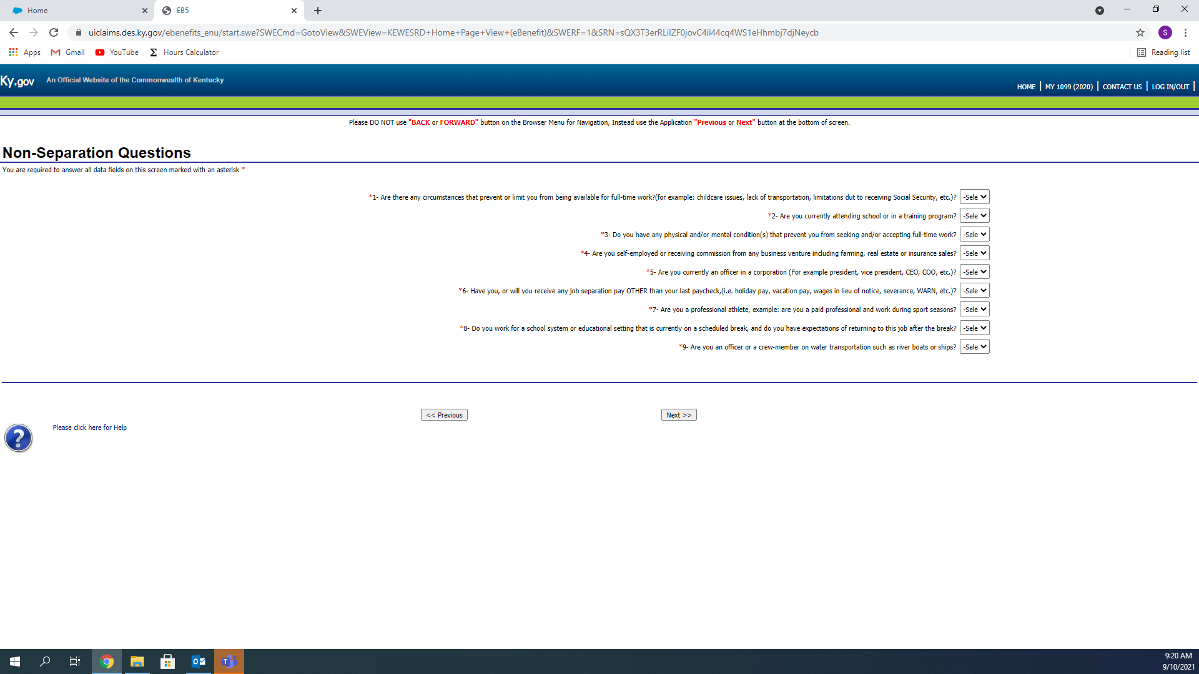

Depending on your Answers on this page, the next page will vary. Select the description that best fits your situation, you will have to choose a secondary description, too. (I.E. Primary: Lack of work, Secondary: Laid off, Definite return to work date)

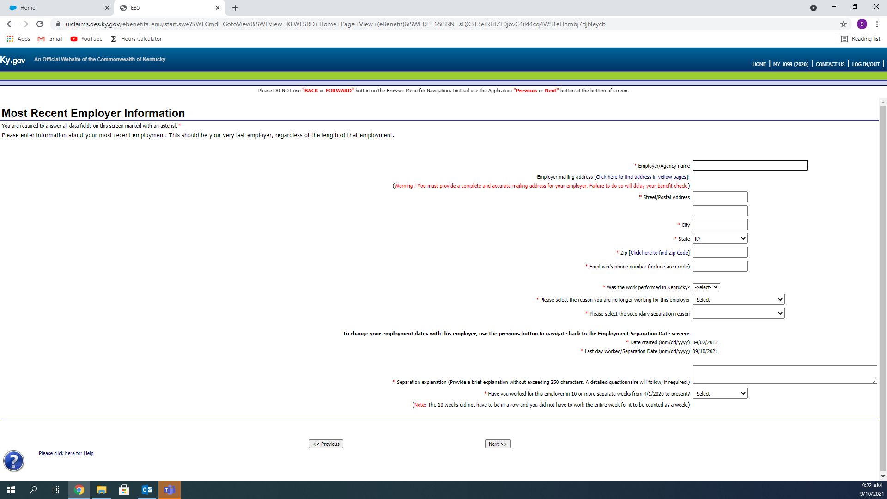

This is an example of one of the possible pages. If you were to select Quit for your Primary and Prospect of Other work as your secondary, you would answer these questions before moving on. Again, Your page may not be the same.

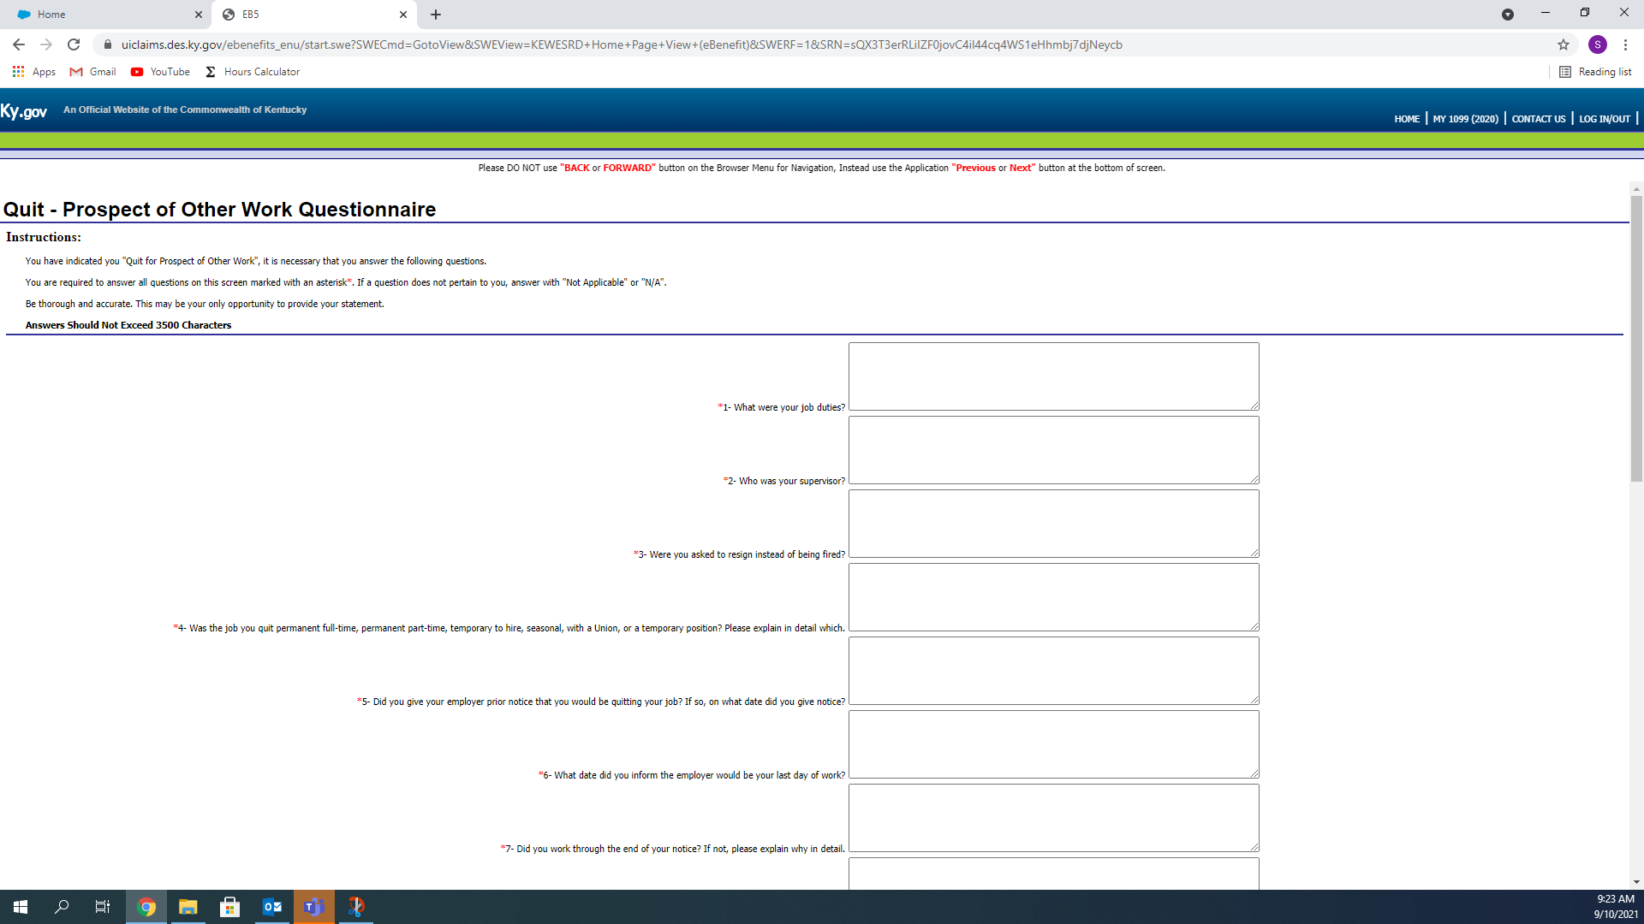

In most cases, this portion will need to be completed, as the work search requirement is in effect. Complete the page, making sure all fields are completed.

You will have to search for a Job Title, to search for a job you think you’d be qualified to do.

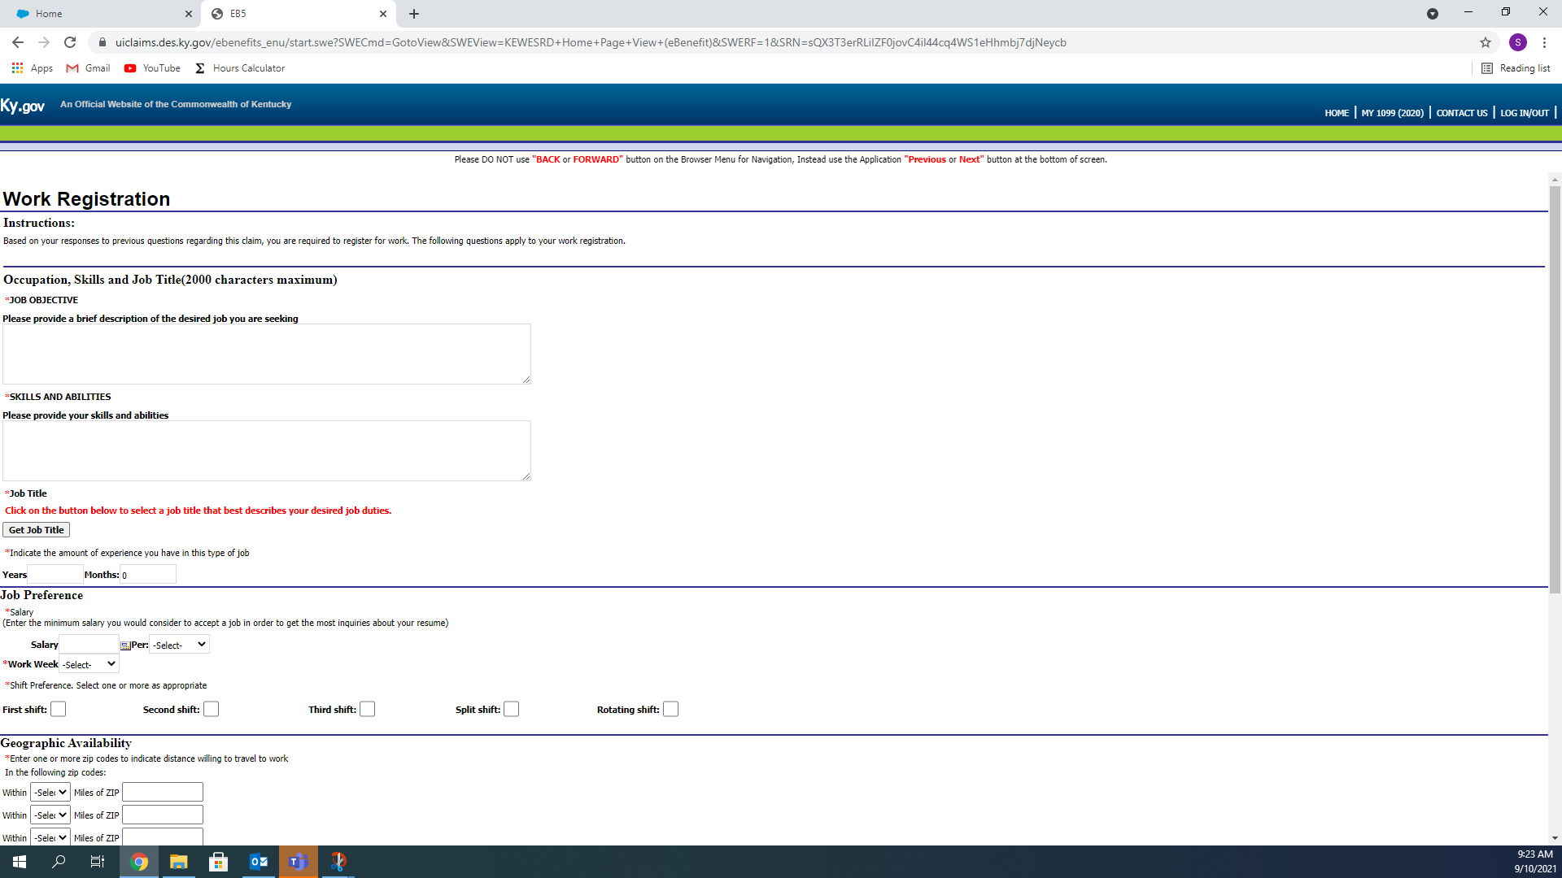

Clicking the “Get Job Title” button will open this. Click the little square in the top right corner of the box.

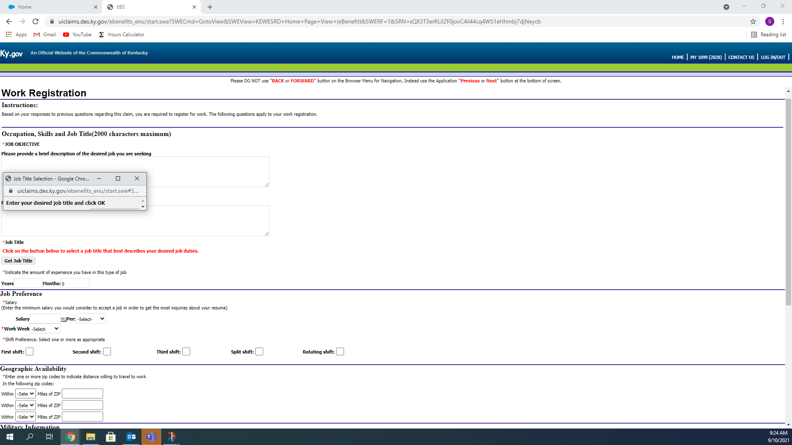

Now you can type the Job Title in the open field and click ok to search

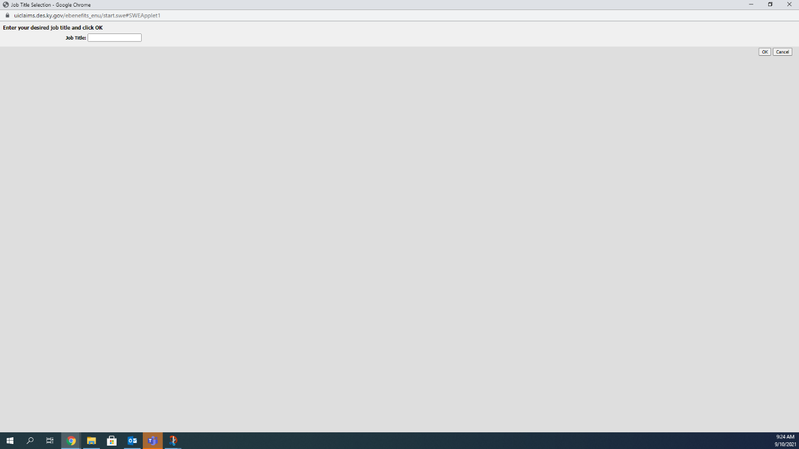

When that is completed, you will be asked very specific questions to verify your identity. Select the Corresponding letting in the drop down box. It will have A,B,C,D, and E options to choose from.

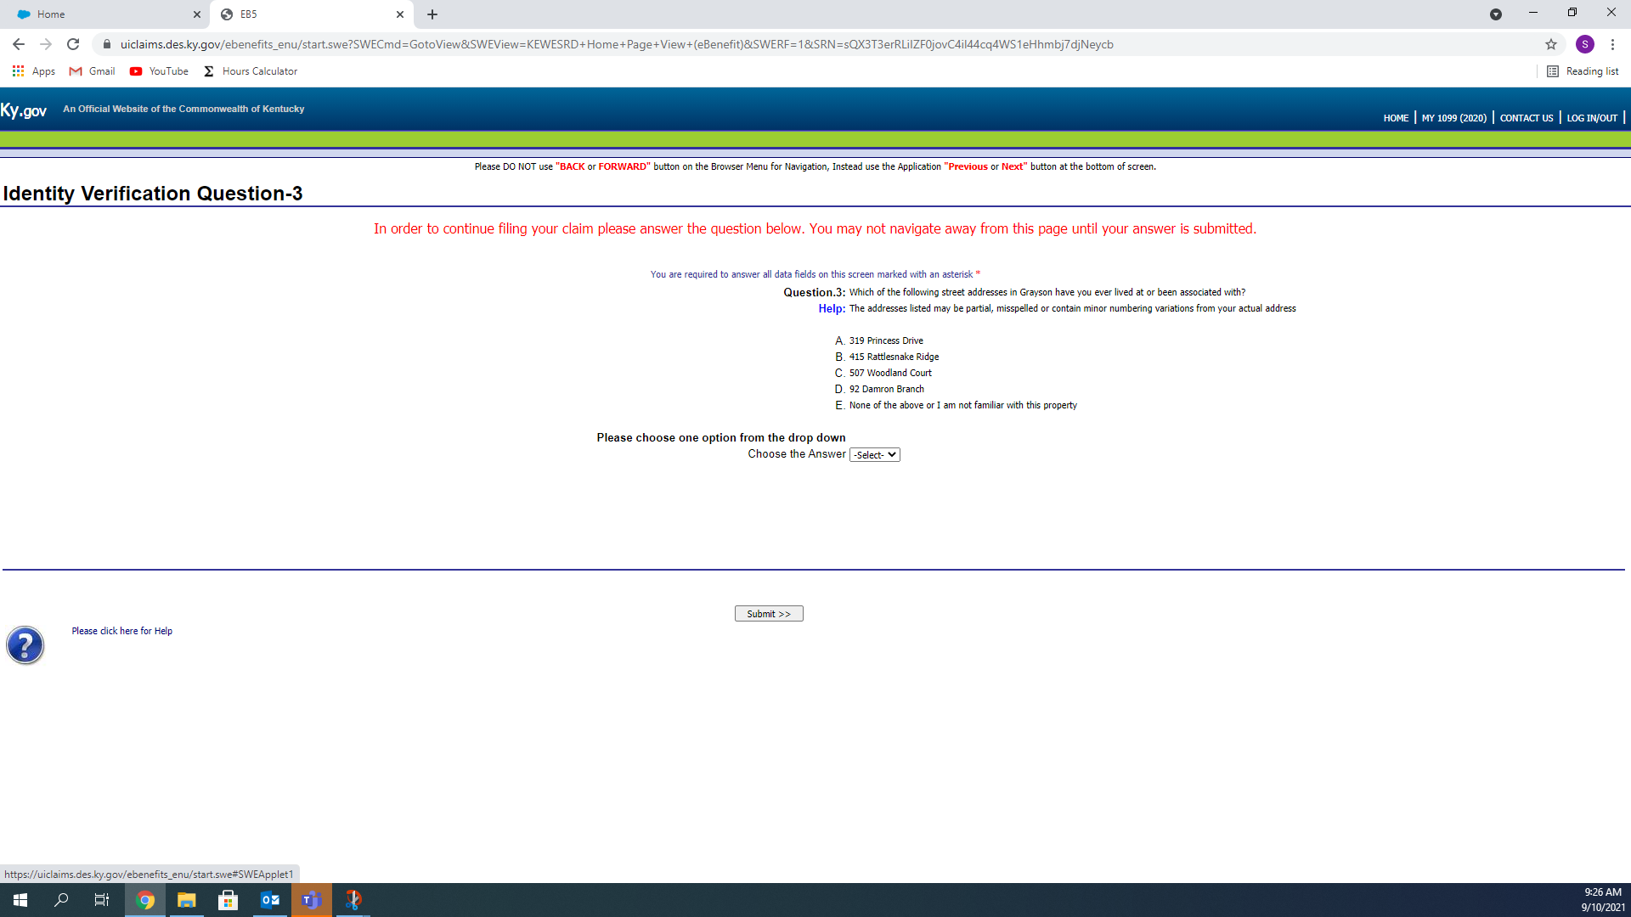

Type your First and Last Initials in the boxes, after carefully reading each one, and then type your full name with middle initial to complete filing your claim. Once you click Agree, You are finished!!

