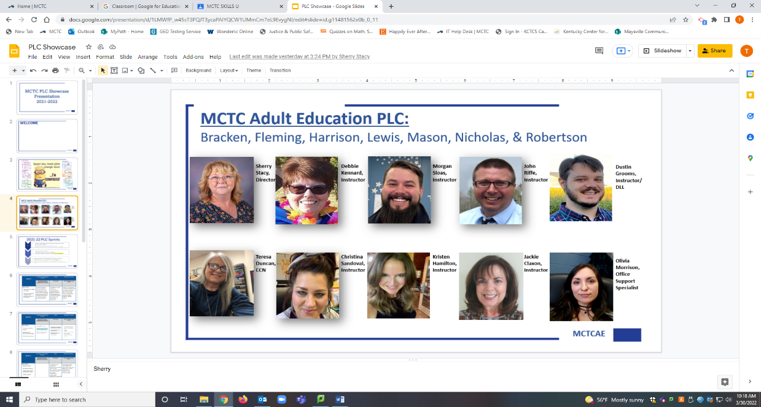

**Bracken County Adult Ed**

**Dustin Grooms & Kristen Hamilton**

*2nd Floor in Courthouse*

**116 West Miami Street**

**Brooksville, KY 41004**

**(606) 735-2212**

**Hours: Tuesdays & Thursdays**

**8:00-AM-4:00 PM**

**Fleming County Adult Ed**

**Christina Sandoval**

**c/o: Fleming County Public Library**

**202 By Pass Blvd**

**Flemingsburg, KY 41041**

**Phone: (606) 356-1416**

**Hours: Monday - Friday**

**8:00 AM—4:30 PM**

**Harrison County Adult Ed**

**Morgan Sloas**

*Licking Valley Campus of MCTC, Room 104B*

**319 Webster Avenue**

**Cynthiana, KY 41031**

**Phone: (859) 234-8626, ext. 66422**

**Hours: Tuesday-Thursday**

**8:00 AM-4:30 PM**

**Teresa Duncan, College/Career Navigator: (859) 234-8626, ext. 66413**

**Olivia Morrison, Office Support:**

**(606) 759-7141, ext. 66163 or 66142 (SSS)**

**Sherry Stacy, Director of MCTC Adult Ed: (606) 759-7141, ext. 66278**

**Lewis County Adult Ed**

**Debbie Kennard, Kimberly Sparks, & Jackie Claxon**

*Located in the old Courthouse on 3rd floor*

**112 Second Street, Suite 300**

**Vanceburg, KY 41179**

**Phone: (606) 796-0245**

**Hours: Monday – Friday (Debbie)**

**Tuesdays& Thursdays (Jackie)**

**7:50 AM—4:00 PM**

**Mason County Adult Ed**

**Dustin Grooms & Kristen Hamilton**

*MCTC Room A307 of Administration Bldg.*

**1755 US Hwy 68**

**Maysville, KY 41056**

**Phone: (606) 759-7141,**

**Ext. 66249 (Christina) or 66261**

**Hours: Monday - Friday (Dustin)**

**M/T/TH/F (Kristen)**

**8:00 AM—4:30 PM**

**Mason County Detention Center,**

**John Riffe**

**M/W 8:00 AM-4:00 PM**

**Nicholas County Adult Ed**

**Morgan Sloas**

**C/o Nicholas County Public Library**

**223 North Broadway**

**Carlisle, KY 40311**

**Phone: (606) 776-7799**

**Hours: Monday and Friday 9:00 AM– 4:00 PM**

**Robertson County Adult Ed**

**-Point of Contact (information only):**

**Robertson County Public Library**

***-Students should call Mason or***

***Nicholas County Adult Ed centers to set up appointments***