# Creating a Focus Career Account

Go to [www.focuscareer.ky.gov](http://www.focuscareer.ky.gov)

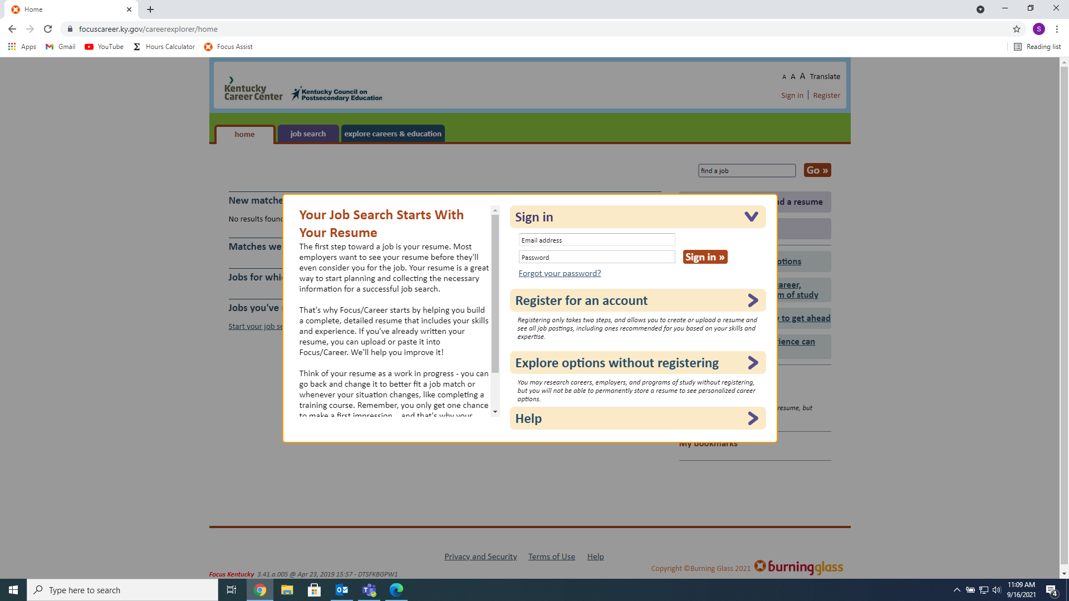

Once there, Click Register for an Account (Click the Actual Words)



Fill out all the Information that is asked, there is more so scroll down the page using the Scroll Bar (The Dark Gray Part)

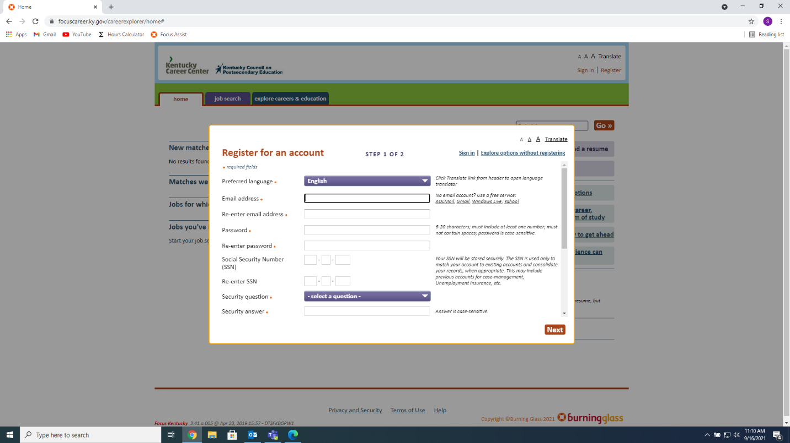

Once it’s all completed, Click Next

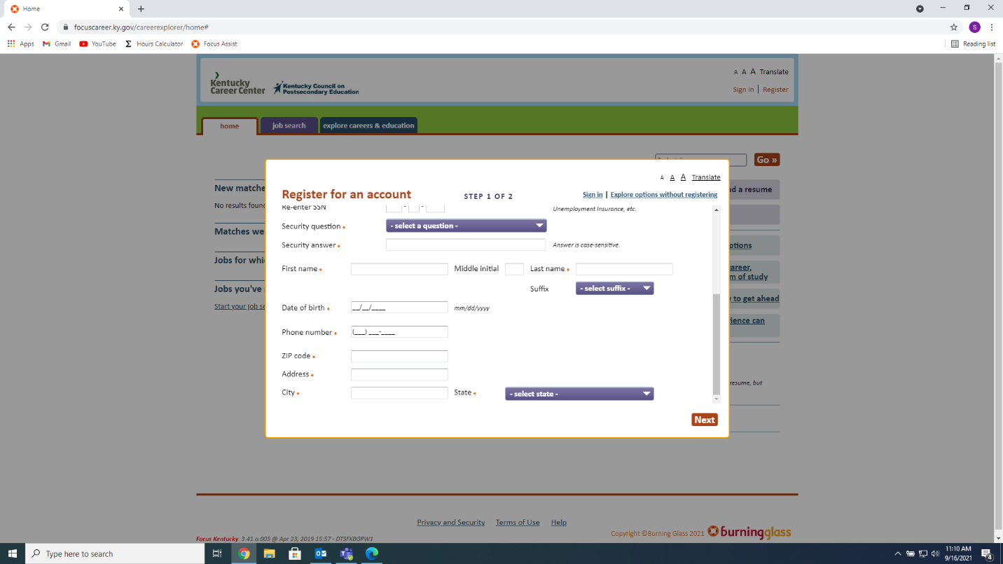

Agree to the Terms and You’re done

